Journal of Geophysical Research: Ocean
Supporting Information for
Physical mechanisms routing nutrients in the central Red Sea

Nikolaos D. Zarokanellos^{1*}, Benjamin Kürten¹, James H. Churchill², Cornelia Roder^{1,3}, Christian R. Voolstra¹ and Yasser Abualnaja¹, Burton H. Jones¹

¹ King Abdullah University of Science and Technology (KAUST), Red Sea Research Center (RSRC), Biological and Environmental Sciences & Engineering Division (BESE), Thuwal, 23955-6900, KSA.
² Woods Hole Oceanographic Institution, Department of Physical Oceanography, Woods Hole, Massachusetts, USA.
³ Alfred-Wegener-Institute, Helmholtz Center for Polar and Marine Research, Section of Shelf Sea System Ecology, 27498 Helgoland, Germany

Contents of this file

Figure S1

Introduction
This supporting information provides a comparison between the profiling CTD and Scanfish system at the same station.

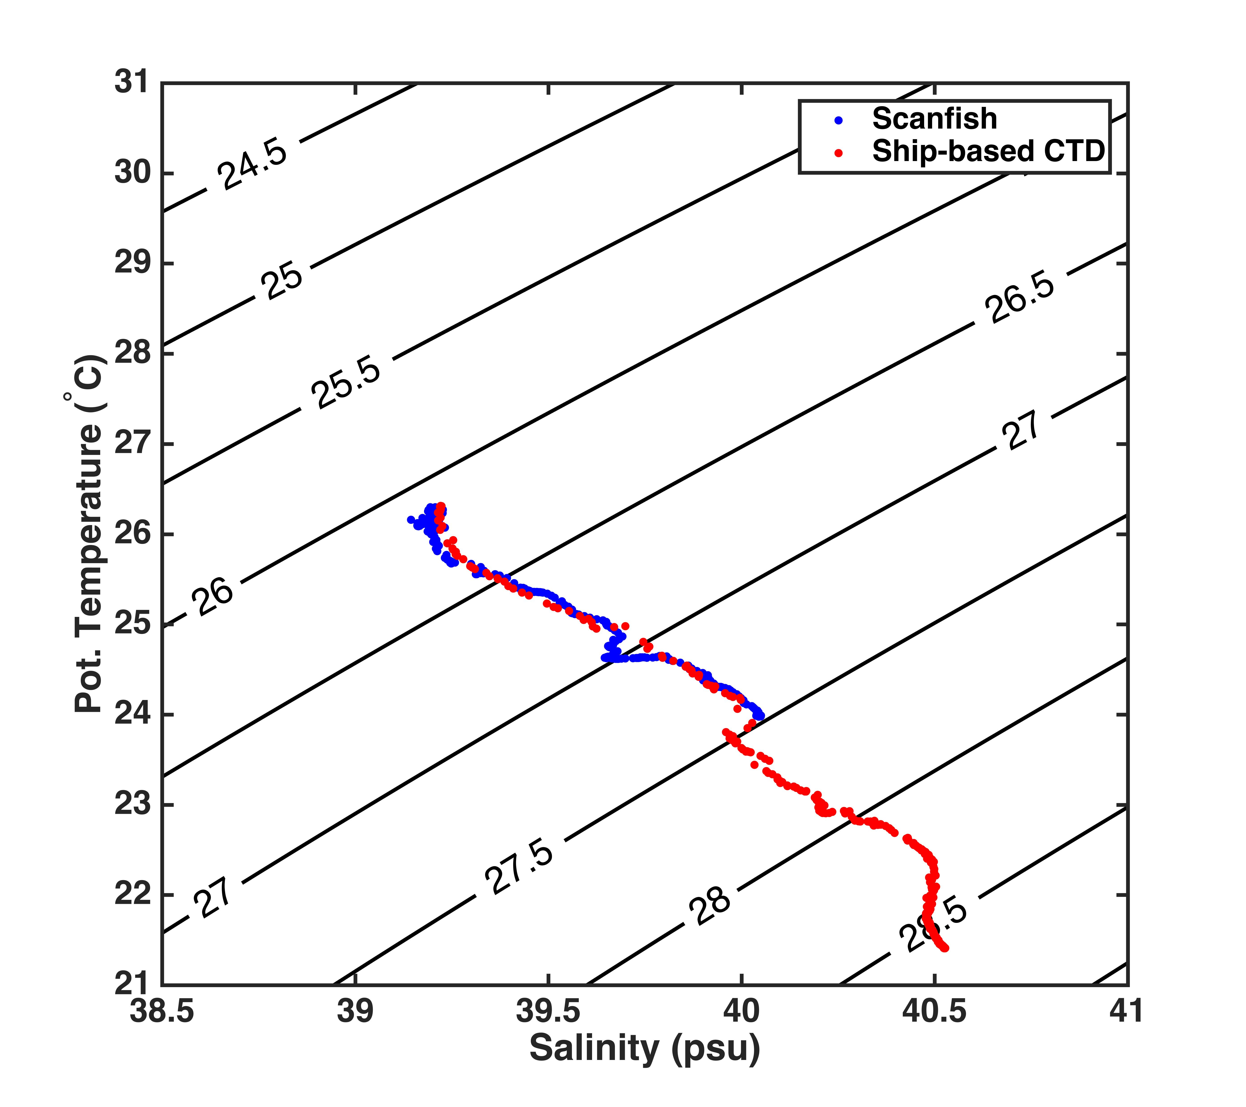

Figure S1: T/S diagram comparison of the profiling CTD and Scanfish system.

