[Paleoceanography]
Supporting Information for
Stable oxygen isotopes and Mg/Ca in planktic foraminifera from modern surface sediments of the Western Pacific Warm Pool: Implications for thermocline reconstructions

Martina Hollstein^{1*}, Mahyar Mohtadi¹, Yair Rosenthal², Paola Moffa Sanchez³, Delia Oppo⁴, Gema Martínez Méndez¹, Stephan Steinke⁵, Dierk Hebbeln¹
¹MARUM – Center for Marine Environmental Sciences, University of Bremen, Bremen, Germany
²Institute of Marine and Coastal Sciences, Rutgers, State University of New Jersey, USA.
³School of Earth and Ocean Sciences, Cardiff University, Cardiff, UK
⁴Department of Geology and Geophysics, Woodshole Oceanographic Institution, Massachusetts, USA
⁵Department of Geological Oceanography, Xiamen University, Xiamen, China

*Corresponding author: Martina Hollstein (mhollstein@marum.de)

Contents of this file

Figures S1 to S8

Additional Supporting Information (Files uploaded separately)

Captions for Tables S1 to S3

Introduction
Additional figures are provided below. Tables showing water column data and Mg/Ca and δ¹⁸O-derived temperatures are provided separately.

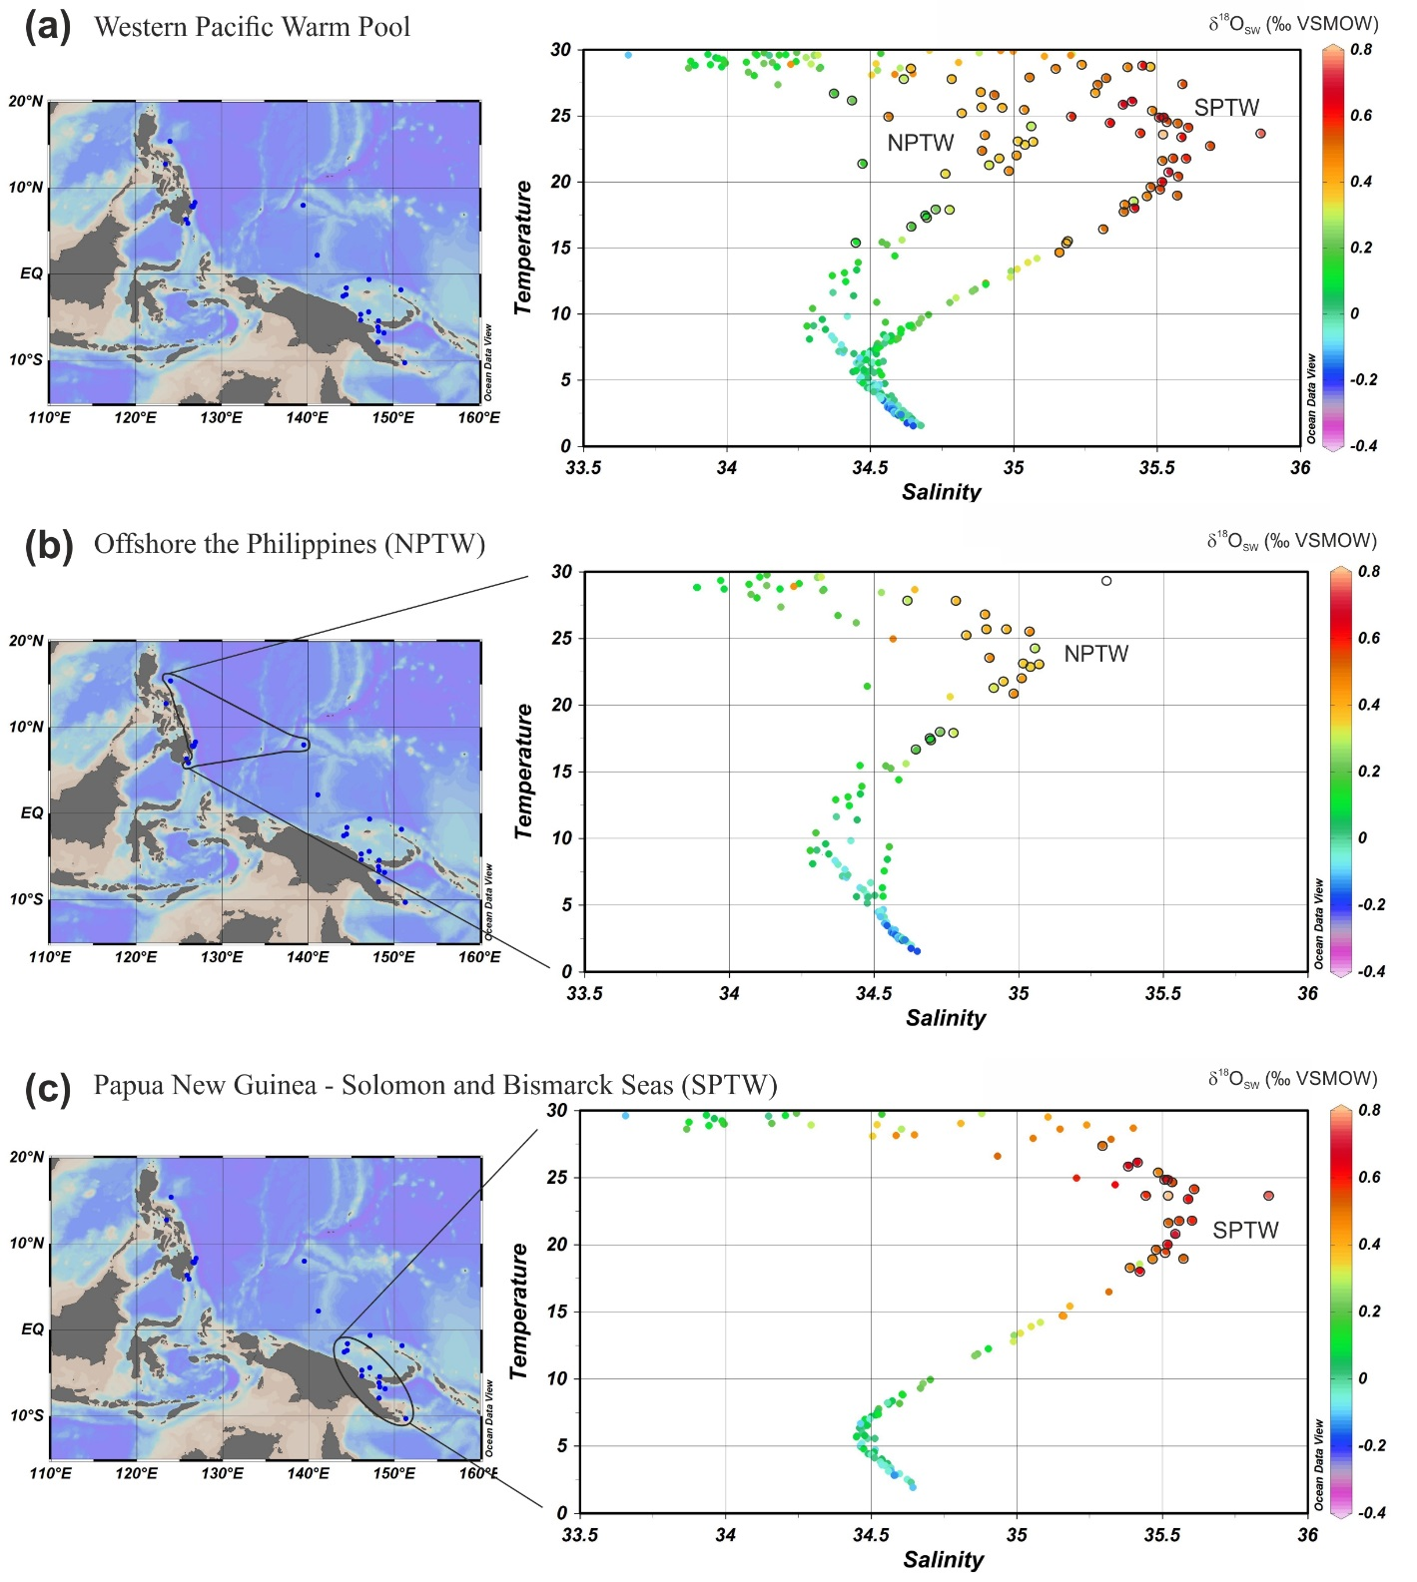
Figure S1. Temperature-salinity diagrams for SO-228 and RR-1313 stations. Colors represent δ¹⁸O_{SW}. Black surrounded dots indicate samples used to calculate the δ¹⁸O_{SW}-salinity regressions of subsurface of (a) the Western Pacific Warm Pool, (b) offshore the Philippines, (c) offshore Papua New Guinea.

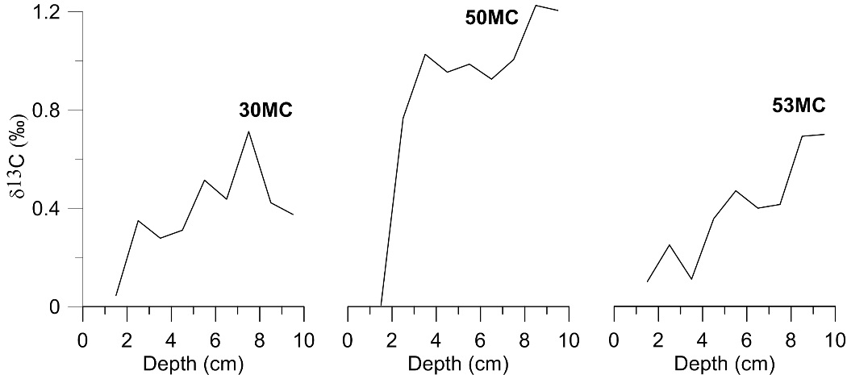
Figure S2. Shell δ¹³C of G. ruber in samples from RR-1313 multicores. Rapid drops in δ¹³C are indicative for the Suess effect.

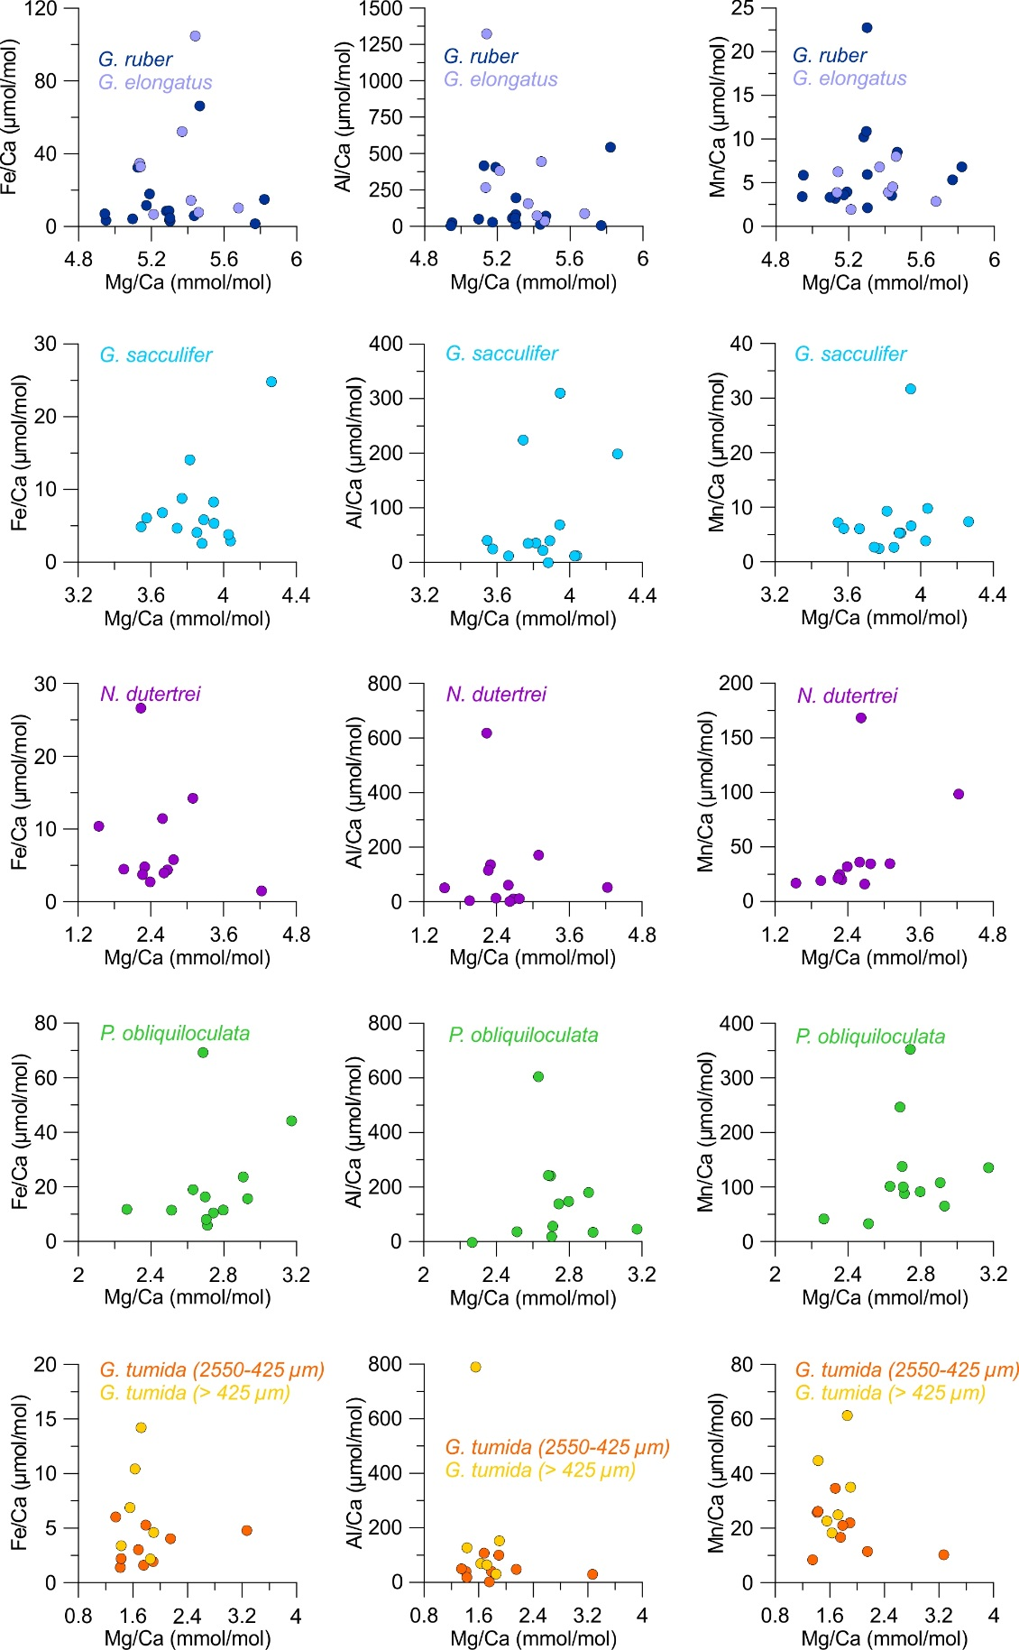
Figure S3. Fe/Ca (left), Al/Ca (middle) and Mn/Ca (right) of each species and sample versus Mg/Ca. Note the different scaling of the axes for individual species. Results from replicate measurements are shown separately.
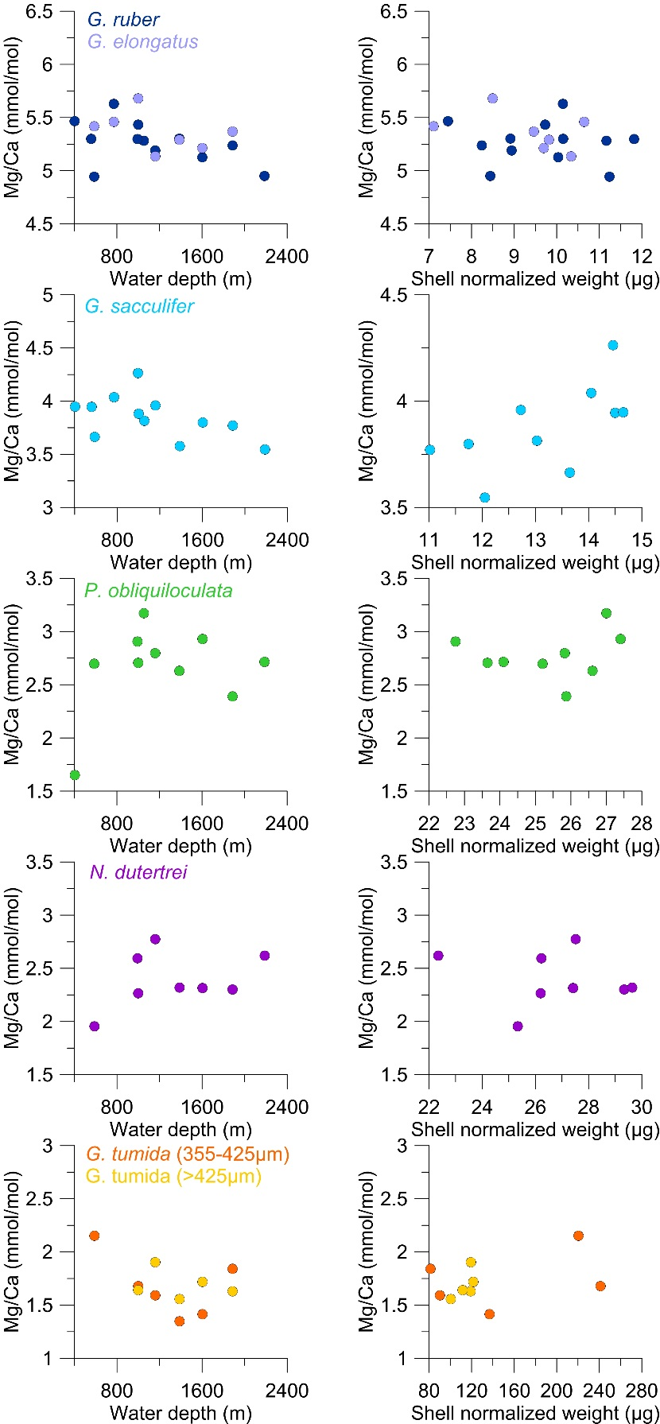
Figure S4. Shell Mg/Ca of each species and sample versus water depth at the respective core sites (left) and shell normalized weight (right).
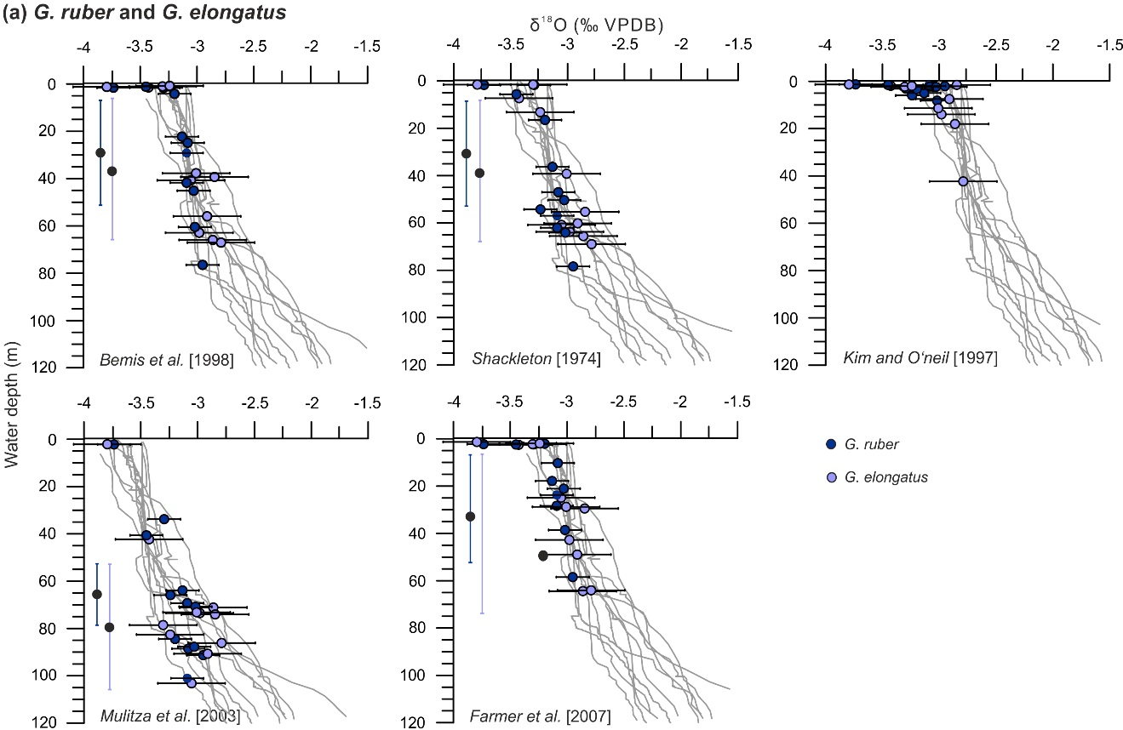

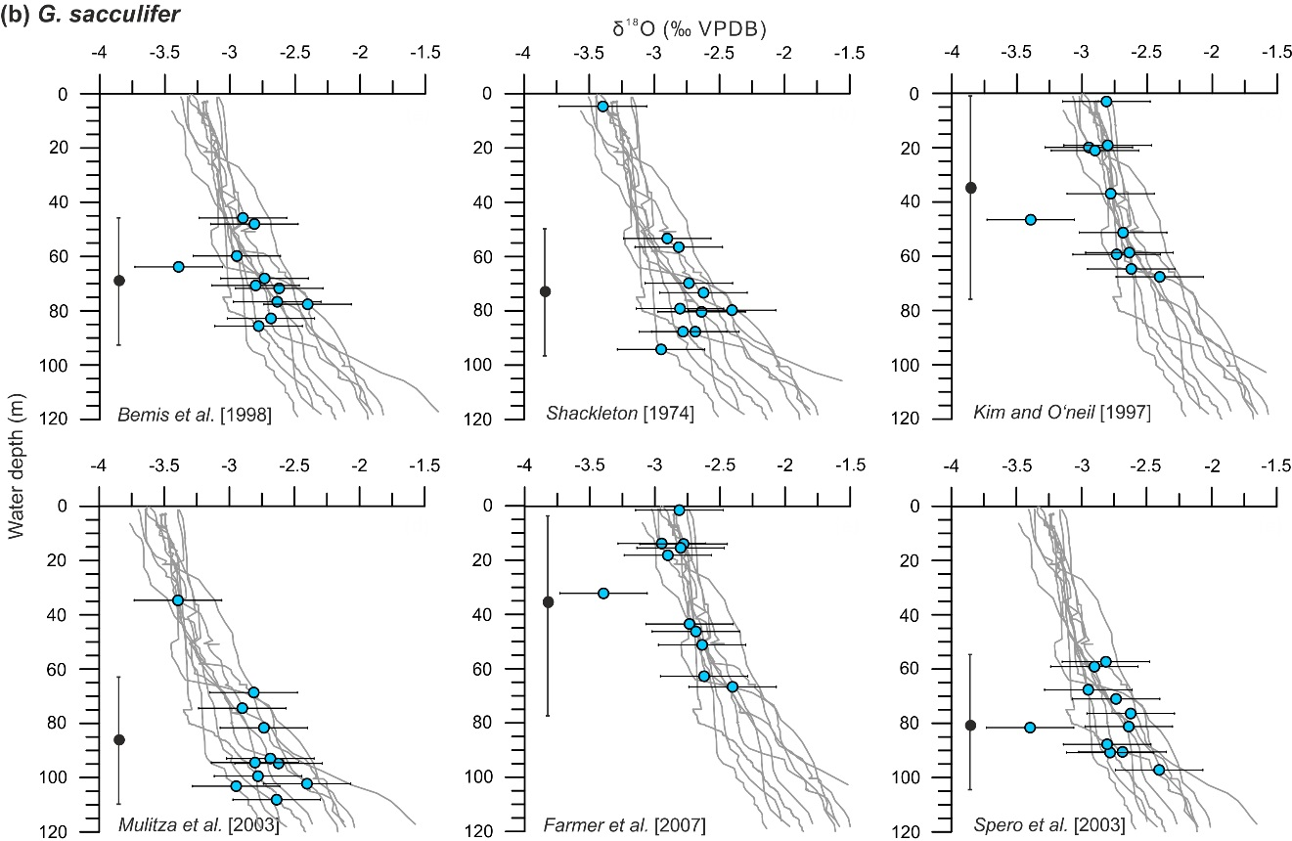

Figure S5. Shell δ¹⁸O derived calcification depth estimates for (a) G. ruber, G. elongatus and (b) G. sacculifer. Colored dots show shell δ¹⁸O. Gray lines indicate depth profiles of predicted δ¹⁸O calcite using the noted paleotemperature equations. CTD temperature and seawater δ¹⁸O calculated from salinity via δ¹⁸O-salinity regressions from the study area were implemented in the equations. Horizontal bars indicate 1σ error ranges for shell δ¹⁸O, vertical bars on black dots show exemplarily average uncertainties in calcification depth derived by projecting shell δ¹⁸O with added/subtracted standard deviations on an average δ¹⁸O calcite profile.

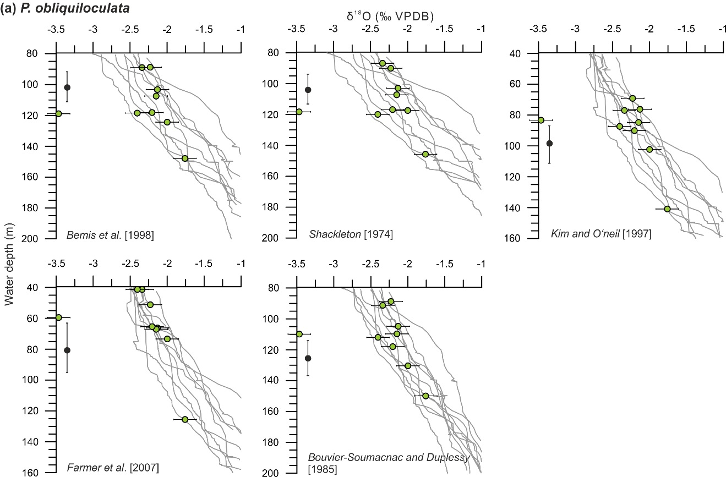

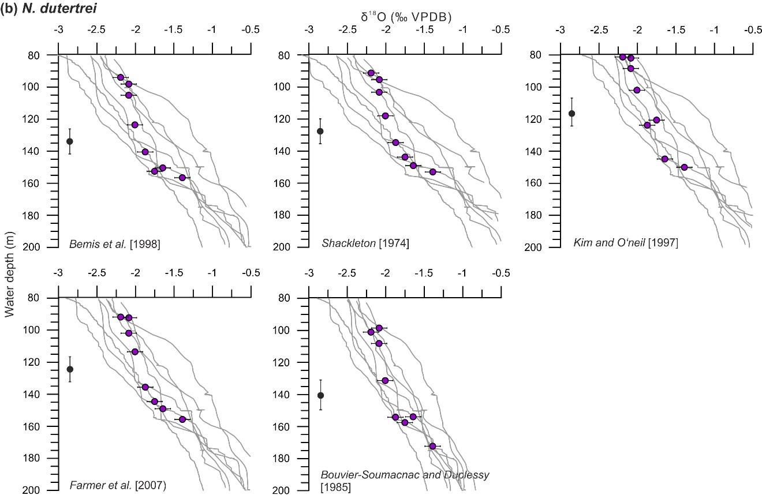

Figure S6. Shell δ¹⁸O derived calcification depth estimates for (a) P. obliquiloculata and (b) N. dutertrei. Colored dots show shell δ¹⁸O. Gray lines indicate depth profiles of predicted δ¹⁸O calcite using the noted paleotemperature equations. CTD temperature and seawater δ¹⁸O calculated from salinity via δ¹⁸O-salinity regressions from the study area were implemented in the equations. Horizontal bars indicate 1σ error ranges for shell δ¹⁸O, vertical bars on black dots show exemplarily average uncertainties in calcification depth derived by projecting shell δ¹⁸O with added/subtracted standard deviations on an average δ¹⁸O calcite profile.

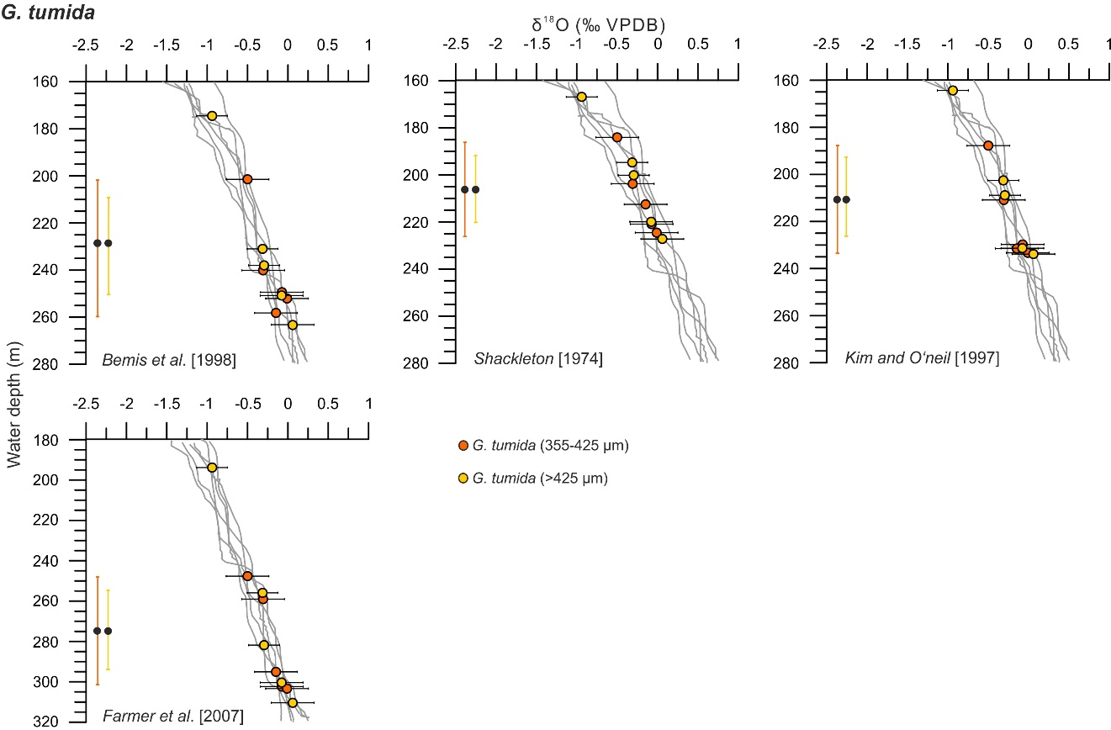
Figure S7. Shell δ¹⁸O derived calcification depth estimates for G. tumida. Colored dots show shell δ¹⁸O. Gray lines indicate depth profiles of predicted δ¹⁸O calcite using the noted paleotemperature equations. CTD temperature and seawater δ¹⁸O calculated from salinity via δ¹⁸O-salinity regressions from the study area were implemented in the equations. Horizontal bars indicate 1σ error ranges for shell δ¹⁸O, vertical bars on black dots show exemplarily average uncertainties in calcification depth derived by projecting shell δ¹⁸O with added/subtracted standard deviations on an average δ¹⁸O calcite profile.
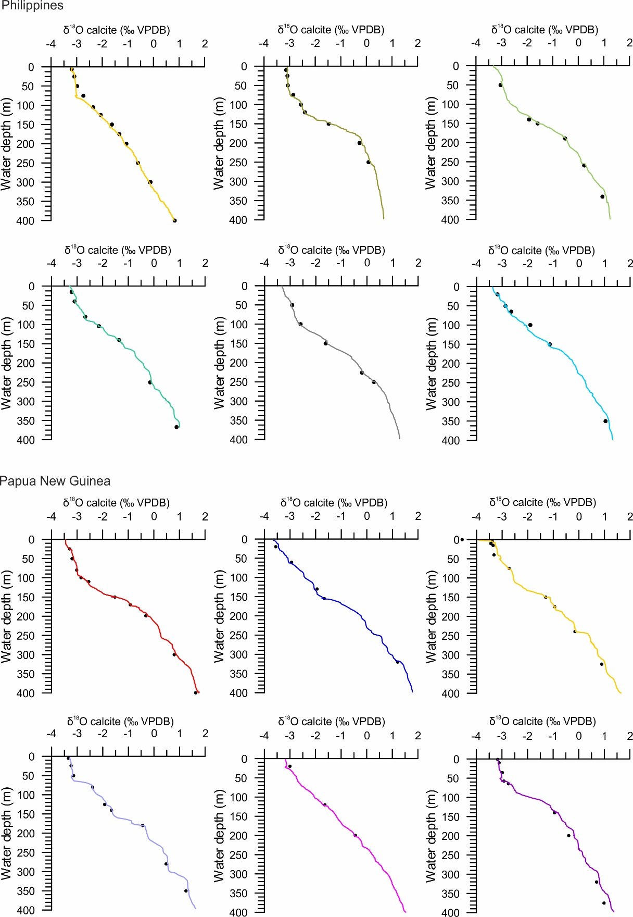
Figure S8. Comparison of δ¹⁸O predicted calcite calculated from δ¹⁸Osw measured in water samples (dots) and from CTD salinity (colored lines) at different stations offshore the Philippines and Papua New Guinea. δ¹⁸O values were converted to the VPDB scale by subtracting 0.27 ‰ [Hut, 1987]. The temperature equation of Bemis et al., [1998] was used to predict equilibrium δ¹⁸O calcite. Profiles from all stations used to estimate foraminiferal calcification depths are shown. The standard deviation for δ¹⁸O_{SW} measurements is smaller than the symbol size and therefore error bars are not shown in the figure.

Table S1. SO-228 and RR-1313 CTD temperature, salinity and δ¹⁸O_{SW}

Table S2. Measured δ¹⁸O_{SW} versus δ¹⁸O_{SW} calculated from CTD salinity. Results for all stations where vertical profiles of δ¹⁸O were used to estimate the calcification depth of severeal planktic foraminifera are shown.

Table S3. Mg/Ca versus δ¹⁸O-derived calcification temperatures. Mg/Ca-temperatures are based on our newly established species-specific regressions; δ¹⁸O-temperatures were calculated with the equation of Bemis et al. [1998].

