[Geochemistry, Geophysics, Geosystems]
Supporting Information for

Reconstructing the evolution of the submarine Monterey Canyon System from Os, Nd, and Pb isotopes in hydrogenetic Fe-Mn crusts
T. A. Conrad^{1,2}, S. G. Nielsen², B. Peucker-Ehrenbrink², J. Blusztajn², D. Winslow¹, J. R. Hein³, and A. Paytan¹
¹University California Santa Cruz, 1156 High Street, Santa Cruz, CA 95060, USA.
²Woods Hole Oceanographic Institution, 360 Woods Hole Road, Woods Hole, MA 02543, USA.
³U.S. Geological Survey, PCMSC, 2885 Mission St., Santa Cruz, CA 95060, USA.

Contents of this file
S1 Ferromanganese crust sample Preparation
S2 Osmium isotope supplemental methods
S3 Neodymium isotope supplemental methods
S4 Lead isotope supplemental methods
S5 Python code for processing LA-MCICPMS Pb isotope data
Figure S1 ¹⁸⁷Os/¹⁸⁸Os standard LoOsStd by date analyzed
Figure S2 Duplicate ¹⁸⁷Os/¹⁸⁸Os isotope analyses on USGS nodule standard A-1 with correction for contamination on ¹⁸⁵Re
Figure S3 Laser ablation cell sample holder with three Fe-Mn crusts and sets of three USGS nodule standards A-1 and P-1 pellets, packed in Crayola Air-Dry Clay.
Figure S4 Plot of time series ²⁰⁶Pb/²⁰⁴Pb, ²⁰⁷Pb/²⁰⁴Pb, ²⁰⁸Pb/²⁰⁴Pb data for three Fe-Mn crusts.
Table S1 Water normalized chemical data for Fe-Mn crusts

Additional Supporting Information
Data set S1 ¹⁸⁷Os/¹⁸⁸Os data for six Fe-Mn crusts, USGS nodule standards A-1 and standard LoOsStd
Data set S2 ¹⁴³Nd/¹⁴⁴Nd data for four Fe-Mn crusts, USGS nodule standards A-1 and P-1, and standard JNdi-1
Data set S3 Lead isotope data for three Fe-Mn crusts, USGS nodule standards A-1 and P-1
Data set S4 Anaconda Python codes (in a zip folder)

Introduction
Supplemental information for sample preparation (S1) and digestion for isotope analysis is presented for Os (S2), Nd (S3), and Pb (S4). Data sets with the Os, Nd, and Pb isotope data for Fe-Mn crusts, USGS nodule standards, and standards are available as excel files. Datasets for the processing of LA-ICPMS using standard sample bracketing using Anaconda Python are available as Python (.py) files. Additional figures showing standard analyses or additional Fe-Mn crust data are also included.

S1 Sample Preparation
The Fe-Mn crusts were encased in Tap Plastic Clear Lite Casting Resin and cut into billets perpendicular to the growth surface prior to mounting on large glass slides with Crystalbond 590 adhesive. The samples were then hand sanded to create a smooth and level surface. Subsamples for Os and Nd isotopes were collected using a New Wave Micromill and Brasseler 1 mm cylindrical (flat head) diamond tipped drill bit. For Fe-Mn crust samples the optimal drill rotation was found to be 40-50% of maximum drill speed (3500 rotations per minute) depending on crust hardness, with harder crusts requiring faster rotation. The optimal lateral drill speed depended on hardness and ranged from 15-45 µm/s, with slower speeds for harder samples. The plunge speed of the drill into the sample ranged from 25 to 50 µm/s. Faster drill speeds increased fracturing along the drill line and faster rotational speeds increased sample loss to air. The sample height, measured by the micromill poking the sample with the drill bit, was only measured on resin encasing the crust, as measurements attempted on samples penetrated and fractured the Fe-Mn crust and did not register a sample height. Drilled subsamples were collected with a paintbrush onto weighing paper. The crust surface, drill bit, and paint brush were cleaned between samples using hand-held compressed gas (Dust-Off) and Kimwipes.
Osmium samples were collected over 2 mm stratigraphic depth, 2 mm deep into the layer, and 10 mm along the layer running parallel to the top of the crust. This yielded a minimum of 15 to 40 mg of material for each subsample. Chipping along the sample line during micromilling and uncertainty in the sample lines is added to the error in the age model. The amount of sample used in the digestions ranged from 13.75 mg to 38.90 mg. Subsamples for Os were stored in cleaned 1 dram (4 ml) glass vials. Subsamples for Nd isotopes were collected using a New Wave Micromill using a 1 mm cylindrical drill bit penetrating 0.5 mm deeper into the same section of the Fe-Mn crust sampled for Os, at 0.3 mm resolution. Neodymium subsamples were stored in acid washed plastic vials. In both cases, fractures along the drill lines were estimated and included in the depth of crust error calculations. Samples for Pb isotopes were collected via laser ablation during analysis.

S2 Osmium Isotopes
Ferromanganese crust samples were prepared for Os analysis using an Anton Paar High Pressure Asher (HPA-S). Samples were prepared using 30-40 ml reagent grade 15.8 N nitric acid. Reagent grade acid was used since Os is volatile under oxic conditions and will become more concentrated in distilled acid depending on the distillation process (Mukul Sharma, personal communication 9/2013). Samples were spiked with an in-house ¹⁹⁰Os standard (BPE95; [Sen and Peucker-Ehrenbrink, 2014] with a concentration of 0.6061 ng/g. Polytetrafluoroethylene (PTFE) tape was used to cover the lip of the vessel and a quartz lid was placed over the tape and wrapped with more PTFE tape to create a seal. Digestion in the Anton Paar High Pressure Asher (HPA-S) used 20 ml quartz vessels for the Hoss Seamount samples and 15 ml quartz vessels for the samples from Davidson and Taney B and D seamounts. USGS A-1 nodule standard was prepared along with all samples, as were blanks, for each HPA digestion. Samples were digested at 280˚ C and 130 bars (1900 psi) for 1 hour with additional time (~1 hr each) for warm up and cool down. This resulted in digestion of the Fe-Mn material, although a residue most likely consisting of aluminosilicates was observed in some of the vials. Subsequently, the quartz vessels were placed in an ice bath to cool. Once cooled the sample was transferred to a 22 ml PFA Teflon beaker and capped tightly. During this process, 1 ml milliQ (MQ) water was used to rinse the vials and added to the sample. Care was taken to exclude residual detrital silicates, which were visually inspected and discarded. Teflon beakers and lids were cleaned by wiping with methanol, rinsed three times with water and then soaked in an acid bath of 50% HNO₃ at 115˚ C for a minimum of ten hours, followed by rinsing three times with MQ water prior to use. Samples were stored in the PFA Teflon beakers in a refrigerator kept at 4˚C until analysis. The storage time ranged from less than half an hour to 10 days. Samples were kept in a cooler on ice until approximately 5 minutes prior to sparging when 5 ml MQ water was added and the PFA Teflon beaker cap was replaced with a sparging cap.
Quartz vials used as digestion vessels in the HPA-S were cleaned by rinsing with deionized (DI) water, dissolving any Fe-Mn crust residue remaining on the sides of the vials with concentrated reagent grade hydrochloric acid, rinsed well with DI water and then cleaned with a cleaning solution of 10 parts MQ water, 5 parts concentrated nitric acid and 1 part concentrated hydrofluoric acid in a sonicator for 1 minute, rinsed well with DI water and run in the HPA-S with 10 ml reagent grade nitric acid. The vials were then rinsed well with MQ water prior to each use.
Samples were analyzed for Os isotopes on a ThermoElectron NEPTUNE MC-ICPMS with three continuous-dynode ion counters at the Woods Hole Oceanographic Institution in the WHOI ICP-MS facility following methods described by Sen and Peucker-Ehrenbrink (2014). A subset of ~10% of the digested Fe-Mn crust samples and nodule standards contained no Os. It is thought that the Os escaped as a volatile OsO₄ during the digestion and decanting process. Another 21% of the subsamples had unknown contaminants on the ¹⁸⁵Re, ¹⁹⁴Pt, and ¹⁹⁶Pt masses (mass/charge). The presence of an unidentified interference on the ¹⁸⁵Re mass resulted in ¹⁸⁷Os/¹⁸⁸Os values below the normal standard values on the seawater curve and in the case of one sample, D173-R2 41-42, the processed data yielded a negative ¹⁸⁷Os/¹⁸⁸Os ratio. These samples were not used to fit the data to the seawater curve. However, replacing the count rates acquired on mass/charge 185 with the blank ¹⁸⁵Re value brought those data points in line with uncontaminated data, and it is this data that is shown on the diagrams. This approach was applied to the nodule standards and Fe-Mn crust samples. Similar interferences have been observed previously using this method [Sen and Peucker-Ehrenbrink, 2014] (Supplemental Fig. S2, S3). Data were processed using mass/charge ratios of 194 (¹⁹⁴Pt) and 196 (¹⁹⁶Pt) to correct for interference on ¹⁹⁰Os and ¹⁹²Os from Pt isotopes, and count rates at the mass/charge of 185 (¹⁸⁵Re) were used to correct for Re interference on ¹⁸⁷Os [Sen and Peucker-Ehrenbrink, 2014]. This yielded the ¹⁸⁷Os/¹⁸⁸Os values that were compared with the Cenozoic Os isotope seawater curve, to determine approximate ages and growth rates for each crust sample. Samples that deviated from the Os seawater curve were not used to determine age; instead, the growth rate was extrapolated using average growth rates as the most conservative estimate.
A subset of 11 samples was also spiked with an in-house Re isotope tracer prior to digestion in the HPA-S and subsequent Os analysis. The samples were prepared following the methods described in Sen and Peucker-Ehrenbrink (2014) and analyzed for Re on the Element-2 ICPMS. Rhenium concentrations were extremely low. This was done to confirm that osmium isotope ratios do not need to be corrected for ingrowth from ¹⁸⁷Re decay since deposition, a finding that is consistent with results from other Fe-Mn crust studies (e.g., Klemm et al., 2008, 2005).

S3 Neodymium Isotopes
For ¹⁴³Nd/¹⁴⁴Nd isotopes, an average of 1.9 mg Fe-Mn crust subsample was rinsed into a 7 ml Teflon beaker with MQ water and the water was evaporated using a hot plate set to 120˚ C for 1.5 hours. To digest the dry sample, 3 ml 6N distilled hydrochloric acid was added and the sample fluxed on a hot plate at 120˚C for a minimum of 8 hours before being re-dried and dissolved in 400 µl 0.25N HCl. Dissolved samples were cooled to room temperature, centrifuged for 3 minutes at 15,000 rpm, and decanted into acid-washed 7 ml Teflon beakers to remove undissolved detrital silicate material. Nd was extracted using a single-step Nd column with a 125 µl stem volume and 50-100 µm particle size Ln resin (lanthanide-specific cation exchange resin) [Scher and Delaney, 2010]. Blanks and USGS Fe-Mn nodule standards A-1 and P-1 were prepared with each batch of Fe-Mn crust subsamples. Nd samples were analyzed in WHOI ICPMS facility on the MC-ICP-MS using a 52-position ASX auto sampler using the method of Huang et al., (2012). Standard JNdi-1 with a reference value of 0.512115 was used. The mean offset of measured JNdi-1 standard values from the reference value was calculated for each auto-changer batch and used to correct the ¹⁴³Nd/¹⁴⁴Nd ratio. Neodymium isotopes are corrected to JNdi-1 = 0.512115 and expressed as Ɛ_{Nd}, which is the ¹⁴³Nd/¹⁴⁴Nd ratio normalized to Chondritic Uniform Reservoir (CHUR = 0.512638), [Ɛ_{Nd}((¹⁴³Nd/¹⁴⁴Nd_{samp}/CHUR)-1) x 1000] [Jacobsen and Wasserburg, 1980].

S4 Lead Isotopes
Lead isotopes on three Fe-Mn crusts, from Hoss, Davidson, and Taney B seamounts were analyzed using a NewWave/Merchantek NWR-193 ArF excimer laser ablation system coupled with the MC-ICP-MS in the WHOI NIRVANA facility. Pellet standards of USGS A-1 and P-1 nodule standards were prepared in the WHOI Experimental Petrology Lab using a hand press and 5 mm die. Nodule standard powder was pressed at 0.3 tons for 5 minutes to create pressed powder pellets. Three Fe-Mn crust samples analyzed for Pb isotopes and three pressed pellets of both the A-1 and P-1 USGS nodule standards were packed into the laser ablation cell sample holder. The sample holder was lined with aluminum foil and filled with Crayola Air-Dry Clay into which the Fe-Mn crust billets, still encased in TAAP Plastic resin and mounted on glass slides, and the standard pellets were placed to create a level surface (Fig. A2.5). For use with laser ablation, it is critical to have as little height variation as possible between the surface of the samples and standards. Future work using this method should encase the bottom of the standard pellets in resin to keep the pellets from adsorbing water from the clay and crumbling.
The laser ablation cell sample holder was placed into the chamber, which was purged with He gas. Up to eight sample lines were analyzed between USGS nodule A-1 and P-1 standard pairs. The laser was set to a 50 µm diameter spot size and a 0.5 mm line was used to account for the heterogeneous nature of Fe-Mn crusts. The laser parameters were slightly modified from published work to 70% power with a 5 µm/s scan speed and 20 Hz repetition rate for all samples and standards [Foster and Vance, 2006]. Resolution through the crusts varied. The highest resolution was measured in the upper 2.9 mm of D11-4 from the Hoss Seamount at 50 µm. The lowest resolution was measured in Fe-Mn crust D173-R2 with 50 µm wide lines placed 0.95 mm apart. The laser ablation cell sample holder was not removed from the ablation chamber during continuous run time. The aluminum foil and clay into which the samples and standards were packed was removed from the ablation cell sample holder and stored when necessary between analytical sessions. This allowed the same lines and reference points to be used for multiple analytical sessions. A python code was written and used to process the Pb data during the analytical sessions.

S5 Python Code for processing Lead Isotope Data.
A Python code was written and used to process Pb isotope data from exp files, allowing for efficient processing of the data during the analysis. The code was run on Python 3.4.3 installed using the Anaconda installation package and using an ipython notebook PbPython_processing.ipynb, an Anaconda ipython example notebook that opens Jupyter Notebook for interactive sample and background selection. The code has three modules in addition to the notebook. The first module is read_exp.py this reads in the exp files, the raw files containing the data from the LA-MC-ICPMS, and will output a file list to be modified in Excel. A sample list created by the user must be imported and all samples must be bracketed by paired standards. The user must identify each file as std, or samp for standard or sample, respectively. All sample files of raw data must exist in the location the user has indicated or an error message will appear. The sample list must start and end with standards. The second and third modules are opened automatically using the ipython notebook. The second module identifies the raw data to keep and which can be discarded. The raw data used for correction and calculation of Pb ratios include values of non-ratio raw data for ²⁰⁴Pb, ²⁰⁶Pb, ²⁰⁷Pb, ²⁰⁸Pb, ²⁰³Tl, ²⁰⁴Tl, ²⁰⁵Tl, and ²⁰²Hg and are contained in ParfileIn.py. The second module Parse_exp.py allows the user to manually separate the files into background and data. This is done using slide bars to set the minimum and maximum for the background and the sample as shown on data graphs. A standard deviation is provided to help select the sample and exclude the background data. This process must be done as one step, the program will not save progress if closed in the middle and must be restarted from the beginning. However, as long as the window remains open the data can be reinterpreted. This uses Process_exp.py and calculates the standard sample bracketing correction to process the raw Pb data using the background and sample selected by the user and yields corrected Pb ratios. Further instructions for each module are included in the code files.
Utilizing a Python code to process LA-MC-ICPMS Pb isotope data greatly reduced the time required to process data and allowed for real-time data analysis. Mounting all samples and standards into a stable setting within the laser ablation cell permitted very accurate sample locations and enabled rapid continuation of work if the laser ablation cell needed to be removed or emptied between runs.
Standard values used for processing [Ling et al., 2005; Foster and Vance, 2006] are in (Methods Table A2.21). Additional values used in the processing code: NIST SRM 997 ²⁰⁵Tl/²⁰³Tl = 2.388.

Figure S1. Plot of duplicate analyses ¹⁸⁷Os/¹⁸⁸Os isotope standard LoOsStd by date analyzed.

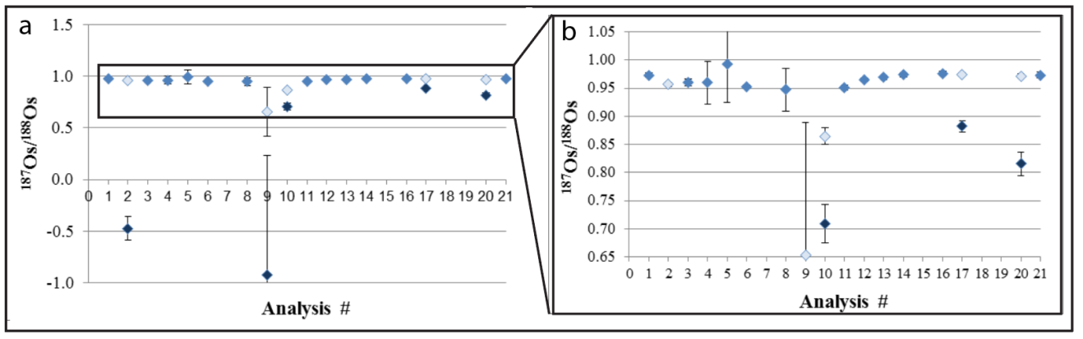
Figure S2. a) Duplicate ¹⁸⁷Os/¹⁸⁸Os analyses of USGS nodule standard A-1. Analysis #s 15, 19, and 21 had no Os present. Analysis #'s 9,10,17, and 20 had an unknown contaminant on the ¹⁸⁵Re line. Dark points for those analyses are with the measured ¹⁸⁵Re and the light points for the same run are with a blank ¹⁸⁵Re value replacing the contaminated ¹⁸⁵Re. Error bars are instrumental error, most are too small to see. b) Larger view of the outlined region in figure a.

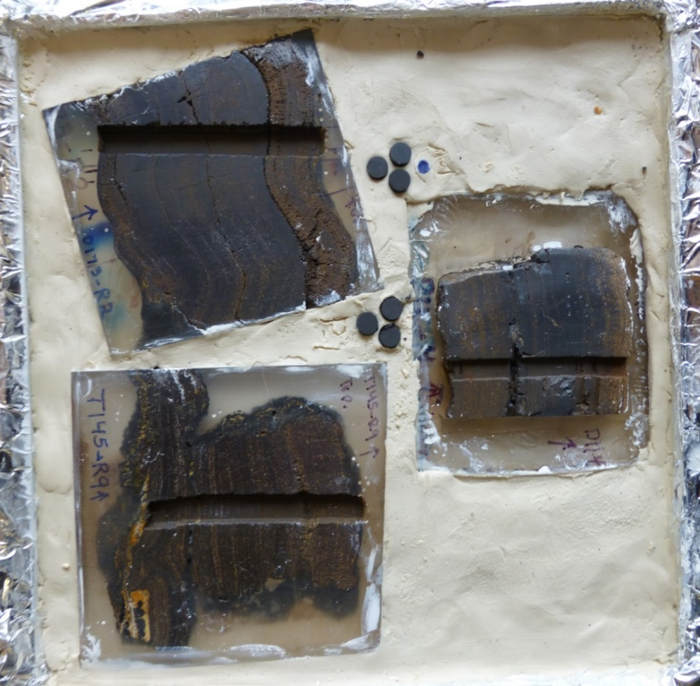
Figure S4. Ferromanganese crusts D11-4, T145-R9, D173-R2 and sets of three USGS nodule standards A-1 and P-1 pellets, packed in Crayola Air-Dry Clay in the laser ablation cell sample holder.

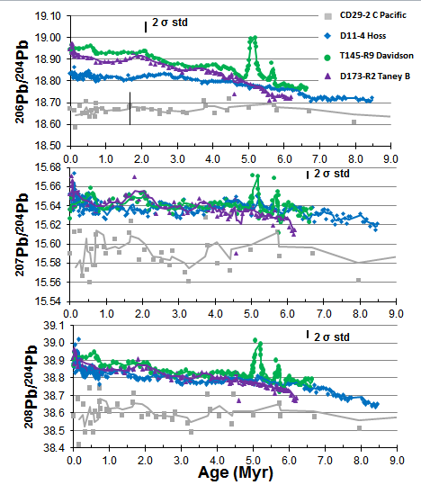
Figure S5. Plot of LA-MC-ICP-MS data for ²⁰⁶Pb/²⁰⁴Pb, ²⁰⁷Pb/²⁰⁴Pb, ²⁰⁸Pb/²⁰⁴Pb compared to CD29-2 [Christensen, 1997; Nielsen et al., 2011]. Trend lines for CA Fe-Mn crusts (colored samples) are three point moving average trend lines.

Table S1. Water normalized chemical data for Fe-Mn crusts
Sample | D11-4 | D11-11 | T141 R-5A | T145 R-9A | D173-R2 | T121 R-5B
Seamount | Hoss | Hoss | Davidson | Davidson | Taney B | Taney D
Cruise | F7-87-SC | F7-87-SC | M. 2000 | M. 2003 | M. 2010 | M. 2000
Collection Method | Dredge | Dredge | ROV | ROV | ROV | ROV
Water Depth (m) | 2,560-2,540 | 2,560-2,540 | 2388 | 3298 | 3178 | 3887
GR (mm/Myr) | 3.72 | 2.53 | 9.80 | 17.1 | 6.06 | 22.1
Age (Ma) | 9.7 | 15.8 | 3.3 | 2.6 | 8.3 | 2.1
Thickness (mm) | 36 | 40 | 32 | 45 | 50 | 46
Fe (wt%) | 21.5 | 20.3 | 29.0 | 25.2 | 21.0 | 25.5
Mn | 18.1 | 18.7 | 22.7 | 16.4 | 15.5 | 20.2
Fe/Mn | 1.19 | 1.09 | 1.28 | 1.53 | 1.35 | 1.26
Si | 8.19 | 6.86 | 9.01 | 13.9 | 8.88 | 10.9
Al | 1.29 | 1.29 | 1.66 | 2.42 | 1.15 | 1.97
Ca | 2.04 | 2.14 | 2.45 | 1.83 | 1.73 | 2.01
Mg | 0.95 | 0.95 | 1.19 | 0.97 | 0.86 | 1.18
Na | 1.7 | 1.74 | 1.77 | 2.01 | 1.42 | 1.86
K | 0.6 | 0.61 | 1.04 | 1.13 | 0.59 | 1.05
P | 0.39 | 0.41 | 0.56 | 0.38 | 0.35 | 0.40
Ti | 0.61 | 0.66 | 0.64 | 0.59 | 0.39 | 0.54
LOI | -- | -- | 15.8 | 15.5 | 36.1 | 16.7
H2O- | 23.1 | 24.2 | 21.1 | 17.5 | 17.9 | 17.9
Ag (ppm) | -- | -- | -- | -- | 0.07 | --
As | 312 | 317 | 322 | 195 | 205 | 226
Ba | 2211 | 1715 | 2041 | 1830 | 1981 | 1754
Be | -- | -- | 2.79 | 3.15 | 5.66 | 2.46
Bi | -- | -- | 21.5 | 17.0 | 10.8 | 11.3
Cd | 1.80 | 1.70 | 3.30 | 2.42 | 2.67 | 4.17
Co | 2861 | 3562 | 2091 | 1208 | 1981 | 1153
Cr | 10.0 | 9.00 | 57.0 | 52.1 | 28.3 | 14.4
Cs | -- | -- | 7.60 | -- | -- | --
Cu | 533 | 369 | 304 | 464 | 532 | 630
Ga | -- | -- | 29.2 | 29.1 | 5.07 | 37.2
Hg (ppb) | -- | -- | 7.60 | 6.06 | -- | 15.4
Hf (ppm) | -- | -- | 19.0 | 18.2 | 4.20 | 7.54
In | -- | -- | -- | -- | 0.12 | --
Li | -- | -- | 6.34 | 4.85 | 8.25 | 14.0
Mo | 585 | 554 | 534 | 322 | 479 | 437
Nb | -- | -- | 40.6 | 40.0 | 26.9 | 27.6
Ni | 2471 | 2507 | 2357 | 1236 | 1415 | 2410
Pb | 1430 | 1451 | 1470 | 1045 | 1285 | 886
Rb | -- | -- | 46.9 | 23.0 | 8.02 | 33.7
Sb | -- | -- | 58.7 | 38.2 | 48.2 | 36.9
Sc | -- | -- | 6.46 | 8.24 | 10.6 | 9.73
Se | -- | -- | -- | -- | 0.94 | 6.79
Sn | -- | -- | -- | -- | 2.36 | --
Sr | 1560 | 1451 | 1195 | 939 | 1344 | 997
Ta | -- | -- | -- | 2.42 | 0.41 | 0.98
Te | -- | -- | 7.22 | 7.27 | 6.49 | 6.05
Th | -- | -- | 38.3 | 41.0 | 23.7 | 40.0
Tl | -- | -- | 61.3 | 15.6 | 13.2 | 25.6
U | -- | -- | 11.5 | 7.88 | 10.9 | 8.37
V | 741 | 686 | 678 | 533 | 636 | 582
W | -- | -- | 87.5 | 44.8 | 95.2 | 44.6
Zn | 702 | 594 | 598 | 555 | 627 | 676
Zr | -- | -- | 798 | 897 | 37.1 | 792
La (ppm) | -- | -- | 317 | 304 | 309 | 305
Ce | 1143 | 1240 | 1508 | 1069 | 943 | 1087
Pr | 79.2 | -- | 64.9 | 73.3 | 72.1 | 79.9
Nd | 321 | 369 | 286 | 320 | 291 | 336
Sm | 68.5 | -- | 59.8 | 67.0 | 66.4 | 76.1
Eu | 16.1 | 20.0 | 16.5 | 17.8 | 15.9 | 19.8
Gd | 68.7 | -- | 60.7 | 64.7 | 65.9 | 68.4
Tb | 11.1 | -- | 11.0 | 11.4 | 10.4 | 12.38
Dy | 66.7 | -- | 64.9 | 63.6 | 62.4 | 72.1
Y | 208 | 224 | 190 | 184 | 223 | 178
Ho | 13.0 | 13.3 | 15.5 | 15.0 | 12.5 | 14.4
Er | 35.0 | 36.3 | 36.2 | 34.4 | 33.0 | 32.4
Tm | 5.33 | 5.30 | 4.94 | 4.61 | 4.88 | 4.45
Yb | 32.9 | 34.2 | 30.9 | 27.5 | 31.0 | 26.2
Lu | 4.56 | 4.71 | 5.04 | 5.07 | 4.52 | 4.09
Au (ppb) | -- | -- | -- | -- | -- | 1.40
Ru | -- | -- | 10.1 | -- | -- | 5.91
Rh | 7.00 | 7.30 | 6.34 | -- | -- | 3.94
Pd | 2.90 | 3.30 | -- | -- | -- | 2.95
Os | -- | -- | -- | -- | -- | 1.97
Pt | 43.0 | 46.0 | 87.5 | -- | -- | 43.3
 | M. = Monterey Bay Aquarium Research Institute (MBARI)
 | -- no data

Data Set S1 Data for ¹⁸⁷Os ^{/188}Os data for six CCM Fe-Mn crusts, USGS standard Nod A-1, and standard LoOsStd (DataSet_S1_OsIsotopes).

Data Set S2. Data for ¹⁴³Nd/¹⁴⁴Nd and ƐNd for Hoss D11-4, Taney D173-R2, Davidson T141-R5, T145-R9, USGS nodule standards A-1 and P-1, and Standard JNdi-1 (DataSet_S2_NdIsotopes).

Data Set S3. Data for ²⁰⁶Pb/²⁰⁴Pb, ²⁰⁷Pb/²⁰⁴Pb, ²⁰⁸Pb/²⁰⁴Pb and ²⁰⁷Pb/²⁰⁶Pb Hoss D11-4, Taney D173-R2, Davidson T145-R9 and USGS nodule standards A-1 and P-1 (DataSet_S3_PbIsotopes).
Data set S4 Anaconda Python codes: ParfileIn, parseExp, processExp, readExp, PbPython_processing

Data Set S4. Anaconda Python codes

ParfileIn.py is an Anaconda Python code that sets the sample parameters to use in processing data.

PbPython_processing.ipynb, an Anaconda ipython example notebook that opens Jupyter Notebook for interactive sample and background selection with a graphical interface for the user to designate sample and background on continuous laser ablation data.

read_exp.py is an Anaconda Python code to create a sample list from file.

parse_exp.py is an Anaconda Python code using ipython notebook
process_exp.py is an Anaconda Python code to process and print the Pb sample data using a background reduction and standard sample standard bracketing for data correction.

