Supplementary figures for “Constraints on lithospheric mantle and crustal anisotropy in the NoMelt area from an analysis of long-period seafloor magnetotelluric data” by Matsuno and Evans.

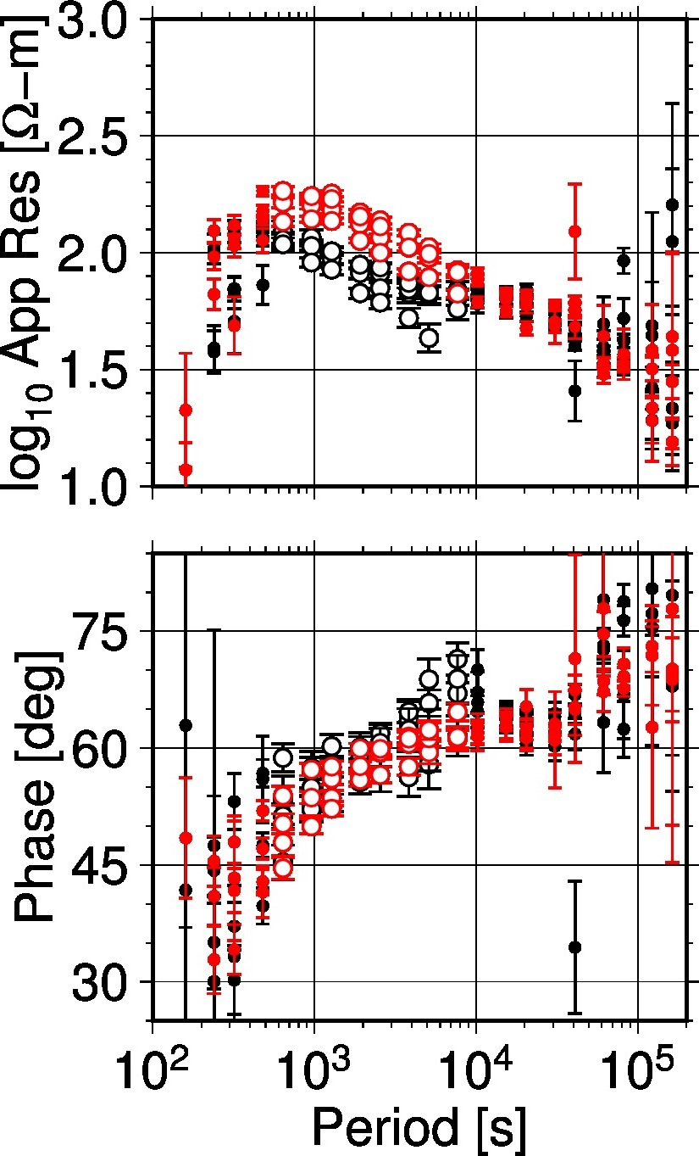
Additional file 1: Figure S1
Observed MT responses in the NoMelt area at the four stations where data are available for the inversion (M01, M02, M04, and M06) [Sarafian et al., 2015]. Black symbols indicate TE-mode (or xy element) response, and red symbols indicate TM-mode (or yx element) response. Open circles denote data used for calculating cumulative phase split at periods from 640 s to 7680 s, and filled circles denote data out of this period band. Cumulative phase splits between the off-diagonal elements are 35°, 8°, 21°, and 18° for M01, M02, M04, and M06, respectively, without data errors.

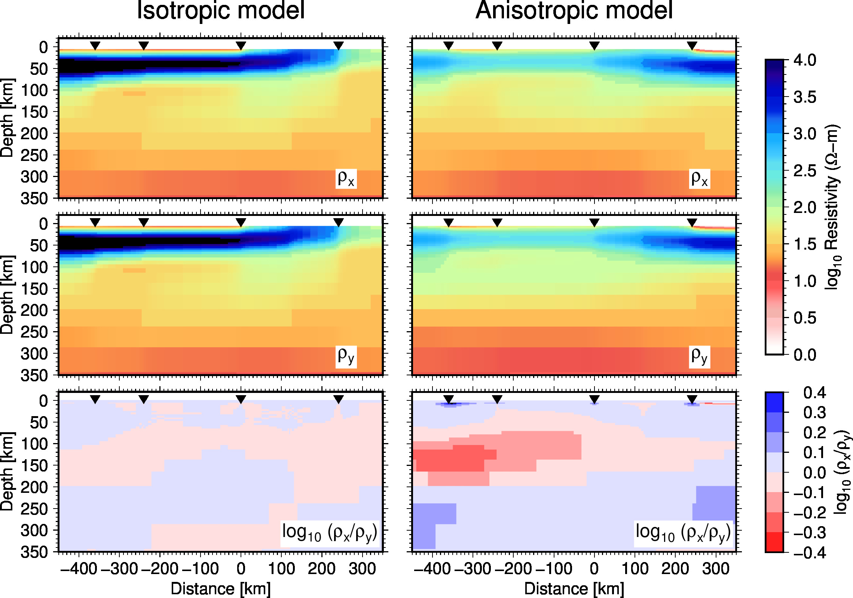
Additional file 1: Figure S2
Isotropic and anisotropic 2D inversion models of ρ_{x} and ρ_{y}, which are horizontal components of transversely anisotropy, as well as their difference in logarithmic scale. These inversion models are obtained by our reanalysis of the Sarafian et al. [2015] data. The same regularization parameter for model smoothness (0.1) was used for both models. The regularization (or closeness) parameter for anisotropy is 100 for the isotropic model and 0.1 for the anisotropic model.

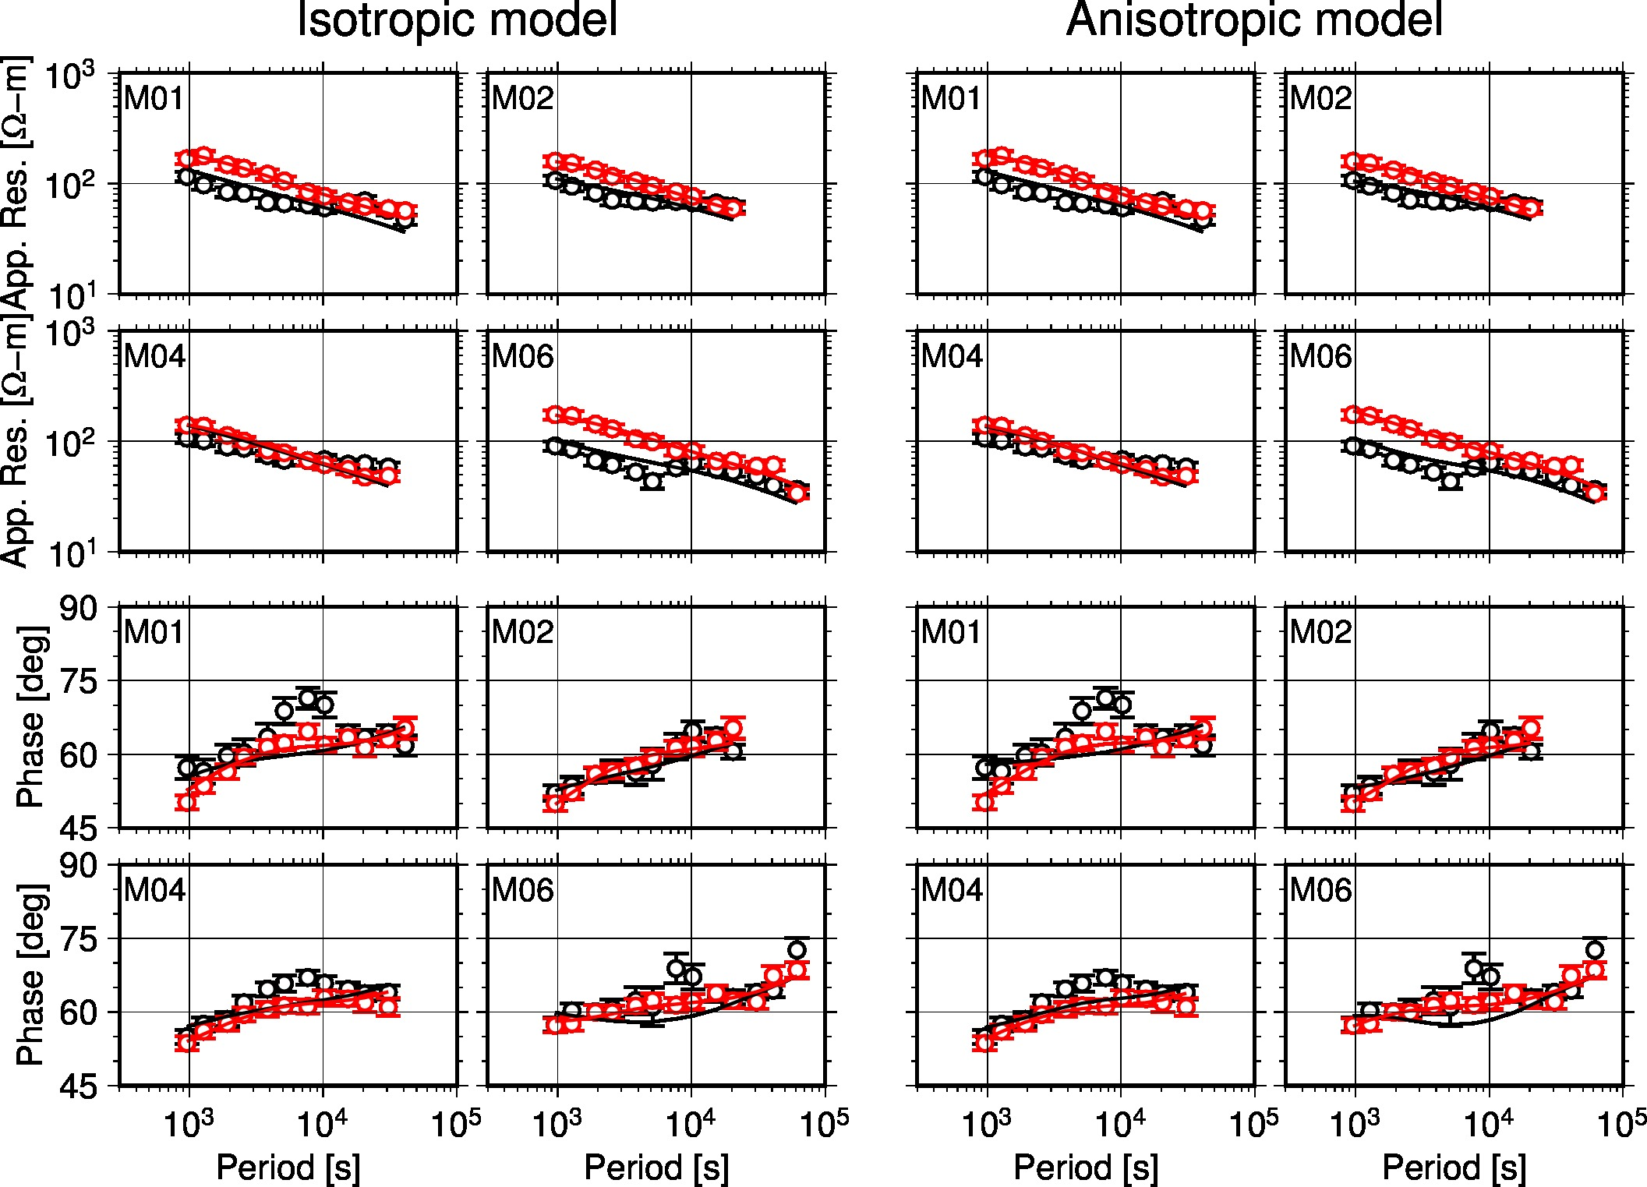
Additional file 1: Figure S3
MT responses observed [Sarafian et al., 2015] (circle with error bar) and predicted from the isotropic and anisotropic 2D inversion models shown by Supplementary figure 2 (curve). Black color indicates the TE mode (or xy element) response and red color indicates the TM mode (or yx element) response. Total RMS misfits for the isotropic and anisotropic inversion models are 1.465 and 1.403, respectively.

