Geophysical Research Letters
Supporting Information for
Storm impact on sea surface temperature and chlorophyll-a in the northwest Atlantic based on daily cloud-free satellite data reconstructions

Taylor Shropshire¹, Yizhen Li², Ruoying He³
¹Department of Earth, Ocean and Atmospheric Sciences, Center for Ocean-Atmospheric Prediction Studies, Florida State University, Tallahassee, FL.
²Department of Applied Ocean Physics and Enginerring, Woods Hole Oceanographic Institution, Woods Hole, MA.
³Department of Marine, Earth and Atmospheric Sciences, North Carolina State University, Raleigh, NC.

Daily daytime Moderate Resolution Imaging Spectroradiometer (MODIS) SST and chl-a data from January 2003 through December 2012 used in this study were level 3 fields provided by NASA’s Goddard Space Flight Center (http://modis.gsfc.nasa.gov/). Six-hourly storm eye position and intensity data were obtained from the National Hurricane Center (NHC) archive (http://www.nhc.noaa.gov/data/ ). In situ ocean temperature data were taken from the National Data Buoy Center (NDBC) (http://www.ndbc.noaa.gov/ ).

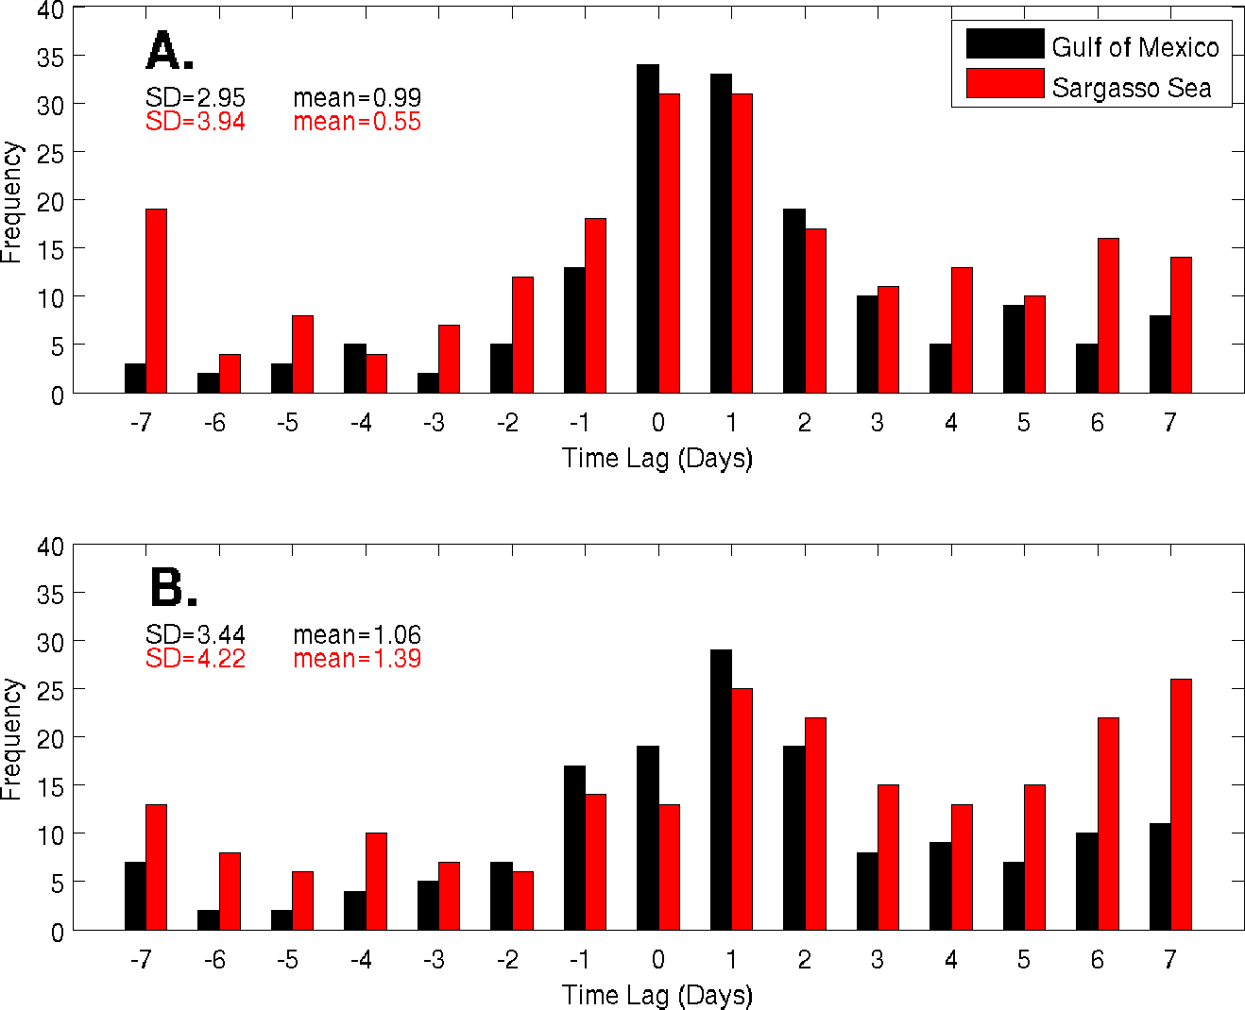
Figure S1. Histograms of (A) maximum response time of ΔSST and (B) maximum response time of Δchl-a associated with all storm track points as a function of time lag (in days) relative to the time of storm passage (i.e., zero days) in the GoM (black) and SS (red).

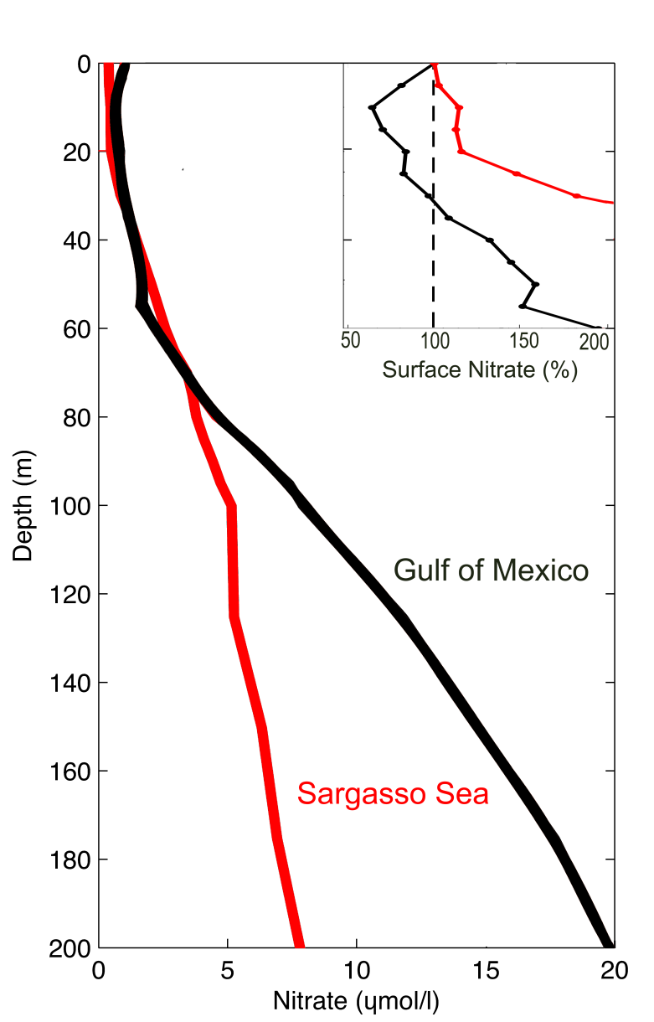

Figure S2. Climatological regional nitrate profiles for the GoM and SS during hurricane season inset with surface relative nitrate.

Table S1. Validations of DINEOF SST reconstruction against daily averaged buoy-measured SST during storm days. Correlation is given for all storm dates and the correlation for all non-storm days are given in parenthesis. Units of Bias and Root Mean Square (RMS) are °C.
 | Buoy ID | Observations | Correlation | Bias | RMS
Yucatan Channel – Gulf of Mexico | 42001 | 141 | 0.79 (0.95) | 1.53 | 1.80
 | 42002 | 148 | 0.77 (0.94) | 1.59 | 1.83
 | 42003 | 132 | 0.75 (0.90) | 1.91 | 2.13
 | 42040 | 151 | 0.82 (0.95) | 1.43 | 1.74
 | 42055 | 138 | 0.63 (0.94) | 1.81 | 2.01
Mid Atlantic Bight – Sargasso Sea | 41001 | 176 | 0.88 (0.96) | 1.59 | 1.85
 | 41002 | 176 | 0.86 (0.94) | 0.99 | 1.38
 | 41010 | 234 | 0.86 (0.94) | 1.72 | 1.90
 | 41047 | 95 | 0.91 (0.95) | 1.80 | 1.97
 | 41048 | 127 | 0.92 (0.97) | 1.67 | 1.86
 | 41049 | 89 | 0.78 (0.95) | 1.83 | 2.10
 | 44088 | 234 | 0.88 (0.97) | 0.31 | 1.78

