Supplemental Materials
Supplementary Table 1. Detailed information on human subjects used for fresh frozen and fixed tissue samples.
Diagnosis | Age (yrs) | Gender | PMI (h) | Tau Staging | Region | Type
Control | 80 | M | 5 | Braak II | Ft Ctx | Fresh Frozen
Control | 75 | F | 17 | Braak II
Control | 88 | M | 27 | Braak II
Control | 76 | F | 13 | Braak II
Severe AD | 69 | M | 8 | Braak VI | Ft Ctx
Severe AD | 90 | M | 19 | Braak V
Severe AD | 93 | M | 10 | Braak V
Severe AD | 83 | M | 12 | Braak VI
PiD | 67 | M | 21 | --- | Ft Ctx
PiD | 55 | M | 9 | ---
PiD | 78 | F | 25 | ---
PiD | 82 | F | 9 | ---
CBD | 75 | F | 11 | --- | Ft Ctx
CBD | 81 | F | 17 | ---
CBD | 54 | M | 24 | ---
CBD | 62 | F | 5 | ---
Control | 83 | F | unk | Braak I | HP | Fixed Sections
Control | 77 | M | 17 | Braak II
Control | 82 | F | 5 | Braak II
Severe AD | 68 | F | 7 | Braak VI | HP
Severe AD | 71 | M | 6 | Braak VI
Severe AD | 91 | M | 4 | Braak VI
PiD | 74 | F | 4 | --- | Ft Ctx
PiD | 66 | M | 16 | ---
PiD | 75 | M | 0 | ---
PiD | 55 | M | 4 | ---
CBD | 57 | M | 2 | --- | Ft Ctx
CBD | 60 | F | 0 | ---
CBD | 64 | F | 13 | ---
CBD | 61 | M | 0 | ---

AD-Alzheimer’s disease; PiD-Pick’s disease; CBD-corticobasal degeneration; M-male, F-female; PMI- postmortem interval; unk-unknown; PMI-post-mortem interval Ft Ctx-frontal cortex; HP-hippocampus. All tissue was obtained from the Brain Bank of the Cognitive Neurology and Alzheimer’s Disease Center at Northwestern University.
Supplementary Figure 1.
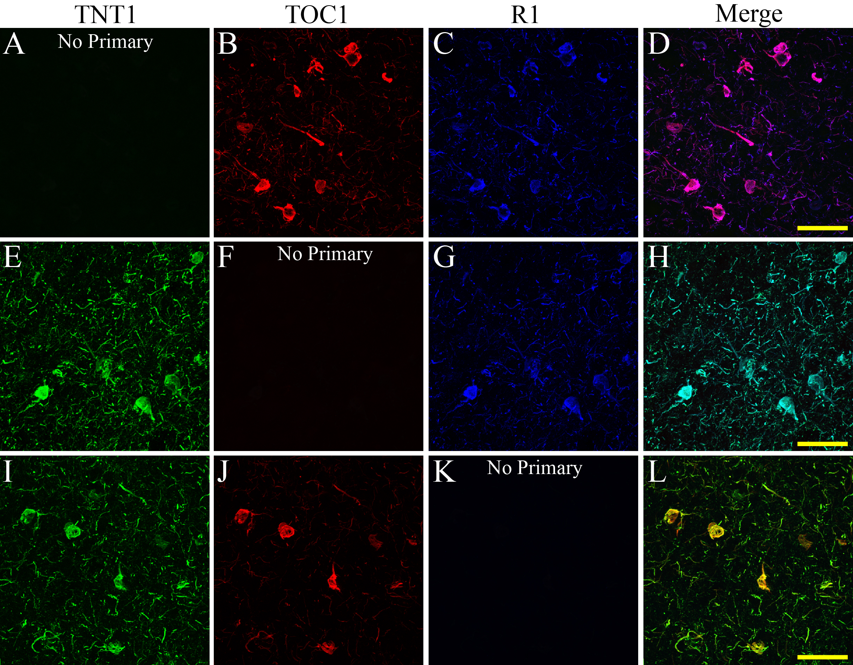

Supplementary Fig. 1. Control immunofluorescence images confirm staining specificity. (A-L) Tissue sections were processed following the triple-label immunofluorescence protocol for TNT1, TOC1 and R1 tau staining with the exception that the (A-D) TNT1 (green), (E-H) TOC1 (red), or (I-L) R1 (blue) primary antibody was omitted. In all conditions, the lack of fluorescent signal for the omitted primary antibody channel confirmed that the signals for each primary-secondary antibody combination were specific and did not produce erroneous signal. All scale bars are 50 μm.

Supplementary Figure 2.
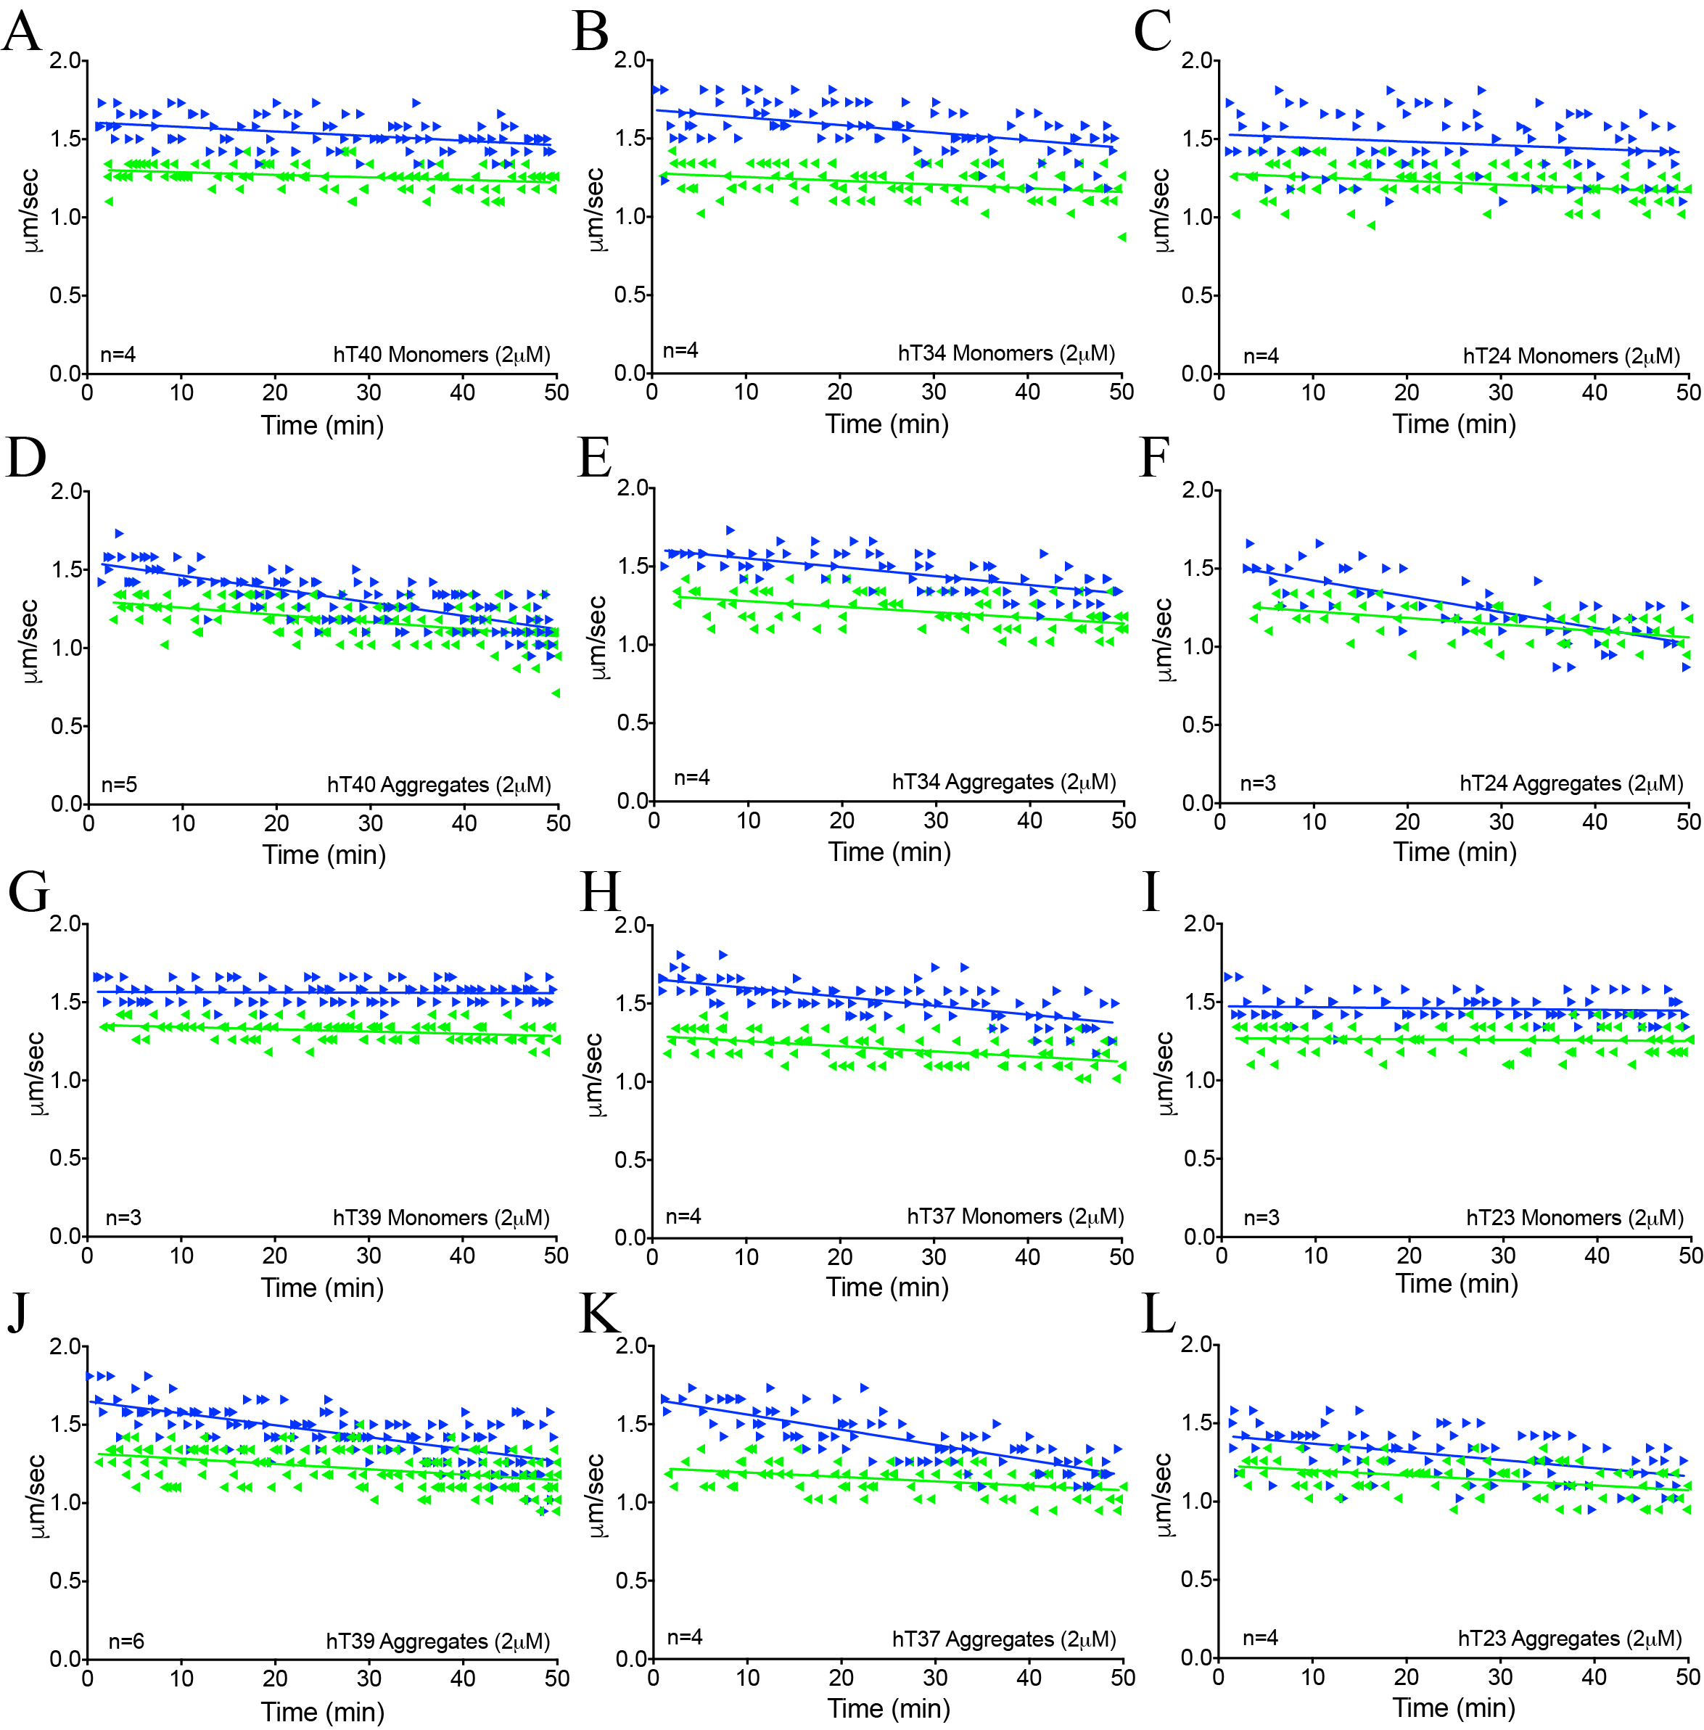

Supplementary Fig. 2. Plots of transport velocity over time in squid axoplasms exposed to each tau isoform monomer and aggregate samples. (A-L) Vesicle motility assays in isolated squid axoplasm were run and individual velocity (μm/sec) measurements of anterograde (blue arrowheads) and retrograde (green arrowheads) are plotted as a function of time (min). (A-C) Perfusion of hT40 (A), hT34 (B) and hT24 (C) monomers did not alter anterograde or retrograde FAT. (D-F) Perfusion of hT40 (D), hT34 (E) and hT24 (F) aggregates selectively inhibited anterograde but not retrograde FAT. (G-I) Perfusion of hT39 (G), hT37 (H) and hT23 (I) monomers did not alter anterograde or retrograde FAT. (J-L) Perfusion of hT39 (J), hT34 (K) and hT24 (L) aggregates selectively inhibited anterograde but did not appear to dramatically affect retrograde FAT. It is noteworthy that a small but significant reduction (~12%) in retrograde transport in axoplasms treated with hT39 aggregates was observed when the average velocity over the last 20 minutes was analyzed (see Fig. 4B).

