
Global Biogeochemical Cycles
Supporting Information for
Decoupling of net community and export production on submesoscales in the Sargasso Sea
M. L. Estapa^{1,*}, D. A. Siegel², K. O. Buesseler¹, R. H. R. Stanley¹, M. W. Lomas^{3,a}, N. B. Nelson²
¹ Department of Marine Chemistry and Geochemistry, Woods Hole Oceanographic Institution, Woods Hole, MA, 02543
² Earth Research Institute and Department of Geography, University of California, Santa Barbara, Santa Barbara, CA
³ Bermuda Institute of Ocean Sciences, St. Georges, Bermuda
*Present address: Department of Geosciences, Skidmore College, Saratoga Springs, NY
ª Present address: Bigelow Laboratory for Ocean Sciences, East Boothbay, ME

Contents of this file

Figures S1 to S9

Additional Supporting Information (Files uploaded separately)

Captions for Table S1

Introduction
This Supplement contains a data table and figures summarizing additional observations made during the two cruises described in the text. Table S1 provides for each underway transect station, the ²³⁴Th deficit observations, mean mixed layer depths, estimated C:²³⁴Th ratios, the computed carbon export, and the net community production derived from O₂/Ar measurements. For all parameters except mixed layer depth, the first column gives the measurement and the second column the error. Please refer to the main text for details on computations and error estimates. Figure S1 contains satellite sea surface temperature composites for the western Sargasso Sea during the 2011 and 2012 cruise periods, in order to orient the reader to the mesoscale context of our observations. Figures S2-S8 are formatted identically to Figures 3-5 in the main text and show physical, biogeochemical, and carbon flux parameters measured underway during surface transects not illustrated in the main text due to space constraints. Figure S9 is formatted identically to Figure 8 in the main text but includes the coefficient of variation for transparent exopolymer particles (TEP). All figure captions are given below.

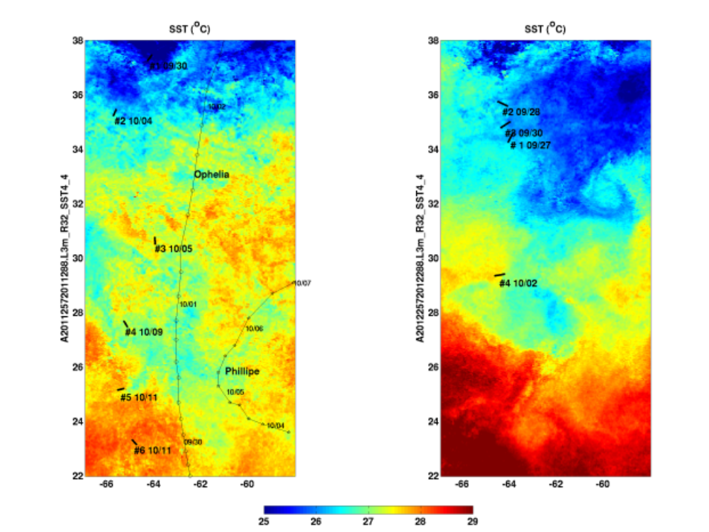Figure S1. Sea surface temperature (SST; MODIS Aqua, nighttime 32-day composite) for 2011 and 2012 cruises. Transect numbers and dates are labeled in black. Left panel: 2011 SST, transects and tracks of Hurricanes Ophelia and Phillipe. Right panel: 2012 SST and transects.

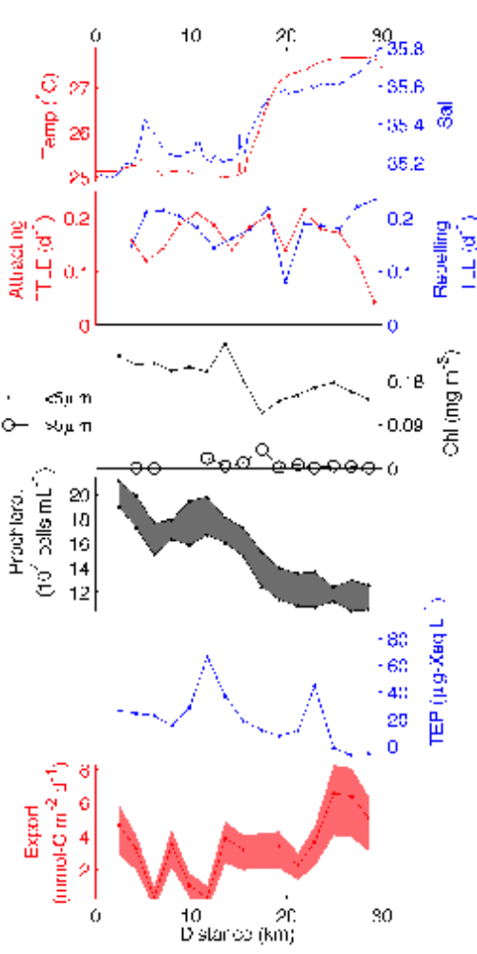

Figure S2. Surface transect 2011 #1. Panel layouts are the same as for Figure 3 in the main text. Transect crossed the wall of the Gulf Stream at approx. 15 km. C:N and NCP data were unavailable (see main text regarding NCP). Note similar scales of periodicity in all parameters.

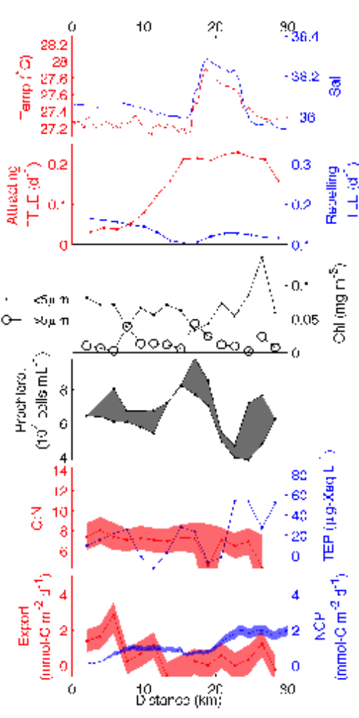

Figure S3. Surface transect 2011 #2. Panel layouts are the same as for Figure 3 in the main text. Note similar scales of spatial variability in biogeochemical and carbon flux parameters.
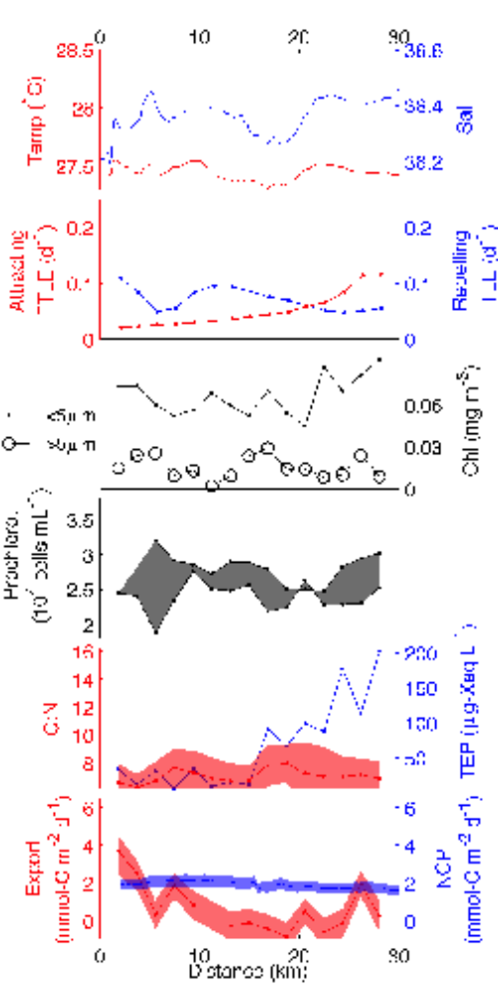
Figure S4. Panel layouts are the same as for Figure 3 in the main text.
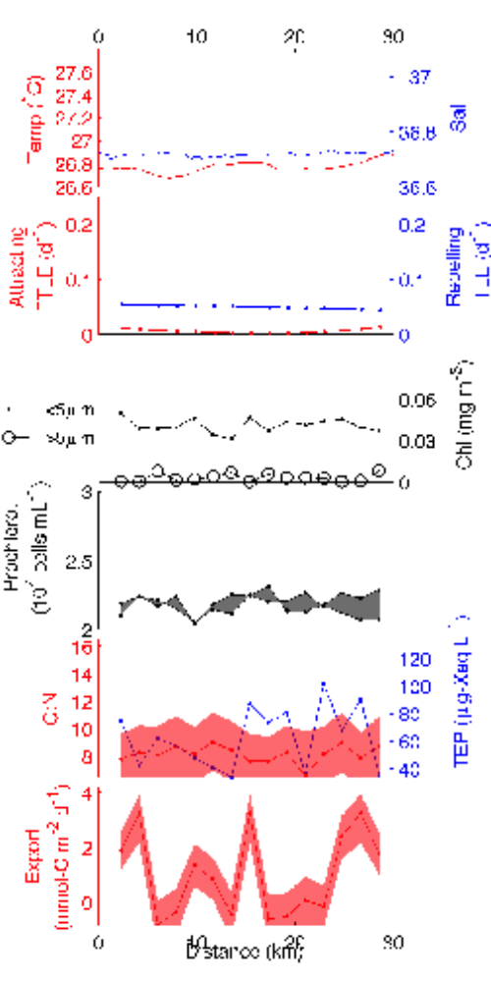
Figure S5. Surface transect 2011 #4. Panel layouts are the same as for Figure 3 in the main text. NCP data are unavailable due to bubbles entering the seawater supply during rough conditions. Low variability in chlorophyll, Prochlorococcus, and C:N ratios corresponds to low-variability physical parameters, but coincident variations in TEP and export persist.

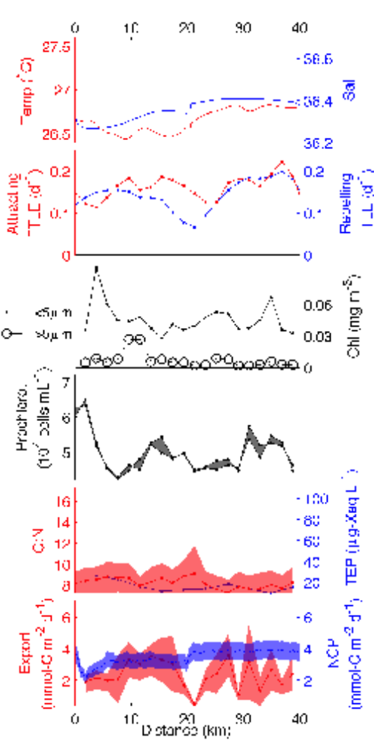
Figure S6. Surface transect 2011 #4. Panel layouts are the same as for Figure 3 in the main text. NCP data are unavailable due to bubbles entering the seawater supply during rough conditions. Low variability in chlorophyll, Prochlorococcus, and C:N ratios corresponds to low-variability physical parameters, but coincident variations in TEP and export persist.

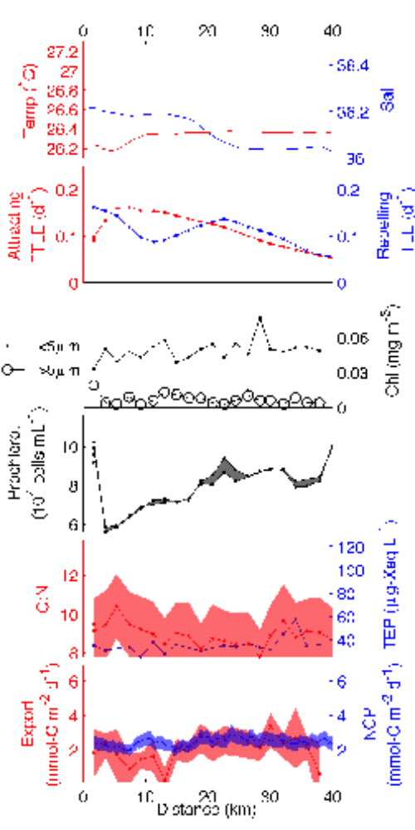
Figure S7. Surface transect 2012 #3. Panel layouts are the same as for Figure 3 in the main text. Note submesoscale variations in Prochlorococcus counts superimposed on mesocale signature of cyclonic eddy (see text and Fig. 6).

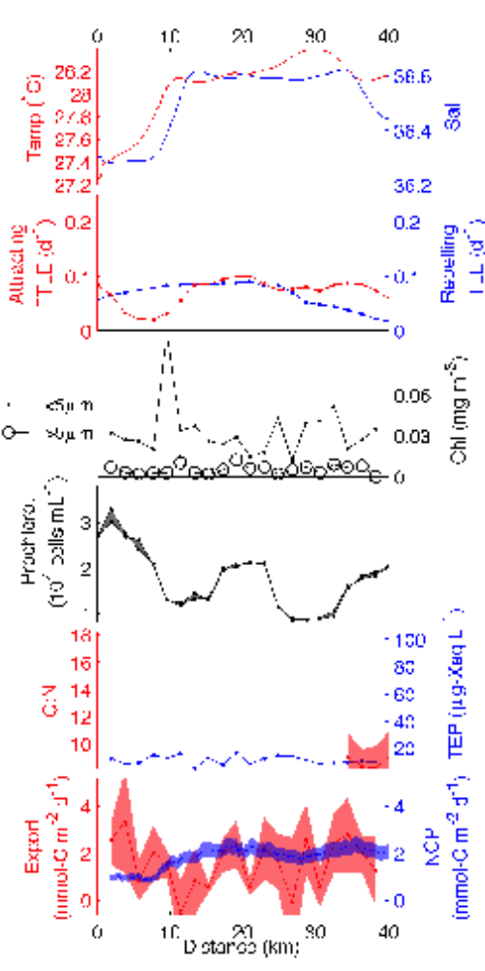
Figure S8. Surface transect 2012 #4. Panel layouts are the same as for Figure 3 in the main text. Note strong variability in small-sized chlorophyll and export, and similar ~10 km scales of spatial variability in Prochlorococcus, large-sized chlorophyll, and NCP.

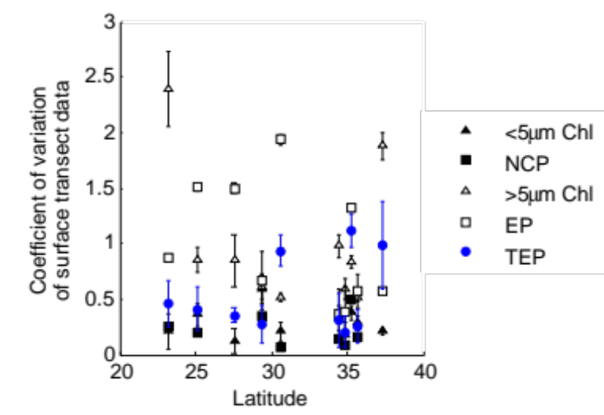
Figure S9. As in main text Figure 8, but also including the across-transect coefficient of variation for TEP (blue circles).

Table S1. Table S1 provides for each underway transect station, the ²³⁴Th deficit observations, mean mixed layer depths, estimated C:²³⁴Th ratios, the computed carbon export, and the net community production derived from O₂/Ar measurements. For all parameters except mixed layer depth, the first column gives the measurement and the second column the error. Please refer to the main text for details on computations and error estimates.

