Geophysical Research Letters
Supporting Information for
Mechanism for normal faulting in the subducting plate at the Mariana trench
Zhiyuan Zhou^{1,2}, Jian Lin^{1,2,3}, Mark D. Behn², and Jean-Arthur Olive⁴
¹State Key Laboratory of Marine Geology, School of Ocean and Earth Sciences, Tongji University, Shanghai 200092, China
²Department of Geology and Geophysics, Woods Hole Oceanographic Institution, Woods Hole, MA 02543, USA
³Key Laboratory of Marginal Sea Geology, Chinese Academy of Sciences, South China Sea Institute of Oceanology, Guangzhou 510301, China
⁴MIT/WHOI Joint Program in Oceanography, Massachusetts Institute of Technology, Woods Hole, MA 02543, USA, Now at: Lamont-Doherty Earth Observatory, Columbia University, Palisades, NY 10964, USA

Contents of this file

Text S1 to S3
Figures S1 to S3

Introduction
This supporting information includes description of the basic modeling method, supplementary illustrations of modeling results, and the data source of high-resolution multibeam bathymetry.

Text S1. Basics of models
At each point, the FLAC method solves a mass balance equation [Cundall, 1989],
$$\frac{∂v_{i}}{∂x_{i}}=0$$
and a stress balance equation
$$ρ\frac{∂v_{i}}{∂t}=\frac{∂σ_{ij}}{∂x_{j}}+ρg_{i}$$
where ν_{i} is nodal velocity in the x_{i} direction, ρ is density, σ_{ij} is stress tensor, and g_{i} is gravitational acceleration.
Yielding of the elasto-plastic material follows the Mohr-Coulomb failure criterion given by Jaeger and Cook [1979],
$$τ=C\left(ε_{ps}\right)+μσ_{n}$$
where τ is shear stress, μ is friction coefficient, σ_{n} is normal stress, and C is cohesion, which is dependent on plastic strain ε_{ps}.
Following the approach of Buck and Poliakov [1998], Poliakov and Buck [1998], and Lavier et al. [2000], we assume the cohesion is reduced with increasing plastic strain:
$$\left\{\begin{aligned}C\left(ε_{ps}\right)=C_{0}-\frac{\left(C_{0}-C_{1}\right)ε_{ps}}{ε_{c}},ε_{ps}≤ε_{c} \\ C\left(ε_{ps}\right)=C_{1},ε_{ps}>ε_{c}\end{aligned} \right.$$
where C₀ is initial cohesion for brittle material, C₁ is remaining cohesion when totally yielded, and ε_{c} is the characteristic plastic strain that controls the slope of cohesion reduction.
The rheological behavior of viscous material follows non-Newtonian power-law rheology given by Chen and Morgan [1990], which depends on temperature and strain rate,
$$η=\frac{1}{4}{(\frac{4}{3A})}^{1/n}{\dot{e}}_{max}^{\frac{1-n}{n}}exp⁡(\frac{Q}{nRT})$$
where ${\dot{e}}_{max}=\frac{\sqrt{2}}{2}\dot{e_{II}}$, $\dot{e_{II}}$ is the second invariant of the strain rate tensor, A is pre-exponential factor, n is creep exponent, Q is activation energy, R is gas constant, and T is temperature.

Text S2. Effect of horizontal tensional force on calculated normal faulting characteristics
Model results suggest that when the horizontal tensional force F₀ increases, the distance of maximum fault throw is calculated to move towards the trench axis (Figure S3a). This implies that F₀ could help to concentrate normal faults towards the trench axis. The observed distance of maximum fault throw is 10-35 km from the trench axis for the southern Mariana trench (Figure S3b). Panel b shows that best-fitting models without F₀, which can explain well the calculated non-isostatic topography, but can not explain the observed distance of maximum fault throw of the southern Mariana trench. In contrast, best-fitting models with F₀ can explain the calculated non-isostatic topography as well as the distance of maximum fault throw.

Text S3. Source of high-resolution multibeam bathymetry data
The high-resolution bathymetry data are downloaded from the National Geophysical Data Center (NGDC, http://www.ngdc.noaa.gov) and Global Multi-Resolution Topography Synthesis (GMRT) [Ryan et al., 2009].

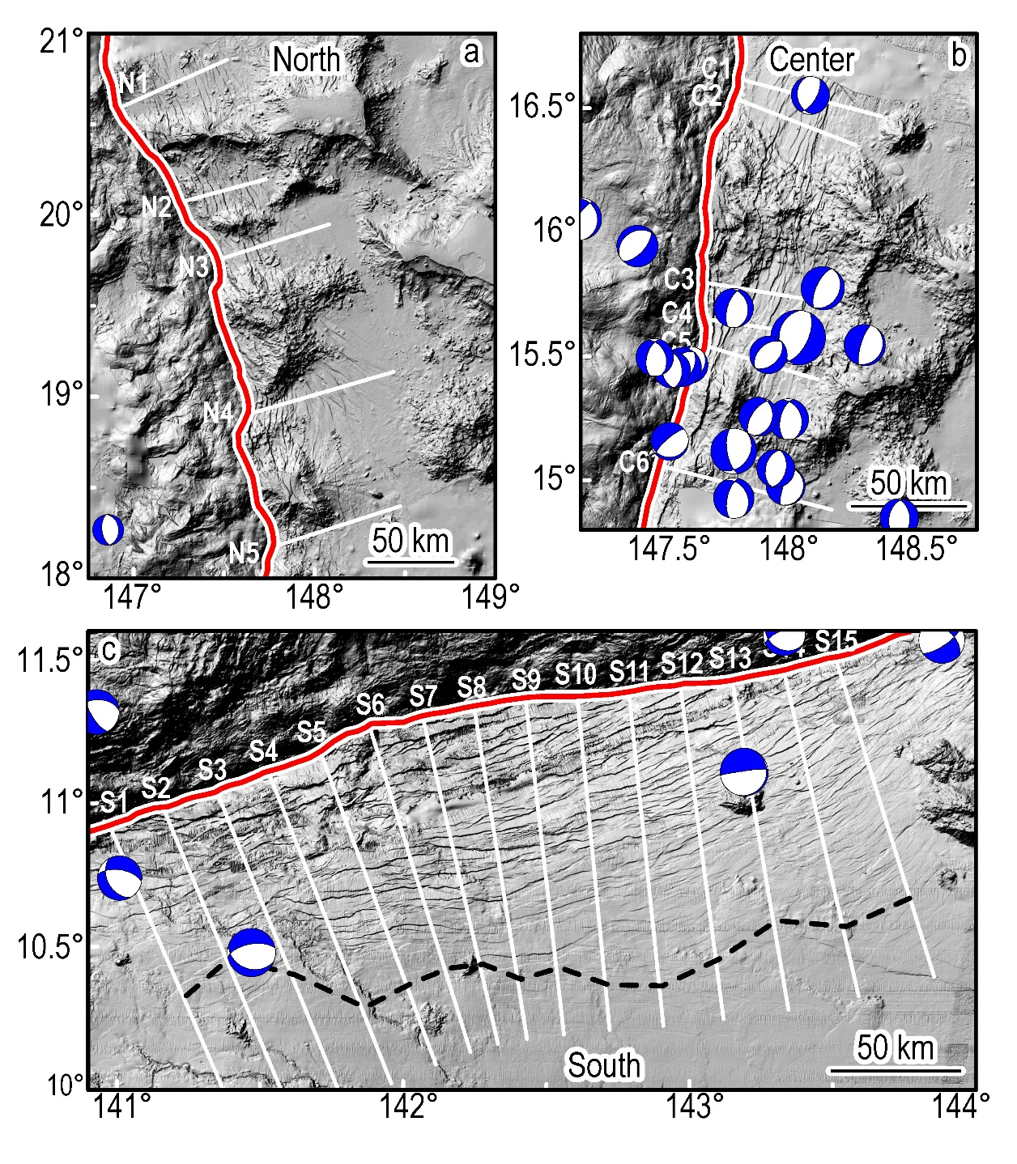
Figure S1. Shade maps of topography illustrating normal faults at the northern, central, and southern Mariana trench. Locations of these three regions are marked by dashed boxes in Figure 1a. Red lines show trench axes. White lines show across-trench profiles for analysis. Black dashed lines in panel c show the approximate location of the central part of the outer-rise region, which was determined from the shallowest point on across-trench profiles of non-isostatic topography. Blue beach balls show normal faulting earthquake focal mechanisms from Global CMT (http://www.globalcmt.org) for events with magnitude greater than Mw 4.5.

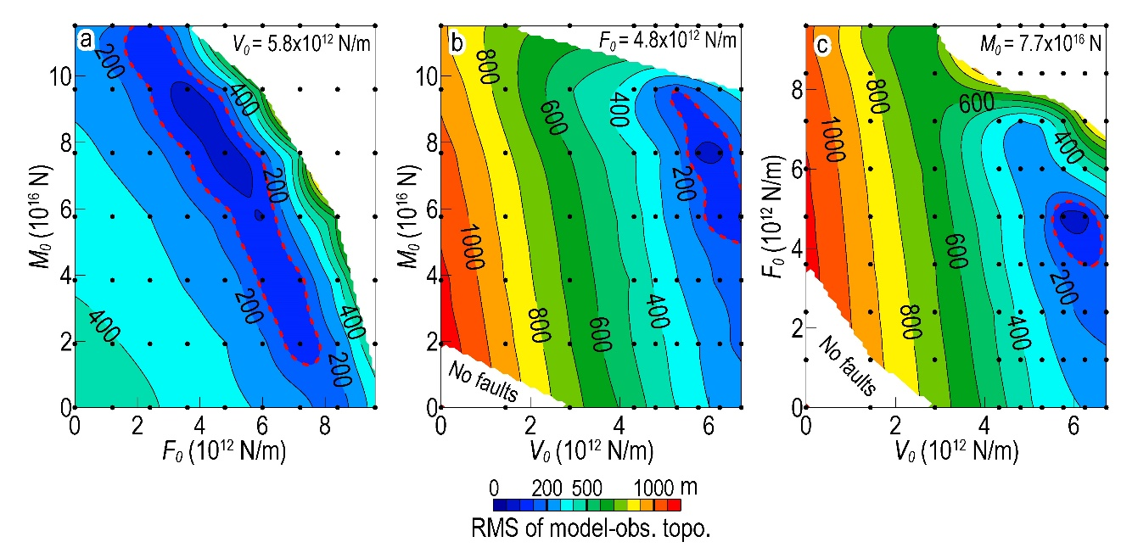
Figure S2. RMS between the calculated non-isostatic topography and model topography as a function of applied tectonic forcing.

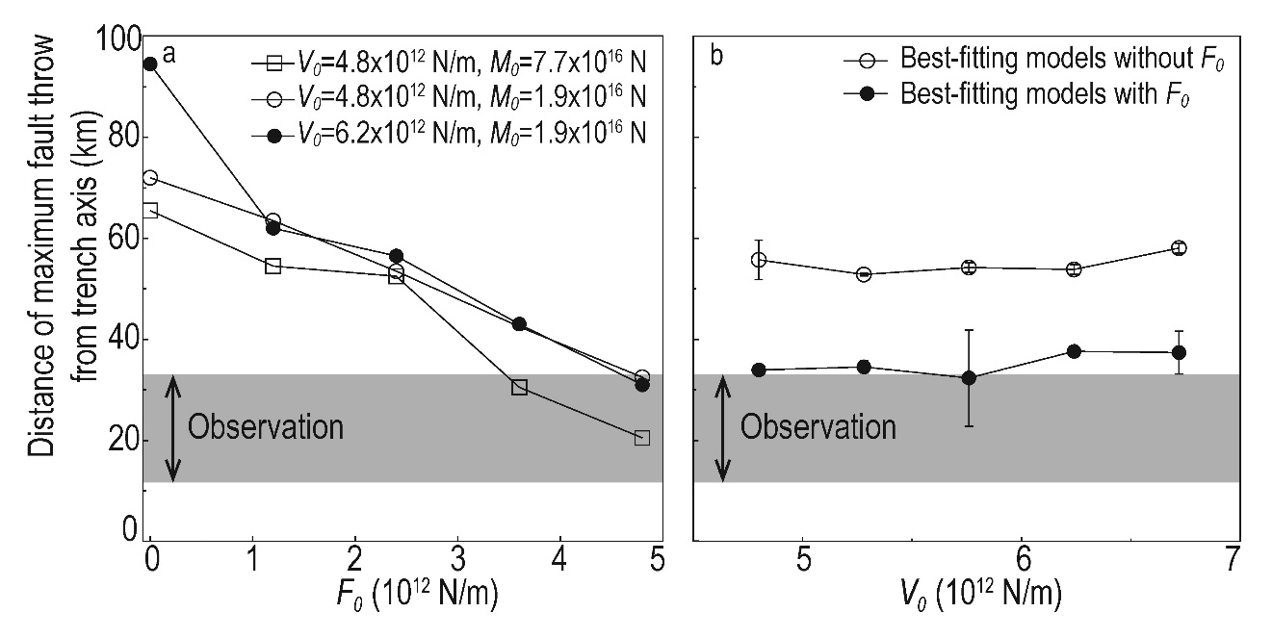
Figure S3. (a) Distance of maximum fault throw as a function of F₀ for fixed V₀ and M₀ values. (b) Distance of maximum fault throw as a function of V₀ for best-fitting models with and without F₀. Grey columns indicate the observed distance of maximum fault throw from the trench axis at the southern Mariana trench.

References:
Buck, W. R., and A. N. Poliakov (1998), Abyssal hills formed by stretching oceanic lithosphere, Nature, 392, 272-275.
Chen, Y., and W. J. Morgan (1990), A nonlinear rheology model for mid-ocean ridge axis topography, J. Geophys. Res., 95, 17583-17604.
Cundall, P. A. (1989), Numerical experiments on localization in frictional materials, Ingenieur-archiv, 59, 148-159.
Jaeger, J. C., and N. G. Cook (1979), Fundamentals of Rock Mechanics, Chapman and Hall, London, pp. 513.
Lavier, L. L., W. R. Buck, and A. N. Poliakov (2000), Factors controlling normal fault offset in an ideal brittle layer, J. Geophys. Res., 105, 23431-23442.
Poliakov, A. N., and W. R. Buck (1998), Mechanics of stretching elastic-plastic-viscous layers: Applications to slow-spreading mid-ocean ridges, in Faulting and Magmatism at Mid-Ocean Ridges, Geophys. Monogr., Ser., vol. 106, edited by W. R. Buck, P. T. Delaney, J. A. Karson, Y. Lagabrielle, AGU, Washington, D. C., pp. 305-323.
Poliakov, A. N., P. A. Cundall, Y. Y. Podladchikov, and V. A. Lyakhovsky (1993), An explicit inertial method for the simulation of viscoelastic flow: An evaluation of elastic effects on diapiric flow in two- and three-layers models, in Flow and Creep in the Solar System: Observations, Modeling and Theory, Kluwer Acad. Pub., pp. 175-195.
Ryan, W. B. F., Carbotte, S. M., Coplan, J. O., O'Hara, S., Melkonian, A., Arko, R., Weissel, R. A., Ferrini, V., Goodwillie, A., Nitsche, F., Bonczkowski, J., Zemsky, R. (2009), Global multi-resolution topography synthesis, Geochem. Geophys. Geosyst., 10, Q03014.

