Supplementary Materials – Analytical protocols
Subsequent to wet sieving, Sample 07-AT-LB-B was subjected to standard magnetic and density-based mineral separation procedures in order to obtain a zircon concentrate. The concentrate was split in half for comparative conventional and laser microprobe dating. Each half was presumed to contain nearly identical samples of the zircon population in 07-AT-LB-B.

Analytical Procedure – Laser Microprobe Dating
From one zircon split, we randomly selected a relatively large number of zircon grains that were greater than 60 μm in their shortest dimension, optimal sizes for laser microprobe work. These grains were mounted in Torr Seal, a high vacuum resin made by Varian that is ideal for noble gas work because of its low vapor pressure under ultrahigh vacuum. Once cured, the mount was polished to submicron levels and ultrasonicated in acetone for 30 minutes to remove any excess Torr Seal residue.
The mount was lightly gold-coated and loaded into the JEOL 840 SEM in the Leroy Eyring Center for Solid State Science (LE-CSSS) at ASU to obtain cathodoluminescence (CL) and scanning electron (SE) images of all grains. Based on our assessment of grain characteristics displayed in these images, we selected 58 grains for analysis. Grains with complex zoning patterns indicative of overgrowths were avoided. Grains with many microinclusions were avoided. Grains with inclusions were only selected for analysis when the U+Th analytical footprint (Figure 1b) could be placed in the crystal interior and still exclude inclusions and their alpha recoil redistribution effects.
After SEM work, the mount was lightly polished using 0.05 μm polishing paper to remove the gold coat, ultrasonicated in acetone for 30 minutes, and placed under a temperature-calibrated heat lamp to drive off any remaining volatiles in the Torr Seal. Care was taken to ensure that the sample temperature did not exceed levels that might cause diffusive loss of helium. The mount was then loaded into an UHV laser chamber, and grains were ablated for ⁴He extraction using a New Wave 193 nm (ArF) Excimer laser with 6 mJ output power and a pulse rate of 5 Hz. Two pit sizes were used depending on the grain sizes. For larger grains, we employed a beam diameter (as measured on the target) of 35 μm and applied 175 laser pulses to mill down to a depth of ~17 μm (as measured subsequently with an ADE PhaseShift MicroXAM interferometric microscope). For smaller grains, we used a 20 μm beam size and fired 100 pulses to achieve a pit depth of ~10 μm. Liberated gasses were purified using a SAES GP50 getter and cryogenically trapped prior to expansion of the purified gas into a Thermo Scientific Helix SFT (Split Flight Tube) mass spectrometer for isotopic measurement. Those measurements were performed using an electron multiplier in ion-counting mode. Instrument sensitivity was monitored using slabs of Durango fluorapatite of known age and U and Th concentration, and was, on average, 58,400 ± 4100 atoms ⁴He/cps. To use Durango as a sensitivity monitor, we assumed that a polished slab of Durango (approximately 5 mm by 5 mm) was uniform in U and Th concentration. Throughout the analytical session, we periodically analyzed spots for ⁴He abundance. When the analytical session was completed, we dissolved the slab and measured its U and Th concentration using solution Inductively Coupled Plasma Mass Spectrometry (ICPMS). Because we know the age of Durango fluorapatite [McDowell et al., 2005] and measure the U and Th concentration, we can calculate how much ⁴He should be present, and calculate sensitivity accordingly. Blanks generally ranged from 3.4 x 10⁶ to 6.0 x 10⁷atoms ⁴He. The volume of each ablation pit, measured using the interferometric microscope, was used to convert ⁴He abundance to ⁴He concentration. We report volumes and ⁴He concentrations in Supplementary Material Table A1.
The laser ablation process typically produces a small rim around the pit produced by the laser and some material ejected from the pit falls onto the polished surface in the immediate vicinity of the rim; these effects can be seen in Figure A1. Prior to U and Th analysis, we lightly polished the sample with 0.05 μm polishing paper to remove this ejected material in case its U and Th concentrations had been inadvertently altered during the ablation process. The mount was again ultrasonicated in acetone to remove any Torr Seal that had flaked into the laser ablation pits during polishing. The mount was then gold coated in preparation for U+Th analysis by secondary ionization mass spectrometry.
U and Th concentrations were measured using the Cameca IMS 6f at ASU. For standardization, a calibration curve was created with two natural zircons (Mahenge and ASU Sri Lanka), NIST 610 glass, and “synzircon”, a zircon powder made from a single natural zircon that has been sintered together using a piston cylinder furnace at 20 kbar and 1100°C to create a rock [Monteleone et al., 2009]. We used a ~20 nA ¹⁶O⁻ primary beam and measured secondary ions ³⁰Si⁺, ⁹¹Zr⁺, ²³²Th⁺, ²³⁸U⁺, ²⁴⁸ThO⁺, and ²⁵⁴UO⁺. The primary beam was focused to 60 μm in diameter with a pre-sputter time of 4200 seconds, and energy filtering was applied using a -75 V offset with a 40 eV window. The purpose of using the large primary beam was to obtain an area-integrated measurement of the total U and Th contributing ⁴He to the region of the laser ablation ⁴He analysis; we accomplished this by centering the broad ion beam directly on the ⁴He laser ablation pit (see Figure 1b). Throughout the analytical procedure, we monitored Mg (which is present in much greater concentrations in Torr Seal than in zircon) to ensure that Torr Seal was not contributing U or Th to the analysis. Each analysis, including time allotted for pre-sputtering, took approximately 20 minutes.
Analytical results and computed laser microprobe (U-Th)/He dates are reported in Supplementary Material Table A1. Dates in that table – and throughout this paper – are reported at the 2σ (~95%) confidence level based on the propagation of analytical uncertainties.
Three sources of error contribute to the age uncertainties we quote: the ⁴He analytical error, the pit volume error, and the parent concentration analytical error. The ⁴He measurement error includes the error associated with the ascribed blank and the error associated with the measurement of the Durango fluorapatite sensitivity monitor. The latter error includes the ⁴He measurement error for the monitor, the solution ICPMS error, and the error associated with how well the age of Durango fluorapatite is constrained. The last error is based upon our conventional running average of shards, 31.70 ± 0.55 Ma, which is well within the established age for Durango apatite of 31.44 ± 0.18 Ma [McDowell et al., 2005]. The pit volume error was calculated from the variance of 6-9 measurements of each ablation pit with dimensional data obtained with the interferometric microscope. Typical calculated 2σ pit volume uncertainties were ~1%. For the U and Th concentration measurement errors, we performed a York [1969] regression through the calibration standard data, thus propagating the SIMS errors and error associated with how well each individual calibration standard is known. When propagated, these analytical errors yield 6-10% 2σ errors for each calculated laser microprobe age.
In order to evaluate the reliability of our procedure, we also performed a series of analyses on the Sri Lanka zircon standard, which has a conventional (U-Th)/He age of 443 ± 9 Ma [Nasdala et al., 2004]. The error-weighted mean of 20 (U-Th)/He dates obtained on a single large polished grain of the standard using the procedure described above was 437 ± 7 Ma (2σ), statistically indistinguishable from the published conventional age noted above. For more information, please see Supplementary Material Table A2.

Analytical Procedure – Conventional Approach
From the second split, we hand-picked 113 prismatic crystals using a stereoscopic microscope with dark field illumination. Crystal selection avoided grains that were overly rounded and contained visible evidence for inclusions, fractures or other imperfections. The geometries of all selected grains were measured for alpha ejection correction after the method of Hourigan et al. [2005] prior to loading into niobium tubes for isotopic analysis.
Helium was measured using an ASI Alphachron system at ASU. Sample tubes were loaded into an ultrahigh vacuum chamber and heated with a 980 nm diode laser for 10 minutes at 20 amps. The released gas was spiked with ³He and gettered, and subsequently measured on a Pfeiffer-Balzers Prisma Quadrupole quadrupole mass spectrometer. The Nb tubes were then removed from the Alphachron, spiked for U and Th analysis, and dissolved using concentrated acids in Parr digestion vessels. The final solutions were analyzed by ICPMS using a Thermo X series instrument in the W. M. Keck Foundation Laboratory for Environmental Biogeochemistry at ASU. Additional information on conventional (U-Th)/He procedures at ASU may be found in van Soest et al. [2011]. Conventional (U-Th)/He data and calculated dates are reported in Supplementary Material Table A3, along with analytical errors. We do not propagate an error associated with the grain measurement. External reproducibility of the running mean of our zircon standard, Fish Canyon Tuff, is approximately 10% (2σ).

Hourigan, J. K., P. W. Reiners, and M. T. Brandon (2005), U-Th zonation-dependent alpha-ejection in (U-Th)/He chronometry, Geochim. Cosmochim. Acta, 69, 3349-3365.

McDowell, F. W., W. C. McIntosh, and K. A. Farley (2005) A precise ⁴⁰Ar-³⁹Ar reference age for the Durango apatite (U-Th)/He and fission track dating standard, Chem. Geol., 214, 249-263.

Monteleone, B. D., M. C. van Soest, K. Hodges, G. M. Moore, J. W. Boyce, and R. L. Hervig (2009), Assessment of alternative [U] and [Th] zircon standards for SIMS, Eos Trans. AGU, 90(52), Fall Meet. Suppl., V31E-2017.

Nasdala, L., P. W. Reiners, J. I. Garver, A. K. Kennedy, R. A. Stern, E. Balan, and R. Wirth (2004), Incomplete retention of radiation damage in zircon from Sri Lanka, Am. Mineral., 89, 219-231.

Van Soest, M. C., K. V. Hodges, J.-A. Wartho, M. B. Biren, B. D. Monteleone, J. Ramezani, J. G. Spray, and L. M. Thompson (2011), (U-Th)He dating of terrestrial impact structures: the Manicouagan example, Geochem., Geophys., Geosyst., 12, Q0AA16, doi: 10.29/2010GC003465.

York, D. (1969) Least squares fitting of a straight line with correlated errors, Earth Planet. Sci. Lett., 5, 320-324.
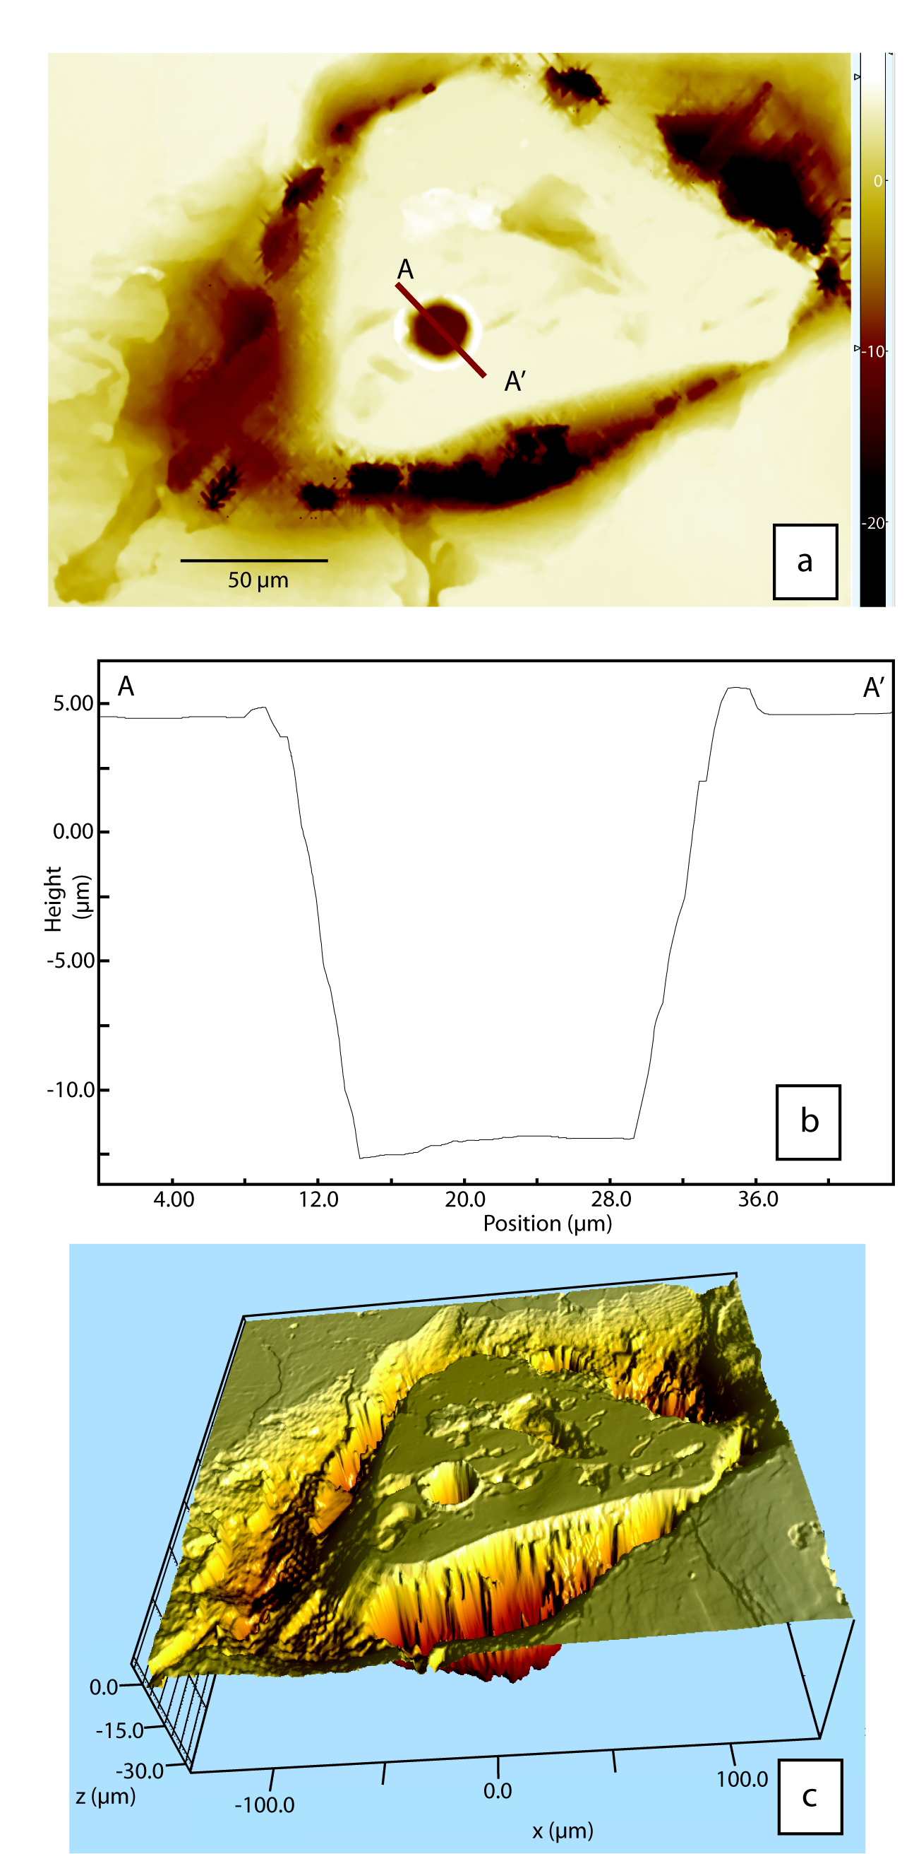

Figure A1. Example of the data produced by ASY ADE Phase Shift white light interferometric microscope. This scan is of a mounted zircon grain with laser pit produced by the New Wave UP193FX Excimer laser. Panel a (top): The obtained surface data is shown as a digital elevation map, where elevation is color coded per the scale bar shown at the side. Elevation is in microns. Line A-A’ shows the position of the cross section shown in panel b. Panel b (middle): Cross section across the laser pit, demonstrating the bucket shape, smooth walls, and slightly sloped pit bottom. The pit is approximately 16 microns deep and was ablated using the 25 micron aperture of the laser. Panel c (bottom): a 3D rendering of the DEM shown in Panel a, illustrating topography of the surface of the grain, including the ejecting pit around the rim of the pit.

