JGR Biogeosciences
Supporting Information for
Environmental controls, emergent scaling, and predictions of greenhouse gas (GHG) fluxes in coastal salt marshes
Authors: Omar I. Abdul-Aziz¹, Khandker S. Ishtiaq¹, Jianwu Tang², Serena Moseman-Valtierra³, Kevin D. Kroeger⁴, Meagan Eagle Gonneea⁴, Jordan Mora⁵, and Kate Morkeski⁶

Affiliations:
¹Ecological and Water Resources Engineering Laboratory (EWREL), Department of Civil and Environmental Engineering, West Virginia University, 395 Evansdale Drive, PO Box 6103, Morgantown, WV 26506, U.S.A.
²The Ecosystems Center, Marine Biological Laboratory, 7 MBL Street Woods Hole, MA 02543.
³Department of Biological Sciences, University of Rhode Island, 120 Flagg Road, Kingston, RI 02881, USA.
⁴Coastal and Marine Science Center, U.S. Geological Survey, 384 Woods Hole Road, Woods Hole, MA 02543.
⁵Waquoit Bay National Estuarine Research Reserve, 131 Waquoit Highway, Waquoit, MA 02536.
⁶Department of Marine Chemistry and Geochemistry, Woods Hole Oceanographic Institution, 266 Woods Hole Road, Woods Hole, MA 02543, USA

†Corresponding author; Omar I. Abdul-Aziz Email: oiabdulaziz@mail.wvu.edu; omariaaziz@gmail.com.

Contents of this file
Text S1 to S2
Tables S1 to S6
Figure S1 to S3

Introduction
The supporting information provides supplementary information about model optimization and performance statistics, presentation of the model in a user-friendly Excel spreadsheet, tables, and figures.
Text S1: Model optimization and performance statistics
The Akaike Information Criterion (AIC) (Akaike, 1974) and the Nash-Sutcliffe Efficiency (NSE) were used to select the optimal number of partial least squares (PLS) components in developing the partial least squares regression (PLSR) models. Performance of the PLSR models was assessed by comparing the observed and predicted GHG fluxes. Apart from the model prediction efficiency (NSE), the ratio of root-mean-square error to the standard deviation of observations (RSR) were used to assess model accuracy. NSE = 1.0 refers to a perfect model; NSE < 0 (i.e., negative) indicates that the developed model is a worse predictor than the average of observations of response variable (i.e., flux) as an alternative model. A perfect to very good model usually has an RSR between 0 and 0.50, a good model has an RSR between 0.50 and 0.60, and a satisfactory model has an RSR between 0.60 and 0.70; RSR > 0.70 indicates an unsatisfactory model (Ishtiaq and Abdul-Aziz, 2015). The performance statistics were computed as follows:
(S1)
(S2)
(S3)
where = the total number of PLS components, = total number of observations, and = the i^{th} observed and predicted GHG fluxes (respectively), is the average of GHG flux observations, and = standard deviation of the observations.
Text S2: Presentation of the predictive scaling models in a user-friendly Excel spreadsheet
A user-friendly, macro-based Excel spreadsheet model named “Coastal Wetland GHG Model (CWGM)” is presented to predict the salt marsh GHG fluxes from instantaneous light (PAR, μmol/m²/s), soil temperature (ST, ºC), and porewater salinity (SS, ppt) data (see CWGM, 2018 to download the Excel model). The model equations (Eq. 5-7) were coded in the Excel spreadsheet by using Visual Basic programming language. Further, we expressed the difference between net carbon (CO₂) uptake and net carbon (CO₂ and CH₄) emissions in the salt marshes by a new term, “net atmospheric carbon removal (NACR)”. NACR is related to the net ecosystem carbon balance (NECB) of a wetland as follows: NECB = NACR – net lateral flux. We proposed NACR because the net lateral fluxes between the salt marsh and the bay were not modeled and predicted in this study. A user can estimate the NACR by upscaling the predicted instantaneous fluxes of CO₂ and CH₄ over the growing period (or any user-defined period) in units of gram carbon (C) per square meter of marsh area (gC/m²). A provision was also included in the Excel model to estimate CH₄ emission fluxes based on the IPCC recommended CO₂ equivalent global warming potentials (GWP) (Myhre et al., 2013). A “Readme” sheet was provided in the Excel model file to describe model overview, assumptions, inputs/outputs, and detailed operational guidance to the users. Further, an “Example” sheet was included to demonstrate the predictions of GHG fluxes and NACR using a sample dataset. Upon enabling the “macros” in the Excel file, a user needs to input data for PAR, soil temperature, and porewater salinity, and click “RUN” to predict the corresponding GHG fluxes and NACR. The Excel-based model may aid the coastal stakeholders (e.g., reserve managers, restoration practitioners, and policymakers) in tidal wetland monitoring and restorations, economic evaluations of blue carbon, and developing GHG offset protocols.
Site | Statistics |  | NEE_{CO2,uptake}  (µmol/m²/s) | PAR  (µmol/m²/s) | ST  (°C) | SS  (ppt) | pH | h  (m) | SM  (%)
Sage Lot  Pond | Mean |  | -6.47 | 1464.29 | 18.01 | 29.83 | 6.85 | 0.45 | 64.34
 | Standard deviation |  | 5.28 | 530.52 | 4.93 | 3.58 | 0.32 | 0.07 | 3.39
 | Minimum |  | -0.05 | 303.70 | 8.89 | 20.00 | 6.20 | 0.36 | 51.20
 | Maximum |  | -17.10 | 2080.37 | 26.10 | 36.00 | 7.87 | 0.64 | 68.67
Hamblin  Pond | Mean |  | -10.36 | 1802.87 | 21.01 | 25.88 | 6.49 | 0.46 | 63.78
 | Standard deviation |  | 4.13 | 180.06 | 0.60 | 5.87 | 0.23 | 0.04 | 2.38
 | Minimum |  | -5.31 | 1427.45 | 20.06 | 20.00 | 6.05 | 0.42 | 59.47
 | Maximum |  | -16.52 | 1984.33 | 21.63 | 33.00 | 6.81 | 0.51 | 66.63
Great  Pond | Mean |  | -8.79 | 1049.72 | 22.95 | 29.50 | 6.92 | 0.50 | 63.08
 | Standard deviation |  | 4.55 | 641.78 | 1.08 | 3.74 | 0.36 | 0.01 | 1.61
 | Minimum |  | -3.44 | 425.37 | 21.71 | 24.00 | 6.30 | 0.48 | 60.30
 | Maximum |  | -14.91 | 1987.03 | 24.27 | 34.00 | 7.56 | 0.51 | 65.13
Eel  Pond | Mean |  | -6.73 | 1651.66 | 21.33 | 32.40 | 6.55 | 0.50 | 60.68
 | Standard deviation |  | 1.40 | 152.25 | 1.56 | 1.52 | 0.16 | 0.00 | 4.46
 | Minimum |  | -4.38 | 1514.95 | 20.03 | 30.00 | 6.39 | 0.44 | 54.27
 | Maximum |  | -7.83 | 1906.83 | 24.01 | 34.00 | 6.79 | 0.44 | 65.43
Table S1: Marsh-specific summary of the relative linkage datasets for the daytime net uptake fluxes of CO₂ and the corresponding environmental drivers for June-October 2013.
Note: NEE_{CO2,uptake}, PAR, ST, SS, pH, h, and SM refer to the daytime net uptake fluxes of CO₂, photosynthetically active radiation, soil temperature, porewater salinity, pH, well water level, and soil moisture content, respectively. ppt refers to parts per thousand. h represents the water level relative to the base of wells inserted at 40 cm depth from the ground surface of the marshes.
Table S2: Marsh-specific summary of the relative linkage datasets for the net emission fluxes of CH₄ and the corresponding environmental drivers for June-October 2013.
Site | Statistics |  | NEE_{CH4,emission}  (nmol/m²/s) | PAR  (µmol/m²/s) | ST  (°C) | SS  (ppt) | pH | h  (m) | SM  (%)
Sage Lot  Pond | Mean |  | 0.91 | 1359.77 | 19.07 | 28.98 | 6.96 | 0.47 | 63.93
 | Standard deviation |  | 0.65 | 708.83 | 4.30 | 3.42 | 0.29 | 0.07 | 3.35
 | Minimum |  | 0.10 | 115.58 | 8.89 | 20.00 | 6.51 | 0.37 | 51.20
 | Maximum |  | 2.35 | 2080.37 | 26.10 | 34.00 | 7.87 | 0.64 | 68.67
Hamblin  Pond | Mean |  | 2.24 | 1813.95 | 21.70 | 24.20 | 6.60 | 0.47 | 62.66
 | Standard deviation |  | 0.45 | 235.53 | 2.55 | 4.92 | 0.17 | 0.04 | 5.78
 | Minimum |  | 1.56 | 1408.70 | 20.06 | 20.00 | 6.38 | 0.43 | 52.50
 | Maximum |  | 2.83 | 1984.33 | 26.17 | 30.00 | 6.81 | 0.51 | 66.63
Great  Pond | Mean |  | 1.61 | 1155.35 | 23.03 | 30.00 | 6.93 | 0.50 | 63.16
 | Standard deviation |  | 0.59 | 678.83 | 1.04 | 3.81 | 0.34 | 0.01 | 1.53
 | Minimum |  | 1.03 | 425.37 | 21.71 | 24.00 | 6.30 | 0.48 | 60.30
 | Maximum |  | 2.61 | 2000.37 | 24.27 | 34.00 | 7.56 | 0.51 | 65.13
Eel  Pond | Mean |  | 1.18 | 1139.56 | 22.72 | 32.14 | 6.56 | 0.31 | 63.43
 | Standard deviation |  | 0.44 | 561.53 | 2.64 | 1.68 | 0.14 | 0.16 | 5.38
 | Minimum |  | 0.69 | 500.37 | 20.03 | 30.00 | 6.39 | 0.13 | 54.27
 | Maximum |  | 1.74 | 1657.03 | 26.35 | 34.00 | 6.79 | 0.44 | 68.57
Note: NEE_{CH4,emission}, PAR, ST, SS, pH, h, and SM refer to the net emission fluxes of CH₄, photosynthetically active radiation, soil temperature, porewater salinity, pH, well water level, and soil moisture content, respectively. ppt refers to parts per thousand. h represents the water level relative to the base of wells inserted at 40 cm depth from the ground surface of the marshes.
Table S3: Summary of the predictive modeling datasets for GHG fluxes and environmental drivers for May-October 2013 at four salt marshes in Waquoit Bay and adjacent estuaries, MA.
Dataset | Variables | Mean | Standard deviation | Minimum | Maximum
Net uptake fluxes of CO₂ Sample size, N = 137 | NEE_{CO2,uptake} (µmol/m²/s) | -5.33 | 4.72 | -0.05 | -17.10
 | PAR (µmol/m²/s) | 1395.53 | 519.73 | 303.7 | 2093.08
 | ST (ºC) | 17.57 | 4.15 | 8.89 | 26.10
 | SS (ppt) | 30.50 | 4.70 | 10.00 | 40.00
Net emission fluxes of CO₂ Sample size, N = 22 | NEE_{CO2,emission} (µmol/m²/s) | 2.46 | 1.13 | 0.92 | 4.25
 | ST (ºC) | 16.31 | 4.89 | 9.63 | 25.26
Net emission fluxes of CH₄ Sample size, N = 107 | NEE_{CH4,emission} (nmol/m²/s) | 0.62 | 0.55 | 0.10 | 2.35
 | ST (ºC) | 17.21 | 4.39 | 8.75 | 26.35
 | SS (ppt) | 31.22 | 3.97 | 20.00 | 40.00
Note: NEE_{CO2,uptake}, NEE_{CO2,emission}, NEE_{CH4,emission}, PAR, ST, and SS refer to daytime net uptake fluxes of CO₂, net emission fluxes of CO₂, net emission fluxes of CH₄, photosynthetically active radiation, soil temperature, and porewater salinity, respectively. ppt refers to parts per thousand. The negative sign indicates the net uptake fluxes of CO₂.
Table S4: Results of one-way ANOVA to compare the GHG fluxes across the N loading gradient (5-126 kg/ha/year) among the four salt marshes based on the predictive modeling datasets.
Source of variation | Sum of squares | Degrees of freedom | Mean square | F-statistics | F-critical | p-value
Net uptake fluxes of CO₂ (NEE_{CO2,uptake})
Among marshes | 0.51 | 3 | 0.17 | 0.46 | 2.67 | 0.71
Within marshes | 49.13 | 133 | 0.36
Total | 49.64 | 136
Net emission fluxes of CH₄ (NEE_{CH4,emission})
Among marshes | 0.38 | 3 | 0.13 | 0.98 | 2.69 | 0.41
Within marshes | 13.24 | 103 | 0.13
Total | 13.62 | 106
Note: Significance of difference was evaluated at the 95% level of confidence (p-value < 0.05).
Table S5: Results of one-way ANOVA to compare the GHG fluxes between high and low tide conditions across the four salt marshes based on the predictive modeling datasets.
Source of variation | Sum of squares | Degrees of freedom | Mean square | F-statistics | F-critical | p-value
Net uptake fluxes of CO₂ (NEE_{CO2,uptake})
Between tidal conditions | 3.84 | 1 | 3.84 | 11.33 | 3.91 | < 0.001
Within tidal conditions | 45.80 | 135 | 0.34
Total | 49.64 | 136
Net emission fluxes of CH₄ (NEE_{CH4,emission})
Between tidal conditions | 2.40 | 1 | 2.40 | 22.47 | 3.93 | < 0.001
Within tidal conditions | 11.22 | 105 | 0.11
Total | 13.62 | 106
Note: Significance of difference was evaluated at the 95% level of confidence (p-value < 0.05).
Table S6: List of 20 downscaled global climate models (GCMs) used to calculate the anticipated changes in GHG fluxes of the salt marshes at Cape Cod, MA.
Model Name | Source | Resolution  (Lat. × Lon.)
bcc-csm1-1 | Beijing Climate Center, China Meteorological Administration | 2.8˚ × 2.8˚
bcc-csm1-1-m | Beijing Climate Center, China Meteorological Administration | 1.12˚ × 1.12˚
BNU-ESM | College of Global Change and Earth System Science, Beijing Normal University, China | 2.8˚ × 2.8˚
CanESM2 | Canadian Centre for Climate Modeling and Analysis | 2.8˚ × 2.8˚
CCSM4 | National Center of Atmospheric Research, USA | 0.94˚ × 1.25˚
CNRM-CM5 | National Centre of Meteorological Research, France | 1.4˚ × 1.4˚
CSIRO-Mk3-6-0 | Commonwealth Scientific and Industrial Research Organization/Queensland Climate Change Centre of Excellence, Australia | 1.8˚ × 1.8˚
GFDL-ESM2M | NOAA Geophysical Fluid Dynamics Laboratory, USA | 2.0˚ × 2.5˚
GFDL-ESM2G | NOAA Geophysical Fluid Dynamics Laboratory, USA | 2.0˚ × 2.5˚
HadGEM2-ES | Met Office Hadley Center, UK | 1.25˚ × 1.88˚
HadGEM2-CC | Met Office Hadley Center, UK | 1.25˚ × 1.88˚
inmcm4 | Institute for Numerical Mathematics, Russia | 1.5˚ × 2.0˚
IPSL-CM5A-LR | Institut Pierre Simon Laplace, France | 1.8˚ × 3.75˚
IPSL-CM5A-MR | Institut Pierre Simon Laplace, France | 1.25˚ × 2.5˚
IPSL-CM5B-LR | Institut Pierre Simon Laplace, France | 1.8˚ × 2.75˚
MIROC5 | Atmosphere and Ocean Research Institute (The University of Tokyo), National Institute for Environmental Studies,and Japan Agency for Marine-Earth Science and Technology | 1.4˚ × 1.4˚
MIROC-ESM | Japan Agency for Marine-Earth Science and Technology, Atmosphere and Ocean Research Institute (The University of Tokyo), and National Institute for Environmental Studies | 2.8˚ × 2.8˚
MIROC-ESM-CHEM | Japan Agency for Marine-Earth Science and Technology, Atmosphere and Ocean Research Institute (The University of Tokyo), and National Institute for Environmental Studies | 2.8˚ × 2.8˚
MRI-CGCM3 | Meteorological Research Institute, Japan | 1.1˚ × 1.1˚
NorESM1-M | Norwegian Climate Center, Norway | 1.9˚ × 2.5
Source: https://climate.northwestknowledge.net/MACA/GCMs.php
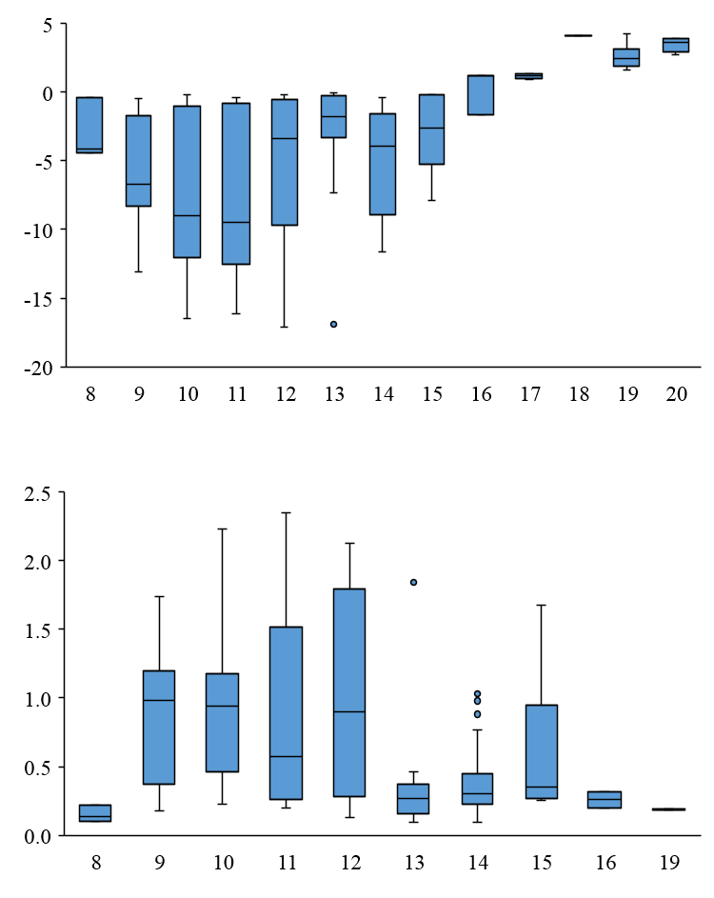
(a)

CO₂ fluxes (µmol/m²/s)

(b)

Net emission fluxes of CH₄ (nmol/m²/s)

Hour of the day

Figure S1: Boxplots of (a) CO₂ (NEE_{CO2,uptake} and NEE_{CO2,emission}) and (b) CH₄ (NEE_{CH4,emission}) fluxes during May-October 2013 based on the predictive modeling data when binned to the closest diurnal hours in four salt marshes of Waquoit Bay and adjacent estuaries, MA. Negative and positive, respectively, indicate the net uptake and emission fluxes.
(a)

CO₂ fluxes (µmol/m²/s)

(b)

CH₄ fluxes (nmol/m²/s)

Julian days

Figure S2: Temporal plots of measured (a) CO₂ (NEE_{CO2,uptake} and NEE_{CO2,emission}) and (b) CH₄ (NEE_{CH4,emission}) fluxes during May-October 2013 based on the predictive modeling datasets for four salt marshes at Waquoit Bay and adjacent estuaries, MA. Negative and positive, respectively, indicate the net uptake and emission fluxes.
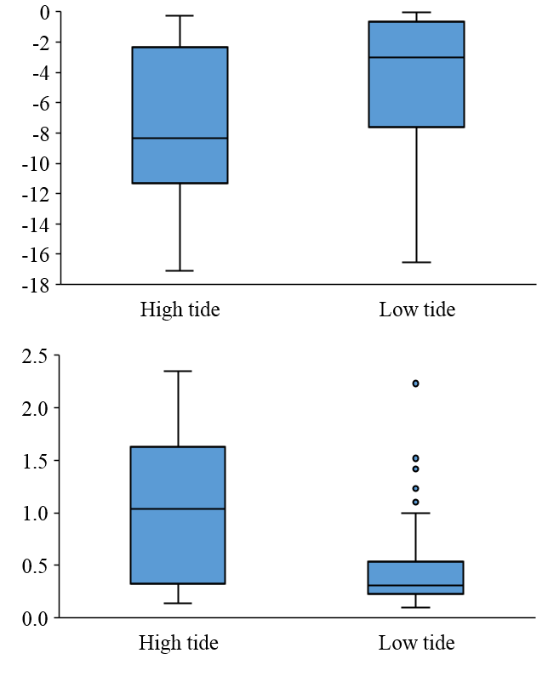
(a)
Net emission fluxes of CH₄ (nmol/m²/s)
Net uptake fluxes of CO₂ (µmol/m²/s)

(b)

Figure S3: Boxplots of (a) CO₂ (NEE_{CO2,uptake}) and (b) CH₄ (NEE_{CH4,emission}) fluxes for high and low tide conditions during May-October 2013 using the predictive modeling datasets for four salt marshes in Waquoit Bay and adjacent estuaries, MA.

