Supplementary data
Table S1. Summary of physico-chemical properties of silver nanoparticles. Data are mean ± SD (n = 3).
Parameters | Value
Size (nm) | 15
Shape | spherical
Hydrodynamic diameter (nm) | 191±12
Surface charge (mV) | -27±2

Table S2. AgNPs characteristics over time. Data are mean ± SD (n = 3).
Time | 1 h | 24 h | 48 h | 96 h
Hydrodynamic diameter (nm) | 191±12 | 346 ±42 | 385±36 | 393±78
Surface charge (mV) | -30±4 | -27±2 | -27±1 | -24±3

Table S3. Measured total Ag concentrations in DECOTAB, surrounding water and the percentage of Ag released from the DECOTABs containing AgNPs of different exposure concentrations.
Nominal concentration (µg/L) | Measured Ag in DECOTAB (µg/L) | Measured Ag in surrounding water (µg/L) | Ion release  (%)
0.2 | 5.935 ± 0.738 | 0.112 ± 0.073 | 1.9 ± 3.4
1.6 | 6.719 ± 1.206 | 0.661 ± 0.090 | 9.8 ± 2.7
6.4 | 13.414 ± 2.387 | 1.501 ± 0.227 | 11.1 ± 1.1

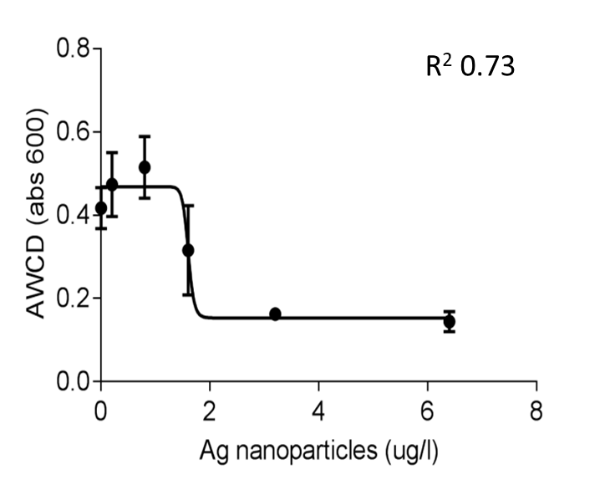
Figure S1. Metabolic diversity of the DECOTAB-associated biofilm with increasing AgNP concentration (expressed as average well colour development, AWCD, using Ecoplate (Biolog) measured at abs. 600 nm). Fitted line represents an exponential decay function; goodness of fit is (adjusted R²) is shown in the figure.
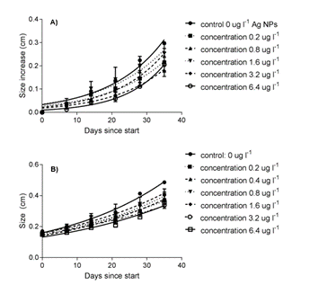
Figure S2: Weekly growth of A. aquaticus feeding on DECOTABs with different silver nanoparticle concentrations during two consecutive experimental incubations. A) represents average growth of 5 individuals per Petr-dish (n=2) in the first experiment. B) represents average growth of 5 individuals per Petr-dish (n=2) in the second experiment.

