

*Journal of Geophysical Research - Solid Earth*

Supporting Information for

**Local Seismicity of the Rainbow massif on the Mid-Atlantic Ridge**

G. Horning1, R. A. Sohn2, J. P. Canales2, and R. A. Dunn3

1Massachusetts Institute of Technology/Woods Hole Oceanographic Institution Joint Program in Oceanography/Applied Ocean Science and Engineering, Woods Hole, MA, 02543, USA.

2Department of Geology and Geophysics, Woods Hole Oceanographic Institution, Woods Hole, MA, 02543, USA.

3Department of Geology and Geophysics, School of Ocean and Earth Science and Technology, University of Hawaii at Manoa, Honolulu, HI, 96822, USA.

Corresponding author: Robert Sohn ([rsohn@whoi.edu)](mailto:email@address.edu))

**Contents of this file**

Text S1 to S3

Figures S1 to S5

**Introduction**

We provide details regarding the methods used to pick phase arrival times and estimate local earthquake moments and magnitudes.

S1. Phase arrival picking and uncertainties

To refine the phase arrival picks generated by Antelope's short-term average/long-term average (*STA/LTA*) algorithm we developed an algorithm based on how the signal-to-noise-ratio (*SNR*) changes as the *P*- and *S*-body waves arrive at the seismic stations. The noise level at the time of each earthquake was estimated for each channel at each station by calculating the signal variance in a one-second window beginning two seconds before the *P*-wave arrival estimate from the *STA/LTA* algorithm. The signal level was then calculated on one-second sliding windows that were applied to all the channels, resulting in a sliding *SNR* estimate for each channel. The *SNR*s were plotted vs. time, and the arrival times for each phase were estimated by identifying the time when the *SNR* slope exceeded a threshold value (Figure S1). *P*-wave arrival times were made using vertical channels, and *S*-wave arrival times were made using horizontal channels. If there was a discrepancy in the *S*-wave arrival time estimates from the two horizontal channels, the pick from the channel with the higher *SNR* was selected. The threshold value triggering a phase pick was variable and depended on the *SNR* of each trace (pick made when *SNR* slope ≥ 4 where  is standard deviation of *SNR* slope for noise on the trace prior to the phase arrivals). This method was developed empirically and it significantly improved the arrival time estimates compared to the *STA/LTA* algorithm for the subset of 300 benchmark events and effectively captured the first break polarity for typical events in the catalog. Uncertainties in the phase arrival picks were assigned based the *SNR* of the arrival. Arrivals with a *SNR* > 100 were assigned an uncertainty equal to the sampling interval (5 ms), arrivals with 100 ≥ *SNR* > 50 were assigned an uncertainty of 50 ms, arrivals with 50 ≥ *SNR* > 20 were assigned an uncertainty of 100 ms, arrivals with 20 ≥ *SNR* > 10 were assigned an uncertainty of 200 ms, and arrivals with *SNR* ≤ 10 were assigned an uncertainty of 400 ms. These relationships were determined empirically based on manual inspection of the results from the subset of 300 benchmarked events.

S2. Hypocenter quality

The quality of the hypocenters depends on the number of phase arrival times used to constrain the estimates and the root mean squared (*rms*) error of the estimate itself. We considered an event to be locatable if it was detected on four or more stations, and there were 80,135 such events in our data records. We considered a hypocentral estimate to be reliable if the rms error was less than 200 ms and there were more than six total (*P*- and *S*-) phase arrival time constraints. Our data contained 41,412 events with *rms* error < 200 ms (Figure S2), and 35,711 of these were constrained by more than six phase arrival times (Figure S3). In this manuscript we therefore show only the 35,711 best-located events from our total catalog size of 80,135. The mean number of phase arrivals for these 35,711 events was 12.4.

To assess the impact of hypocenter quality on the observed spatial patterns we systematically varied the *rms* error threshold from 200 down to 50 ms and plotted the results (Figure S4). While the event density clearly decreases as the threshold is dropped, the overall spatial pattern of the hypocenters does not change. In all cases the events spread across the entire extent of the Rainbow massif, indicating that the diffuse cloud of activity is not an artifact of our hypocentral estimation process.

S3. Earthquake moments and magnitudes

Earthquake seismic moments were estimated using the spectral level of the displacement spectrum [*Brune*, 1970; *Hanks and Thatcher*, 1972]. The seismic moment, *M*0, is expressed as:

(S1)

where  is the long-period spectral level, *B* is a function describing the body wave radiation pattern,  is the rock density, *R* is the range from the earthquake to the seismic station, *K* is the reflection coefficient at the recording boundary (i.e., seafloor interface), and *v* is the shear wave velocity. Note that the reflection coefficient, *K*, here is distinct from the constant of proportionality used in Equation 2 of the manuscript. Because we are using short-period (4.5 Hz natural frequency) geophones we must select a lower cutoff frequency as well as an upper cutoff frequency for the spectral level estimate, as shown in Figure S5. We used the following nominal values for these parameters:  = 3000 kg/m3, *K* = 1.66, and *B* = 0.62. The compressional velocity of the rock matrix for each event was extracted from the 3D velocity model of Dunn et al. [*2017*] and the shear velocity was then estimated by applying a *Vp/Vs* ratio of 2.05, as described in the manuscript. The value for the radiation pattern was selected based on the average shear wave value over all azimuths since we do not know the orientation of the source mechanisms. Seismic moments for each event were estimated by averaging the individual moment estimates from each station.

Local magnitudes were estimated from the earthquake moments using the relation:

 (S2)

described in *Lee and Stewart* [1981]. As described by *Deichmann* [2006; 2017], local magnitude estimates are subject to both random and systematic errors, and can be in error by as much as one unit of magnitude.



**Figure S1.** Illustration of automated picking methodology. Top panels show waveforms for an event recorded on three geophone channels (vertical and two horizontals). Bottom panels show the slope of the signal-to-noise ratio (*SNR*) for these signals, calculated as described in the text. The *p*-arrival was picked based on the maximum *SNR* for the first arrival on the vertical channel (pink dashed line). The *s*-arrival was picked based on the maximum *SNR* for the second arrival on the horizontal channels (red and green dashed lines).



Figure S2. Histogram of rms error for 80,135 locatable events. Only events with *rms* < 200 ms are shown in the results.



Figure S3. Histogram showing the total number of *P*- and *S*-arrivals used to constrain hypocentral locations for the 35,711 events with more than six arrivals (i.e., the events plotted and analyzed in this manuscript).

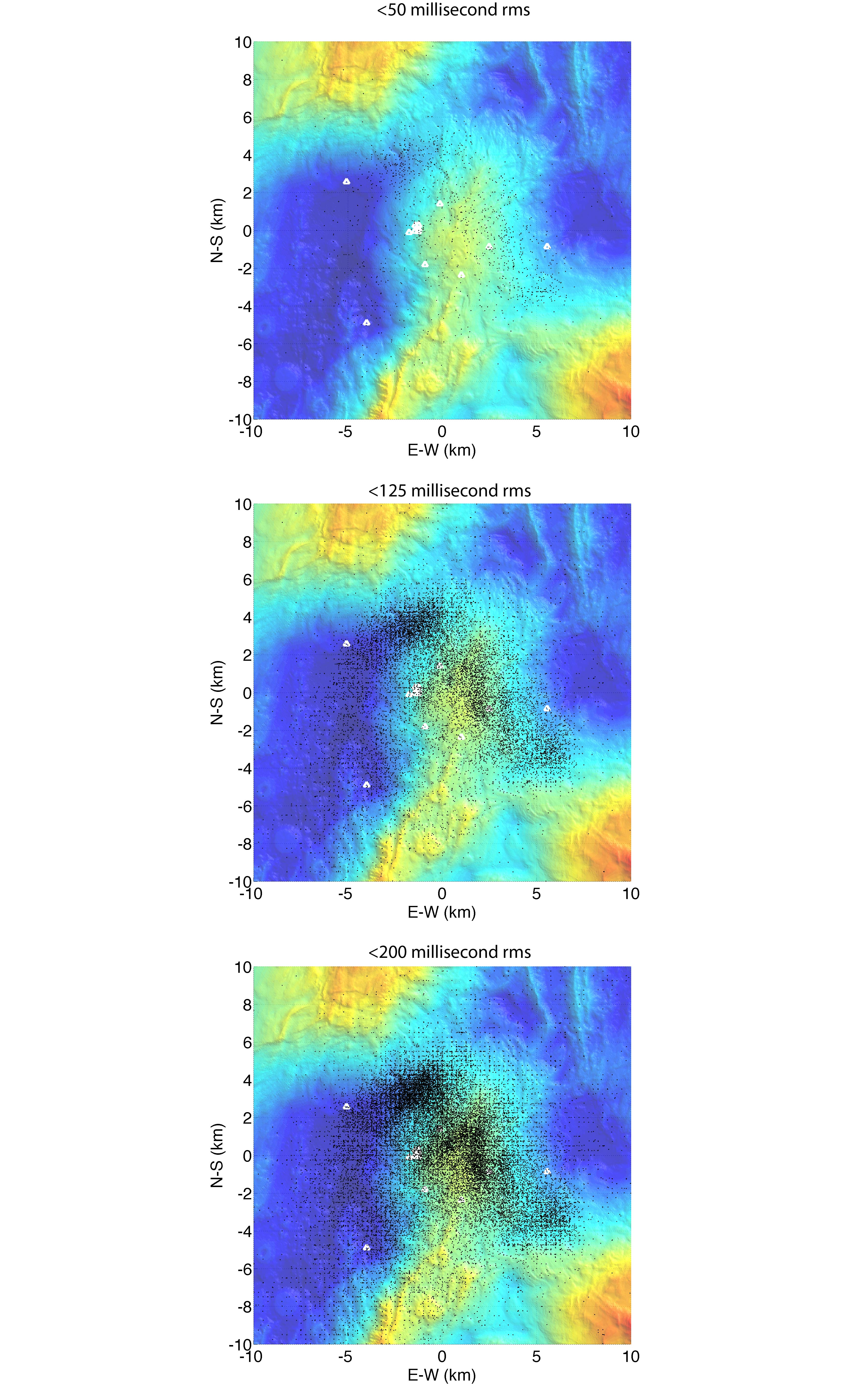

Figure S4. Earthquake epicenters plotted at varying *rms* error thresholds: 50 ms (top panel), 125 ms (middle panel), and 200 ms (bottom panel). OBS locations shown with white triangles.



**Figure S5.** Waveform example illustrating seismic moment estimation. Top panel shows the vertical component waveform from a *M*L 0.52 event recorded on one of the seismometers. Bottom panel shows displacement spectrum for this waveform, and the spectral level estimate used in Equation S1 for moment estimation. Spectral level estimate is based on the average value between 4-20 Hz (horizontal line between two vertical bars).