Figure 1. Buesseler et al. L&O ref#04-053

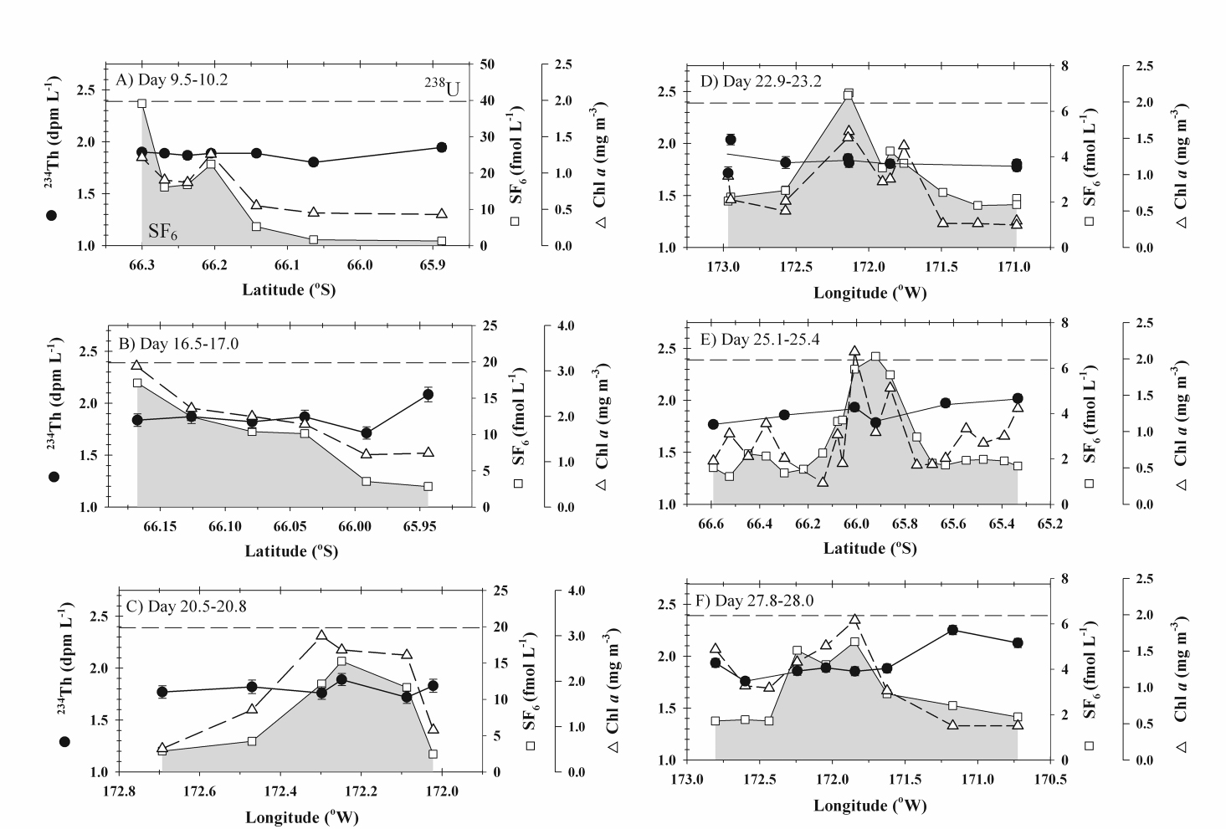

Figure 2. Buesseler et al. L&O ref#04-053

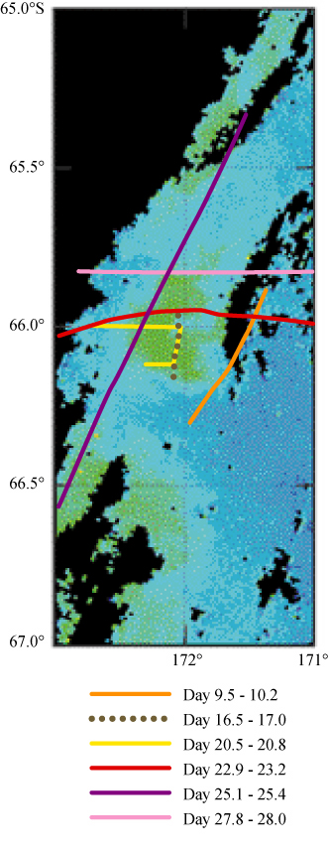
Figure 3. Buesseler et al. L&O ref#04-053

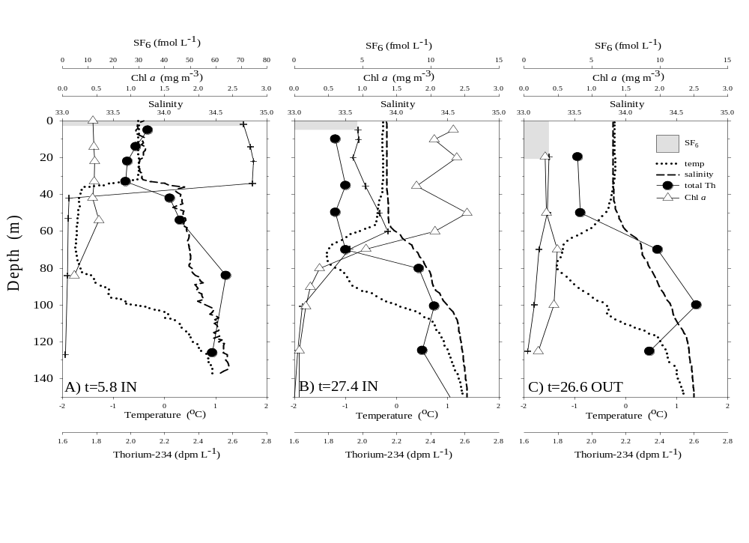
Figure 4. Buesseler et al. L&O ref#04-053

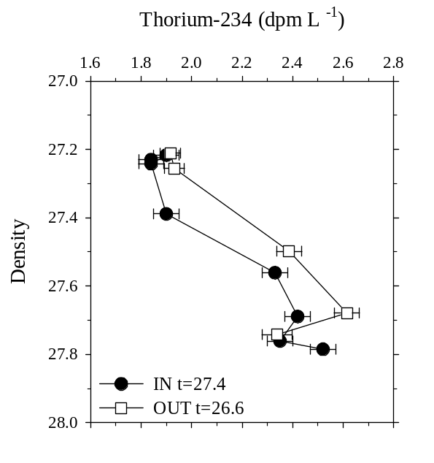

Figure 5. Buesseler et al. L&O ref#04-053

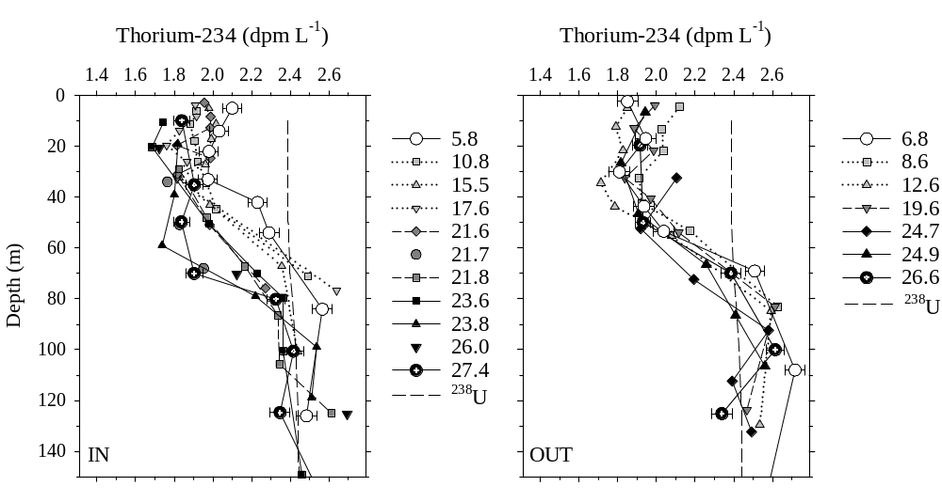

Figure 6. Buesseler et al. L&O ref#04-053

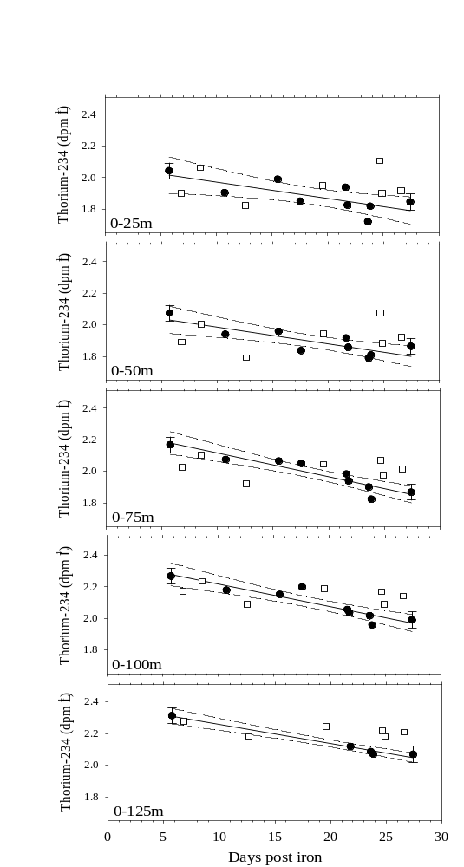
Figure 7. Buesseler et al. L&O ref#04-053

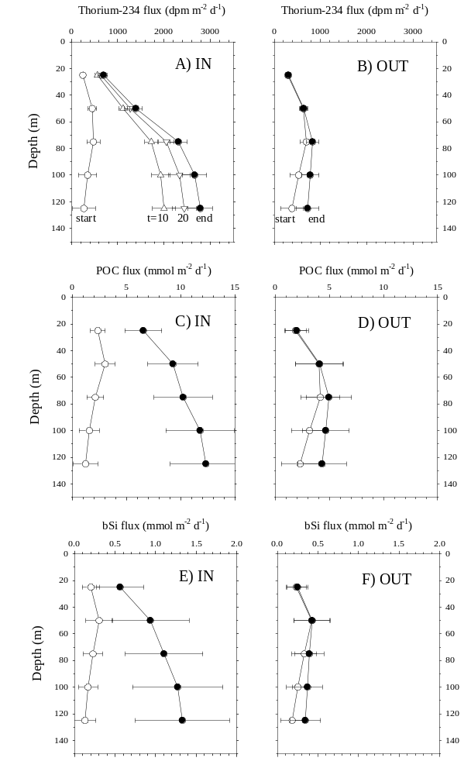
Figure 8. Buesseler et al. L&O ref#04-053

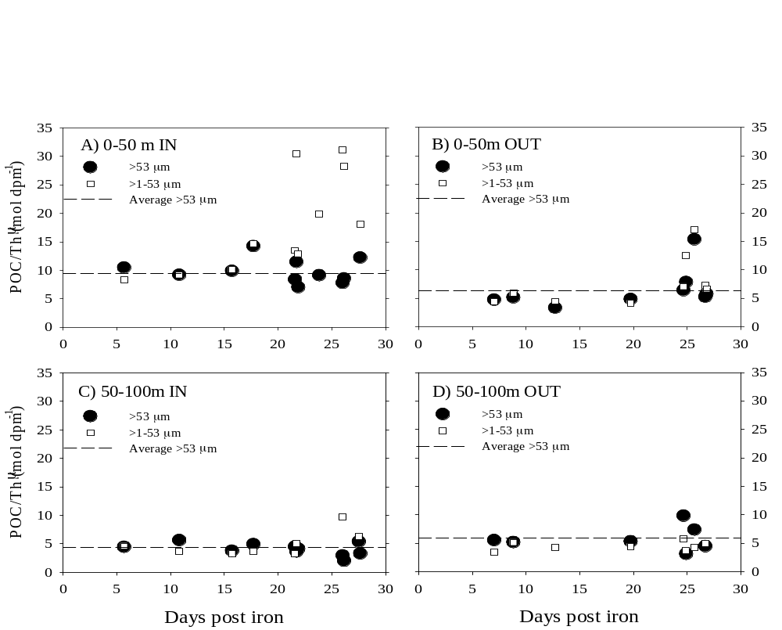
Figure 9. Buesseler et al. L&O ref#04-053

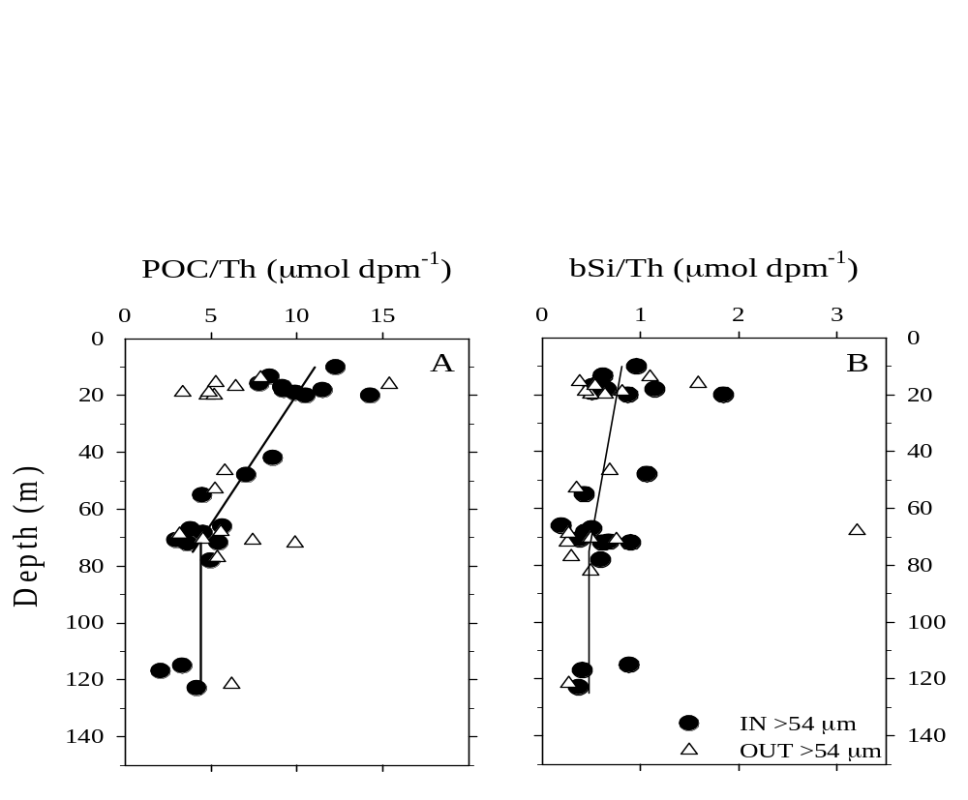
Figure 10. Buesseler et al. L&O ref#04-053



