Geochemistry, Geophysics, Geosystems
Supporting Information for
Segment-scale variations in seafloor volcanic and tectonic processes from multibeam sonar imaging, Mid-Atlantic Ridge Rainbow region (35º45’-36º35’N)
Deborah E. Eason¹, Robert A. Dunn¹, J. Pablo Canales², Robert Sohn²
¹Department of Geology & Geophysics, University of Hawaii, Honolulu, HI, USA
²Department of Geology & Geophysics, Woods Hole Oceanographic Institute, Woods Hole, MA, USA

Contents of this file

Figures S1 to S8

Introduction
In this document we provide additional figures to supplement the Methods (Figures S1-S3) and Results (Figures S4-S8) sections of the paper. See figure captions for additional details.

Methods: Supporting Figures

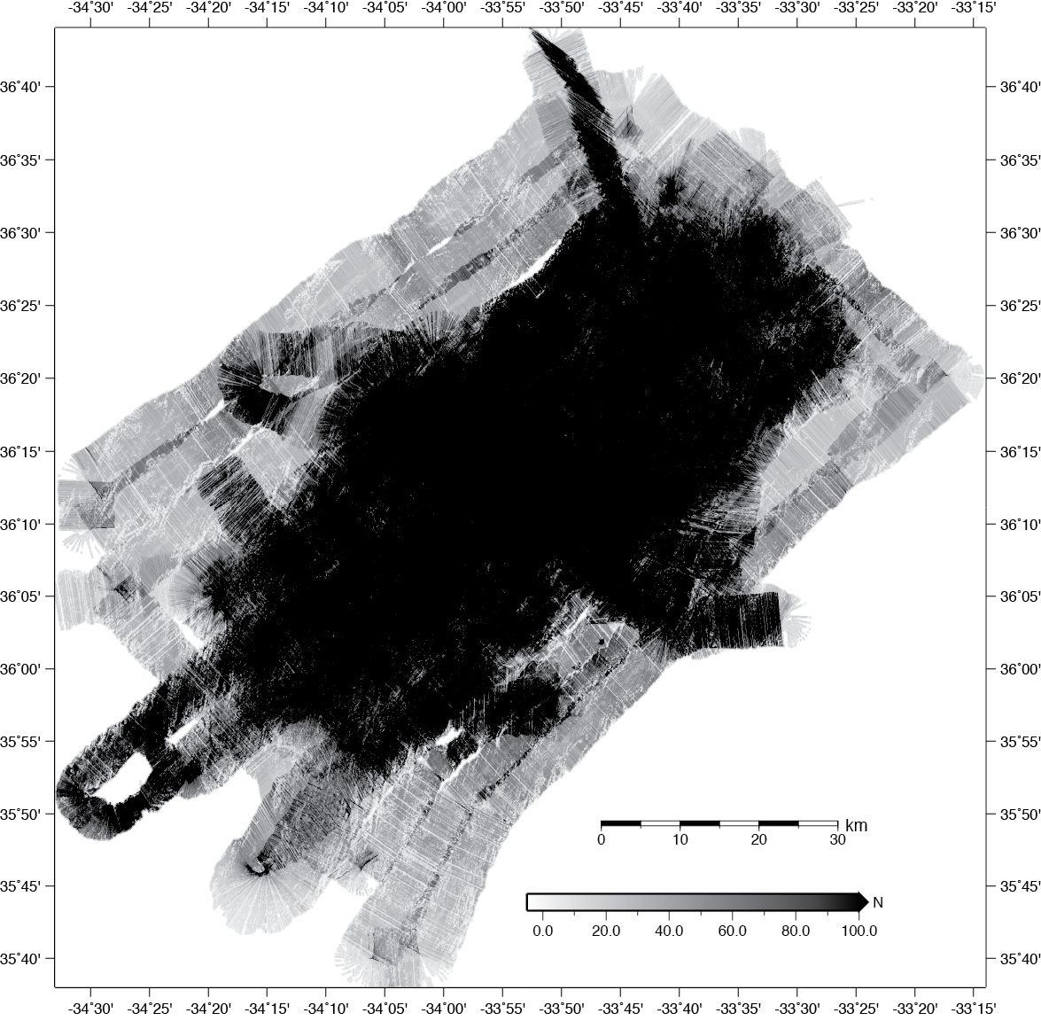

Figure S1. Data density used in the creation of the backscatter sonar image (Fig. 3 of the main text). The image shows a raw count of the number of data, N, used to construct the value for each pixel of the image. Data density is highest in the interior of the experiment, exceeding 100 data values per pixel over most of this area.

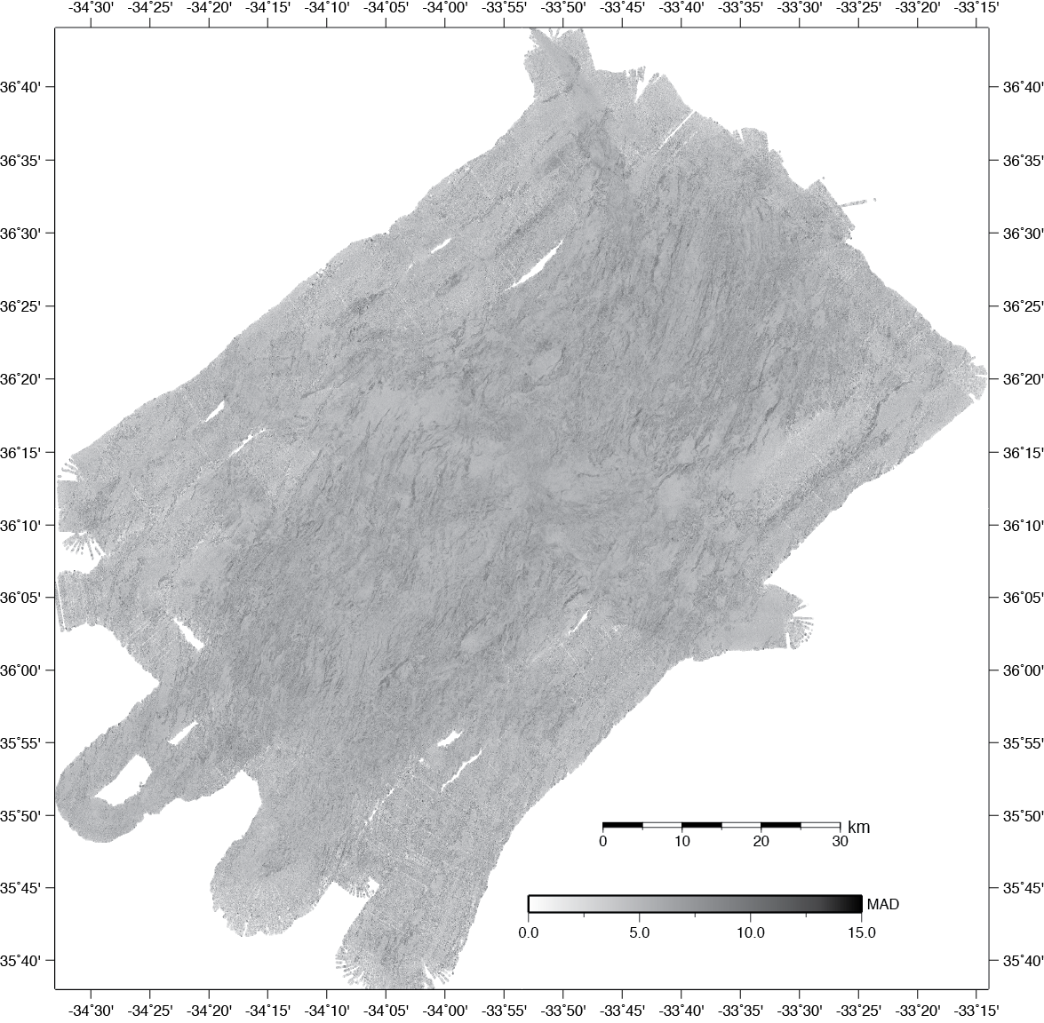

Figure S2. Spread of the sonar data used in the creation of the backscatter sonar image (Figure 3 of the main text). The image shows the data spread calculated as the median absolute deviation (MAD) of the values that contribute to each pixel. Here the MAD is scaled by 1.4826, which is akin to a standard deviation for normally distributed data (https://en.wikipedia.org/wiki/Median_absolute_deviation). Across the survey area, the median of the MAD is ~5 db, with its own MAD of 1.5. The close grouping around 5 db indicates a stable noise process, possibly introduced by small errors in navigation and effects that are not accounted for by the processing assumptions. Some of the largest values of the MAD appear along fault surfaces, indicating that some of the spread is due to uncorrected local slope effects.

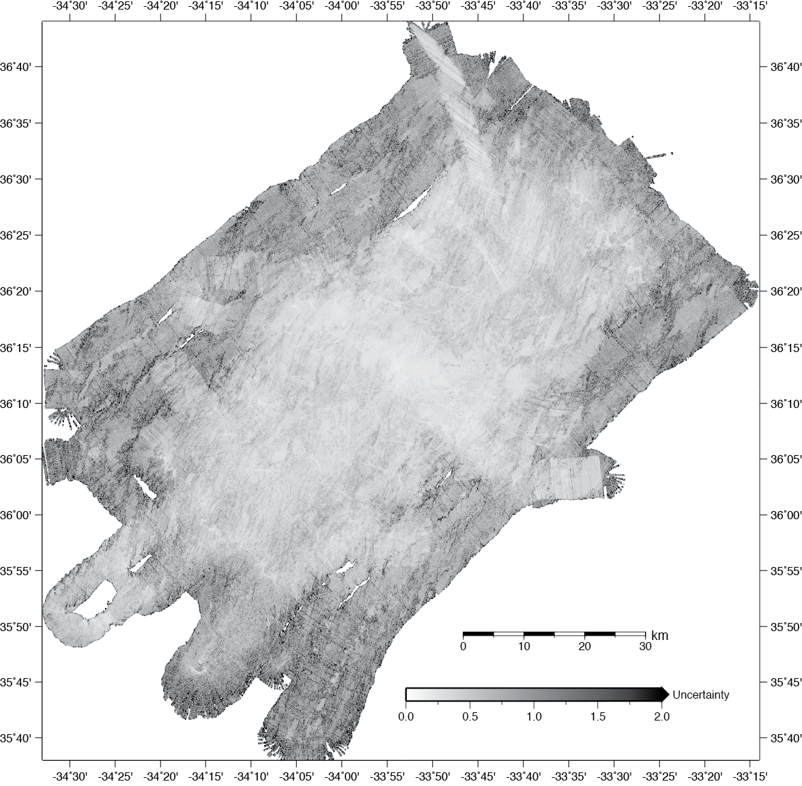

Figure S3. Standard error of the backscatter sonar image (Fig. 3 of the main text). The image shows the standard error of the image pixel values as estimated from the data spread and data density. The uncertainty is lowest within the interior of the experiment, where it tends to be ~0.3 db, on average. These small uncertainties are a testament to the R/V Langseth’s high-quality navigation and sonar system, as well as to the utility and quality of the processing steps and the overall data density. One can see the uncertainty improvement that comes with overlapping ship tracks by comparing the interior region with the areas that surround the interior where there are no overlapping ship tracks (see ship tracks in Figure 1c for reference).

Results: Supporting Figures

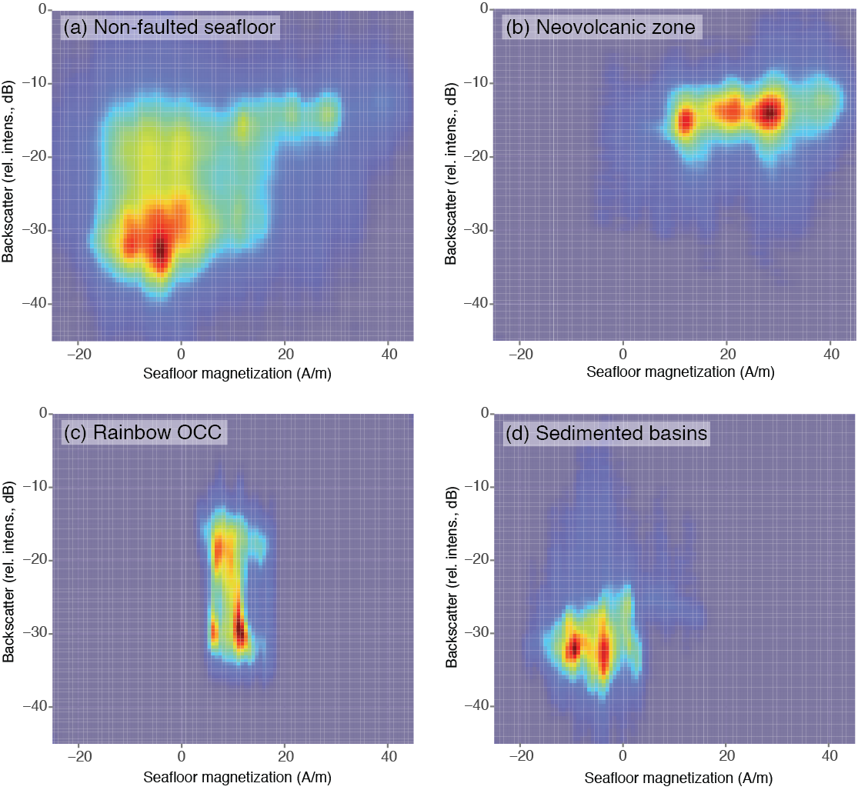

Figure S4. Density distributions of backscatter strength (relative intensity) versus seafloor magnetization for (a) fault surfaces (as defined by Paulatto et al. [2015]), (b) the neovolcanic zone, (c) Rainbow OCC, and (d) sedimented basins. The density distributions are shown as heatmaps, with red colors corresponding to high density and blue corresponding to low density. There is a general positive trend between the seafloor magnetization and backscatter amplitude, with a very large spread at weak and/or reversed seafloor magnetization. The neovolcanic zone is characterized by relatively high backscatter seafloor and strong positive seafloor magnetization, while the sedimented basins are dominated by weak reversely magnetized and low backscatter amplitude seafloor. Rainbow OCC has a more bimodal distribution in backscatter intensities, but a narrow range of weakly positive seafloor magnetization.

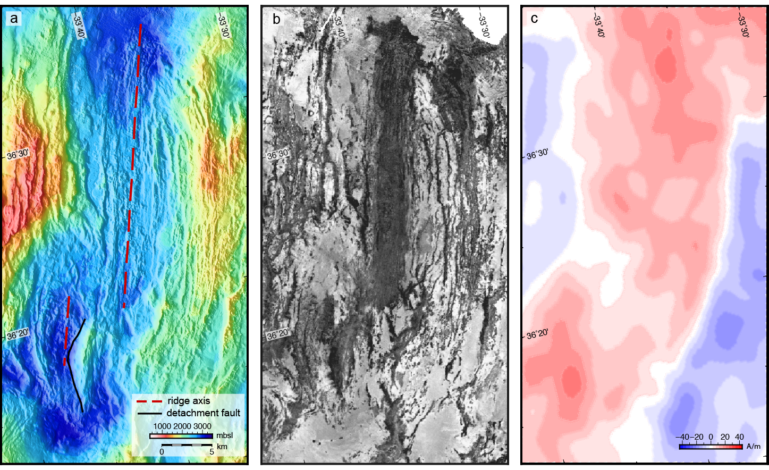

Figure S5. Maps of (a) bathymetry, (b) intrinsic backscatter, and (c) seafloor magnetization of the AMAR and AMAR Minor N segments. Thick black line denotes western edge of proposed nascent detachment fault.

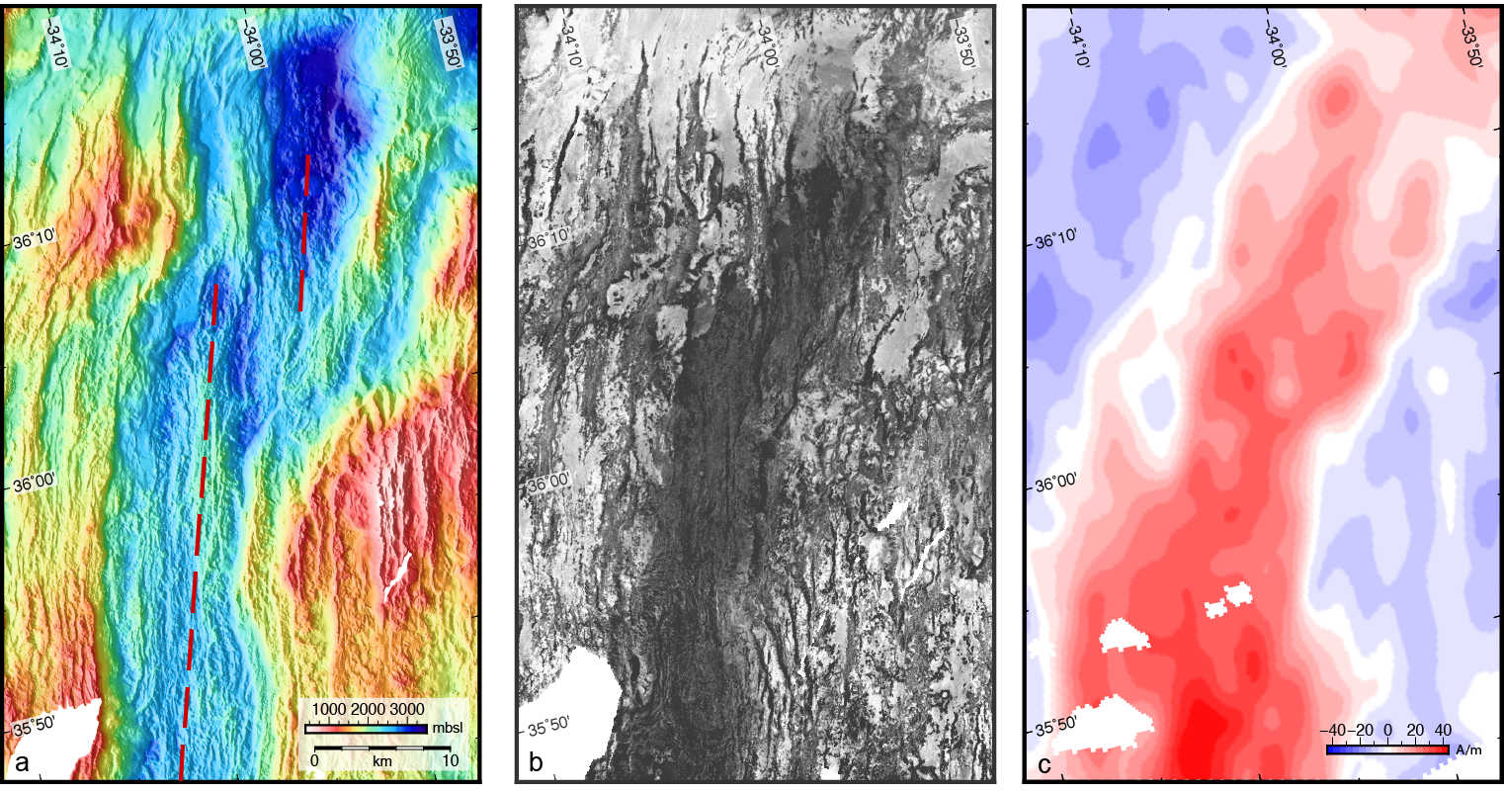

Figure S6. Maps of (a) bathymetry, (b) intrinsic backscatter, and (c) seafloor magnetization of the S AMAR and AMAR Minor S segments.

Figure S7. Maps of (a) bathymetry, (b) intrinsic backscatter, and (c) seafloor magnetization of the Rainbow massif area. Note that the shipboard magnetics data is relatively low resolution and caution should be used when comparing to the backscatter at these scales. Higher resolution magnetics data collected by ROV is available from Szitkar et al. [2014] shows very high magnetization seafloor (~30+ A/m) associated with the hydrothermal field, for example, which is not resolved by the shipboard data.

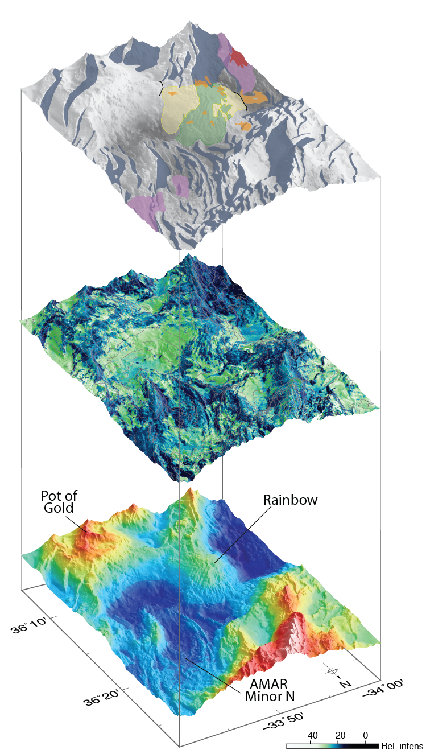

Figure S8. Three-dimensional perspective views of bathymetry (bottom), backscatter intensity draped over bathymetry (middle), and geologic interpretation (top) for the Rainbow area (view of AMAR Minor N with proposed nascent detachment fault, with Rainbow and Pot of Gold massifs in the background; vertical exaggeration: 2x). Backscatter image (middle): light greens correspond to low backscatter intensity, dark blues correspond to high backscatter intensity, and gray lines denote 200 m contours of water depth. The sonar images are shaded by the slope of the bathymetry. Colored fields as in Fig. 8 of main text.

