# **Supporting Information**

The supporting section details all of the equations used in wave calculations. Both linear Airy wave theory and shallow water wave assumptions are detailed for wave shoaling (assuming shore-normal waves and therefore no refraction). In addition, this supporting document contains values for the derivatives of the wave velocity components used in the bed evolution formulation for linear waves (eq. 8-11 in the main text). Last, for completeness we present plots of the diffusivity and advection terms as a function of depth for different wave and sediment characteristics.

## *Wave Equations*

The following section describes the calculations of the deep-water wave variables and depth-dependent shoaling computations for both linear Airy wave theory and shallow-water wave assumptions.

### *Deep Water Wave Parameters*

For a given a wave period (*T*) and a deep-water wave height (*H0*), deep-water wavelength is:

(s1)

The wave celerity is given by:

(s2)

which enables the calculation of the group wave speed:

(s3)

with the wave dispersion factor for deep-water waves.

### *Linear Airy Wave Theory*

The Eckart equation [1952] is used to estimate the local wavelength, for a given deep water wavelength (*L0*)as a function of the depth (z):

(s4)

Other methods for analytically estimating local wavelength besides the Eckart equation were investigated (including the *Soulsby* [2006] and *Fenton and McKee* [1990]) and there was less than 5% variation on the calculated sediment transport (*qs*) flux.

The wave speed or celerity is then calculated as:

(s5)

The wave group speed, Cg, is calculated using the dispersion relationship:

(s6)

where the wave number is:

(s7)

such that the group wave celerity is:

(s8)

Conservation of energy then leads local wave height (*H*) at each depth where:

(s9)

### *Shallow-water Wave Assumptions*

For shallow-water wave assumptions, the wavelength computation simplifies to:

(s10)

and wave celerity becomes:

(s11)

Because *n* = 1 in shallow water, group speed simplifies to:

(s12)

The local wave height is therefore:

(s13)

## *Bedload vs. Suspended Load Sediment Transport*

We compare the cross-shore sediment flux for bedload and suspended load transport for each of the six study sites using the smoothed averaged profiles and the calculated characteristic morphodynamic wave height and wave period (Figure S1). For all sites (and for medium-grained sand), suspended sediment flux is an order of magnitude larger than bedload sediment flux. Even for the coarsest sediment, only at Eel River, CA is the bedload flux on the same order of magnitude as suspended sediment flux.

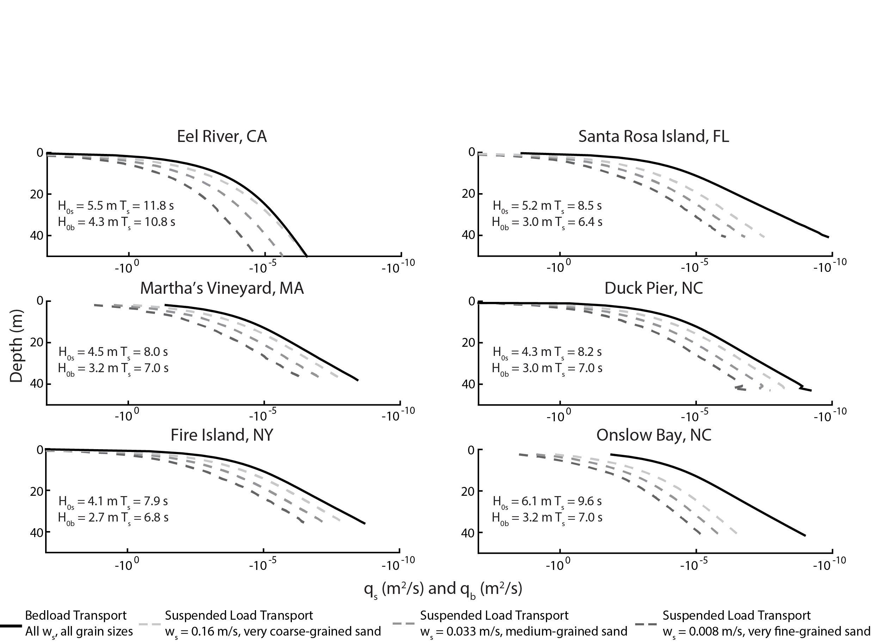

Figure S1. Cross-shore suspended sediment flux (qs) and bedload sediment flux (qb) for six study sites using linear theory, the actual smoothed slope, and the characteristic morphodynamic wave height and wave period based on suspended and bedload weighting for varying grain size. Negative values indicate onshore-directed sediment transport.

## *Full Exner Equation for Bed Evolution*

Here we provide the full values for the spatial derivative terms in the equation for bed evolution arising from the derivative of sediment flux with respect to cross-shore distance:

(s14)

where the single apostrophe denotes:

(s15)

These derivatives are complex because each wave component is a function of depth, as are the terms inside each component, i.e. wavelength, wave number, and wave height. Using linear Airy wave theory to compute the wave components and using the product and chain rule, the cross-shore derivative for the wave orbital velocity is:

Macintosh HD:private:var:folders:cg:_dxs0wm957d0gkgs8jpz72ym0000gn:T:TemporaryItems:latex-image-1.eps . (s16)

The wave drift term is then:

Macintosh HD:private:var:folders:cg:_dxs0wm957d0gkgs8jpz72ym0000gn:T:TemporaryItems:latex-image-1.eps. (s17)

Finally, the wave asymmetry term is:

Macintosh HD:private:var:folders:cg:_dxs0wm957d0gkgs8jpz72ym0000gn:T:TemporaryItems:latex-image-1.eps . (s18)

In these equations (16-18), the *H’* term denotes the derivative of wave height with respect to *z* such that:

and *L’* denotes the derivative of the wave length with respect to z:

It is important to note that in the above equations of the derivative of the wave components (equations 16-18), the terms containing the derivative of wave height (*H’*) and wavelength (*L’*) are of secondary importance in determining the magnitude, typically accounting for 40% of the total magnitude. The equilibrium bed slope is calculated using first-order Eulerian integration of the bed depth.

## *Advection-Diffusion Equation Terms*

Here we provide plots of the depth dependence of the advection and diffusion terms. We investigate the dependence of bed evolution and how those terms respond to changes in wave climate or grain size. Kinematic bed celerity (equation 13) is sensitive to wave height and period, but not settling velocity (Figure S2). Compared to the wave period and grain size, at a depth of 20 m the advection term ranges within 4 orders of magnitude as *H0* varies from 1 – 5 m. As water depth increases, however, wave period has the strongest control on the advection term. By 50 m, kinematic celerity ranges 8 orders of magnitude between 6 s and 14 s waves.

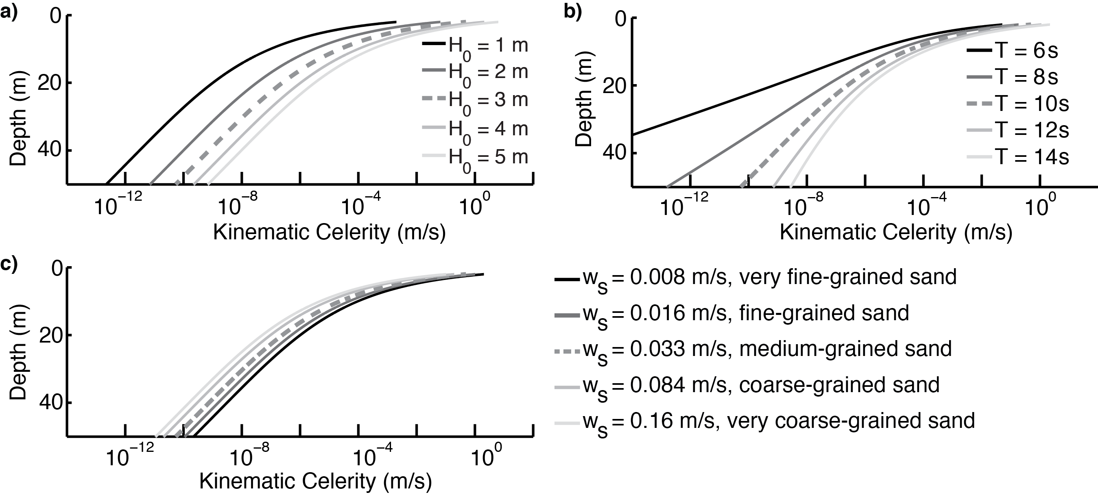Figure S2. Kinematic celerity of an equilibrium shoreface computed using linear theory over depth with (a) varying deep-water wave height for *T* = 10 s and *ws* = 0.033 m/s, (b) varying wave period with *H0* = 3 m and *ws* = 0.033 m/s, (c) and varying sediment fall velocity with *H0* = 3 mand *T* = 10 s.

Diffusivity (equation 16) also varies over depth (Figure S3). At shallow depths, the deep-water wave height provides a strong control on the diffusivity, with wave period exerting stronger control with depth, much like for the kinematic celerity. Note that the diffusivity is more sensitive to sediment size than the advection term. Given a morphodynamic Péclet number less than unity, the system is dominated by diffusive processes. Thus, when looking at the predicted timescale of kinematic celerity (Figure S4), the depths at which this value asymptotes are much shallower. In essence, the kinematic celerity (or advection term) predicts a shallower morphodynamic depth of closure. This shallower MDOC reflects decreased predicted shoreface activity assuming the shoreface is advection dominated.

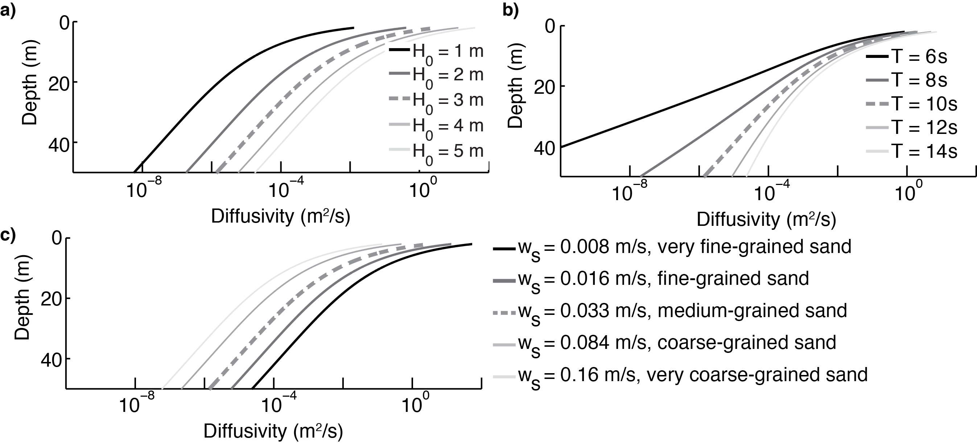

Figure S3. Diffusivity of equilibrium shoreface computed using linear theory over depth with (a) varying deep-water wave height for *T* = 10 s and *ws* = 0.033 m/s, (b) varying wave period with *H0* = 3 m and *ws* = 0.033 m/s, (c) and varying sediment fall velocity with *H0* = 3 mand *T* = 10 s.

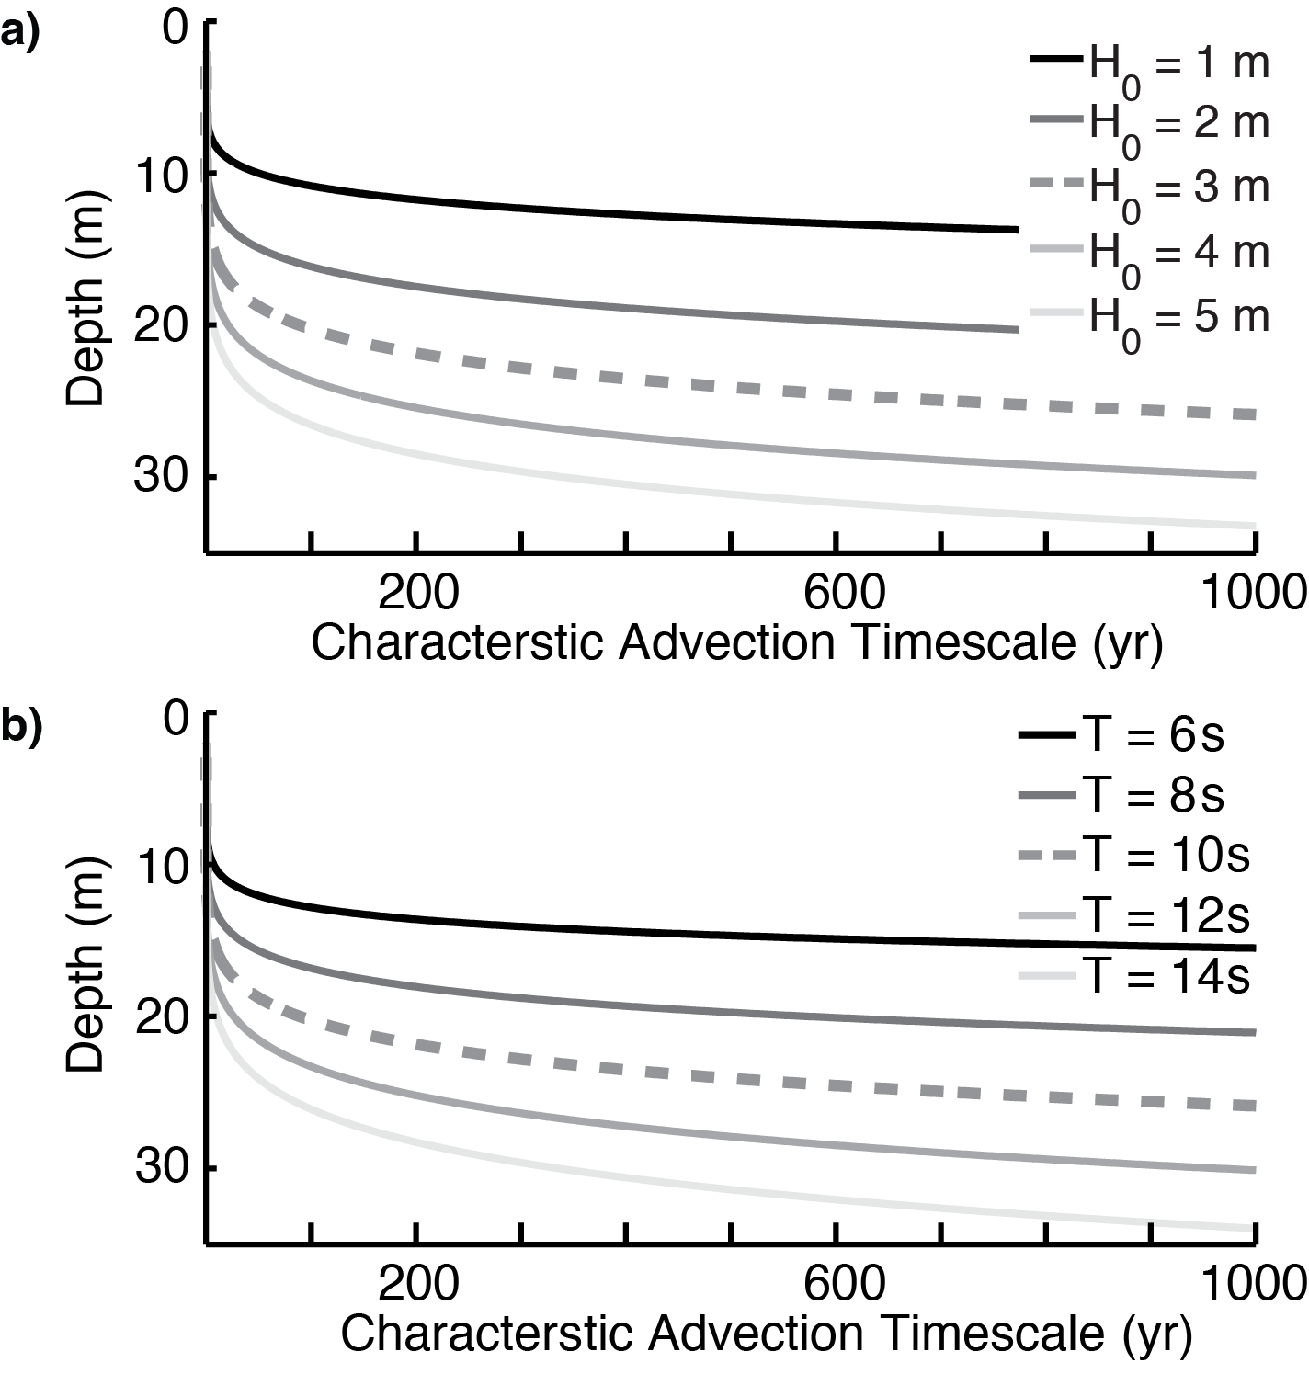

Figure S4. Computed characteristic timescale of kinematic celerity using linear theory over depth with varying (a) deep-water wave height with *T* = 10 s and (c) varying wave period with *H0* = 3 m.

**References**

Eckart, C. (1952), The propagation of waves from deep to shallow water, in *Proceedings of the NBS Semicentennial Symposium on Gravity Waves*, vol. Circular 5, edited by N. B. of Standards, p. 165, NBS.

Fenton, J. D., and W. D. McKee (1990), On calculating the lengths of water waves, *Coast. Eng.*, *14*(6), 499–513.

Soulsby, R. L. (2006), *Simplified calculation of wave orbital velocities*, HR Wallingford Ltd., Wallingford, TR-155.